MA HIX Project

# Optum Operations & Maintenance (O&M) Manual

Version 16.0

09/30/2025

Record of Changes

Table 1 – Record of Changes

| Version Number | Date | Author/Owner | Description of Change |
| --- | --- | --- | --- |
| 1.0 | 02/08/2021 | Optum O&M | Baseline Version |
| 2.0 | 05/14/2021 | Optum O&M | Updated based on feedback from Commonwealth Project team and IV&V |
| 3.0 | 06/11/2021 | Optum O&M | Updated based on feedback from Commonwealth Project team and IV&V |
| 4.0 | 07/16/2021 | Optum O&M | Post R22.6 - Batch Schedule |
| 5.0 | 09/08/2021 | Optum O&M | Post R23 updates - R23 SAD, miscellaneous updates |
|  | 10/08/2021 | Optum O&M | Post R23.1 – No Updates |
| 5.1 | 10/20/2021 | Optum O&M | Post Commonwealth O&M Manual revisions to remove references to sections not covered in Commonwealth O&M Manual. |
| 6.0 | 01/21/2022 | Optum O&M | Post R24 - SAD updates, batch schedule, miscellaneous updates |
|  | 03/14/2022 | Optum O&M | Post R24T – No Updates |
|  | 05/13/2022 | Optum O&M | Post R24.2 – No Updates |
| 7.0 | 09/16/2022 | Optum O&M | Post R25 updates including updates from: Akami to CloudFront, R25 SAD, FDSH unavailable feature, user counts and peak processing, batch schedule, miscellaneous updates |
| 7.1 | 10/5/2022 | Optum O&M | Minor update to correct inadvertent omission of Audit Data Processing Job #., |
|  | 10/28/2022 | Optum O&M | Post R25.1 (Including R25 emergency releases) – No updates |
| 8.0 | 02/10/2023 | Optum O&M | Post R26.0 updates including updates to Batch Schedule table, Monitoring Table, MA21 service, MCP service, change application/system dependency due to asynchronous functionality |
| 9.0 | 05/31/2023 | Optum O&M | Post R26.1 updates including updates to MOCC Notification for P3 incidents, DDE flowchart, DOR COMET disabled, |
| 9.1 | 06/09/2023 | Optum O&M | Updated based on CoM feedback |
| 10.0 | 09/15/2023 | Optum O&M | Post Release 27 functionality updates including Disability Review, Member Communication Portal, and Infrastructure changes |
|  | 11/01/2023 | Optum O&M | Post Release 27.1 – no updates |
| 11.0 | 02/02/2024 | Optum O&M | Post Release 28 functionality updates including Verified Chronically Homeless and Periodic Verification Confirmation. |
| 12.0 | 06/21/2024 | Optum O&M | Post Release 28.1 updates – no functional changes. Administrative updates to include current contacts, counts, etc. |
| 13.0 | 08/30/25 | Optum O&M | Post Release 29 functionality updates including Omnibus Return Mail and Medicaid Household Composition rules added to Business Rules Engine. |
| 14.0 | 04/04/25 | Optum O&M | Post Release 30 functionality updates including User Administration. Administrative updates including reports, members visits, etc. |
| 15.0 | 06/04/2025 | Optum O&M | Post Release 31 functionality updates in batch jobs and reporting. Addition of CDC DDE |
| 16.0 | 09/30/2025 | Optum O&M | Post Release 32 functionality updates in batch jobs. Administrative updates. |

Table of Contents

1 Introduction 7

2 Referenced Documents 8

3 System Overview 9

3.1 Functional System Overview 9

3.1.1 Application/System Dependency 12

3.1.2 CloudFront 21

3.2 Physical System Overview 21

3.2.1 Physical Architecture 21

3.2.2 System Software to Hardware Specifications 22

3.2.3 System Firewall Specifications 22

3.3 System User Overview 22

3.3.1 Estimated Users 22

3.3.2 Peak Processing Time 22

3.3.3 Hours of Operation 27

3.3.4 User Impact for System Failure 27

3.4 Processing Overview 28

3.4.1 Interaction 29

3.4.2 Scheduling 29

3.4.3 Data Flow Diagram 59

3.4.4 Data Sources 60

3.4.5 Data Refresh 71

3.4.6 Reporting Requirements 72

3.4.7 Key Performance Measures (KPMs) 77

3.5 Security and Privacy Overview 81

4 Operations and Maintenance Activity Roles and Responsibilities 82

4.1 Meetings Hosted by Optum O&M 83

4.1.1 Daily Operations call 83

4.2 Optum O&M Operating hours 84

5 Operation Procedures 85

5.1 Operations Sequence 85

5.1.1 Incident Management 85

5.1.2 Problem Management 94

5.2 Operations Procedures 96

5.2.1 Access Requests 96

Manage Agent & Assister Access Menu on Agent Portal 97

5.2.2 Member Resolutions 97

5.2.3 L Errors resolutions 101

5.2.4 MMIS Manual processing 104

5.2.5 5.2.5 Daily Data Extract (DDE) processing 107

5.2.6 Open Enrollment 118

5.3 Production Control Procedures 131

• Change management 131

• The Goal of Change Management 131

• Change Management Process flow 131

5.4 Diagnostic and Problem Handling Procedures 133

5.5 Monitoring Procedures 134

• Monitoring RACIs 134

5.6 Maintenance Procedures 142

• Maintenance Scheduling 142

6 Data and Database Administration 143

6.1 Data Administration Procedures 143

6.2 Database Administration Procedures 143

7 Configuration Management 144

7.1 Configuration Changes – Reason for Changes 144

7.2 Configuration Changes – Process Workflow 144

List of Figures

Figure 1: Environment System Configuration 12

Figure 2: Monthly Peak Processing Time 25

Figure 3: Yearly Peak Processing Time-Individual Portal 26

Figure 4: Yearly Peak Processing Time-Agent Portal 27

Figure 5: Yearly Peak Processing Time-Assister Portal 28

Figure 6: Spring Batch Framework 29

Figure 7: Data Flow – Interface View 60

Figure 8: Interface and Member Data Exchange 61

Figure 9: AWS QuickSight integration 77

Figure 10: Daily Ops Agenda 85

Figure 11: Non-Security MA HIX Incidents Workflow 88

Figure 12: O&M Incident Process Flow 93

Figure 13: Optum O&M Workaround Process Flow 94

Figure 14: Optum O&M Exclusion Process Flow 95

Figure 15: O&M Data Correction Process Flow 97

Figure 16: L Errors Process Flow 104

Figure 17: MMIS Issue Tracker 108

Figure 18: DDE file transfer process 109

Figure 19: Sample CCA DDE Extract Delivery Email 110

Figure 20: Sample MH DDE Extract Delivery Email 111

Figure 21: DDE Data Issue Process Diagram 113

Figure 22: DDE Late Delivery Process Diagram 113

Figure 23: Sample MH DDE Report 114

Figure 24: Sample CCA DDE Report 114

Figure 25: Launch Informatic PROD 115

Figure 26: Informatic Select Monitor Service 115

Figure 27: Informatic Goto All Jobs 116

Figure 28: Informatic Job Failure 116

Figure 29: Informatic Analyze Failure 116

Figure 30: Informatic Restart 117

Figure 31: Informatic Select Data Integration 117

Figure 32: Informatic Select DDE Jobs 118

Figure 33: Informatic Failure Task 119

Figure 34: Sample NMLB Report 130

Figure 35: OE Scrum Meeting Minutes Template 131

Figure 36: Configuration Change Process Flow 146

Figure 37: Post-Release Validation Status Overview 150

Figure 38: Post-Release Regression Validation Status 150

List of Tables

Table 1 – Record of Changes ii

Table 2 – Referenced Documents 8

Table 3 – Application/System Dependency – configurable services 13

Table 4 - Application/System Dependency – non-configurable services 20

Table 5 – Estimated Users 22

Table 6 – Batch Schedule 30

Table 7 – Operations and Support KPMs 78

Table 8 – Roles and Responsibilities 82

Table 9- Optum O&M Roles and Responsibilities 82

Table 10 – Key Terminologies 85

Table 11 – Priority Definition 86

Table 12 – P1 P2 Weekend Distribution List 88

Table 13 – Initial Incident Notification 89

Table 14 – Half Hourly UPDATE Notification 90

Table 15 – Resolved Notification 90

Table 16 – DDE Batch Schedule 110

Table 17 – High Level OE Batch Schedule 119

Table 18 – Optum Change; SMX resource required 131

Table 19 – Optum Change; no SMX resource required 132

Table 20 – SMX Initiated Request 132

Table 21 – MOCC Monitoring & Alerts 134

Table 22 – Optum O&M Contact List 150

Table 23 – MOCC Contact List 150

Table 24 - Acronyms 151

Table 25 - Glossary 155

## Introduction

This document provides an overview of the Optum Operations & Maintenance (O&M) team processes and procedures for the Managed Applications technical operations as stated in Task Order 3 (TO3) contract.

*Managed Application(s) means the New HIX/IES functionality represented by the hCentive Software that includes Individual Portal, Agent Portal and Assistor Portal, as well as IAM, and the functionality developed by Contractor under Task Order 1 and any other Task Order or Change Order. The Managed Applications include the in-scope items specified in AMENDED (and) RESTATED (master services and license) AGREEMENT (ARA) r 1 and any other contract, Task Order or Change Order. The Managed Applications exclude the out-of-scope and Client Responsibilities set forth in ARA and any other contract, Task Order or Change Order, the Client Provided Third Party Software, Client Provided Third Party Services, External Systems and Client provided data sources. Support of integration with the Managed Applications is also in Scope, to the extent that each integration point is monitored by Contractor on an ongoing basis for successful execution and Managed Application Incident management is provided by Contractor when issues occur involving that integration point. In the event that the hCentive License Agreement is assigned to Client, the hCentive Application(s) shall cease to be a Managed Application for purposes of AOM Services, Enhancement Services and Cross Functional Services as of the effective date of such assignment, and it shall be a partial termination within the meaning of Section 7.2.*

The Optum O&M Team processes include high priority Incident Management, Problem Management, Change Management, Triaging, Reporting, Batch processes and other Operational categories.

* + Optum O&M team is responsible for Managed Application services only. Infrastructure associated with Managed Application is provided and managed by Smartronix (SMX) and hosted on Amazon Web Services (AWS).
  + Smartronix / AWS has a separate contract with Commonwealth of Massachusetts for the operations and management of the infrastructure services.

This document is intended to provide Commonwealth and Commonwealth third party vendors with an understanding of Optum O&M team ongoing activities. It will be updated no less than annually.

Per Commonwealth request, Optum O&M have included sections in this document which are outside of Optum O&M responsibility, and references to documents which are not created or managed by Optum O&M. Inclusion in this document does not imply Optum O&M team responsibility. These sections are noted as not applicable to Optum O&M, identify the section owner to the best of Optum O&M's knowledge, or identify the specific role Optum O&M has.

Infrastructure related processes and procedures for the managed applications are covered in the SMX cloud operations manual supplied to the Commonwealth of Massachusetts (CoM).

## Referenced Documents

Table 2 – Referenced Documents

| Doc Name | Location |
| --- | --- |
| HIX-OTS MSA between EOHHS and OptumInsight Inc. (OTS Contract) | Location to be shared by CoM |
| System_Architecture_Design | EOHHS SharePoint |
| HIXIS-859 DC WA Exclusion DM processes and definitions | EOHHS JIRA |
| AWS Smartronix HIX Cloud Operations Plan | EOHHS SharePoint |
| HIX Cloud Governance Plan | EOHHS SharePoint |
| Project O&M Manual | EOHHS SharePoint |
| MA HIX Optum Technical Services Manual | EOHHS SharePoint |
| AMENDED (and) RESTATED (master services and license) AGREEMENT (ARA) | Location to be shared by CoM |

## System Overview

This section provides a high-level overview of the system architecture, describes the data flow design associated with the system, and identifies the human-machine interface and operational scenarios. The Massachusetts Exchange System (MA HIX) is built using the Webinsure Commercial off-the-shelf (COTS) as primary software portal component for the Healthcare Information Exchange (HIX) solution.

### Functional System Overview

The hCentive platform provides standard HIX functionality: application intake, eligibility determination (program determination), shopping / plan selection, plan management, enrollment and renewal capabilities.

Currently there are three application portals to MA HIX:

* **Individual Portal** is the site/application through which an individual or a family login and can use the marketplace to request financial assistance, view available qualified health plans, enroll in a new plan, or change plans. Individual users can also report changes to their circumstances such as an address change or additional family member. If enrolled in a qualified plan, individuals can review relevant plan details. One can access this page by clicking on this [link](https://www.mahix.org/individual/)
* **Agent Portal** is the site/application through which provides an interface for Commonwealth or third-party customer service representatives to login and help the individuals perform all of the above functions. Agents can search for individuals/families by different means. In additional to Individual Portal functionality, the Agent Portal provides role-based access to additional back office functionality, such as processing eligibility verifications and adding assister information to an individual/families account. One can access this page by clicking on this [link](https://www.mahix.org/agent/)
* **Assister Portal** functionality provides Certified Assisters the ability to complete eligibilities, enrollment, and understand plan details on behalf of an individual. Certified application counselor designated organizations (CDOs) are a vital component of the assister community. For purposes of this functionality, Certified Assisters include Certified Application Counselors (CACs) and Navigators. Unlike Agents, these individuals are usually affiliated with community health centers or other health care providers, hospitals, or social service agencies. CACs are required to be in-person when working with applicants. One can access this page by clicking on this [link](https://www.mahix.org/assister/)

In addition to these portals, MA HIX has a significant number of batch jobs that are run regularly to support various data transfers and other critical operational needs for MA HIX.

The MA HIX System design is a modern architecture incorporating multiple security zones to support web service communications, Service-oriented Architecture (SOA) and service bus (JBoss) infrastructure to support message routing, and a core hCentive application written completely in Java. In addition, an enterprise job management system (Argent Scheduler), and a secure file transfer protocol (AxWay) server are incorporated into the core hCentive architecture. Argent Scheduler and AxWay are the software chosen by Smartronix (SMX) to be used for these functions on the AWS infrastructure. Throughout the architecture are security hardware and software components that perform specialized functions for the exchange. MA HIX has extensive connectivity to other systems to attain information used during program determination as well as the Softheon System and Medicaid Management Information System (MMIS) to process members (applicants and enrollees) for Qualified Health Plan (QHP) and Medicaid, respectively.

All systems comprising the core MAHIX are hosted in Amazon Web Services Data Center in Northern Virginia (us-east-1), however, other systems like the Softheon Services are housed in Stony Brook, New York and the MMIS systems reside in the Commonwealth managed data centers in Massachusetts. For the core MAHIX, the systems are placed into security zones:

* A Presentation Zone (PZ) where all communication to external entities is routed through. All communication channels to external entities are secured using x509 certificates.
* Application Zone (AZ) where application servers and services reside. It receives requests from the Presentation Zone and requests necessary data from Data Zone components.
* Data Zone (DZ) contains all data sources including the MA HIX protected data. Access to the data zone is limited to application servers in the AZ.

Until August 2020 the MA HIX application was hosted by Optum in its data centers in Elk River and Chaska, MN. In 2020 Commonwealth moved the application to AWS cloud. This was done by SMX, a third-party company from Maryland contracted by the Commonwealth, who is also an AWS partner. As of May 2021, MA HIX application is hosted on severs owned by AWS and in their US-EAST region. Each AWS Region consists of multiple, isolated, and physically separate Availability Zones within a geographic area. MA HIX resides in the Northern Virginia Zone and it is represented as US-EAST-1.

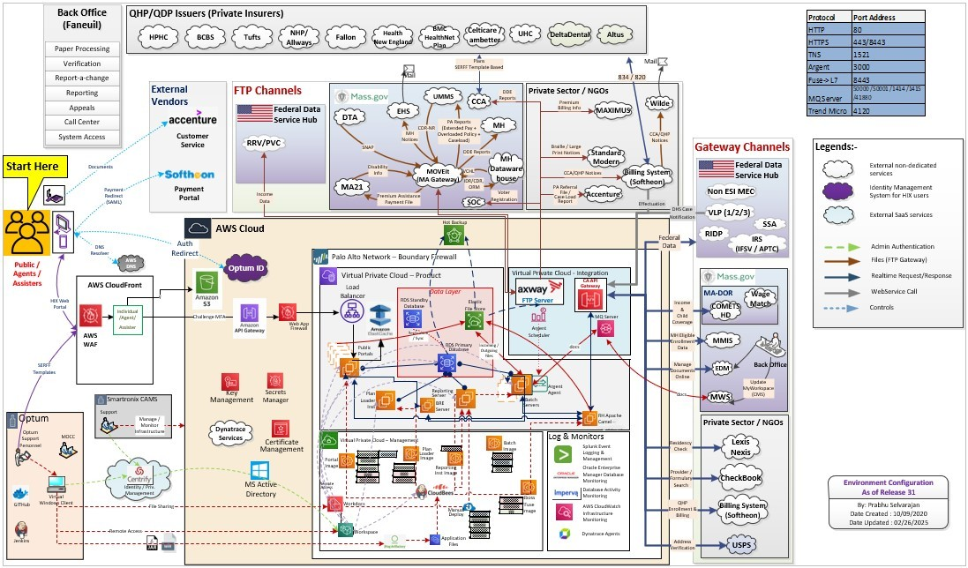

Figure 1: Environment System Configuration

#### Application/System Dependency

The MA HIX system is dependent on external sources to provide information, and electronically verify user entered information for its core functions. The dependency of the MA HIX system on external sources including the impact to the end users is outlined below. With Release 26, functionality has been updated to allow users to proceed with an application, report a change, or other actions when Federal Data Services Hub (FDSH) services are unavailable, in most scenarios. In certain scenarios where the user is allowed to proceed, they will receive a message that their eligibility was not able to be determined, but this will be done soon. The application will be held in a suspended status for no more than 24 hours. The system will try reprocessing this application (at configurable intervals) during that 24-hour period. If the previously unavailable service has been restored, the application will be processed when the service is restored, and eligibility determined. If the service is not restored within 24 hours, determination will be made using available data as per business requirements.

This functionality is configurable based on business direction on two levels. Users are “allowed” to proceed or “not allowed” to proceed. Separately, “Asynchronous” processing can be “On” or “Off”. If the system is configured to “not allow” users to proceed, asynchronous reprocessing is disabled by default.

The impact to end users are given for "allow" with “asynchronous on”, “allow” with “asynchronous off”, and "not allow". There are additional external sources which are not a dependency for MA HIX core functions and are not included in this table. All external sources are included in the Data Sources section with additional details.

Table 3 – Application/System Dependency – configurable services

| Dependent Application/System - Service Owner | Function | Impact if service is unavailable by Portal (Individual, Assister, Agent) – configured "allow" and “asynchronous on” | Impact if service is unavailable by Portal (Individual, Assister, Agent) – configured "allow" and “asynchronous off” | Impact if service is unavailable by Portal (Individual, Assister, Agent) – configured "not allow" |
| --- | --- | --- | --- | --- |
| Social Security Administration - Federal Data Services Hub (FDSH) | Checks applicant for Citizenship Status, Incarceration Status, and Disability Status. | **SSN**  User attests No SSN -  No Impact - RFIs generated based on reason code e.g. "Just Applied"  **User attests SSN with New Application or change in demographic info with Report a Change - Hard Stop**  Cannot proceed from SSN page. Asks user to retry and/or error message saying to revisit another time. User retry count is not increased if service is unavailable.  **User has no change in demographic information with Report a Change - No impact**  User is allowed to proceed. Application will be suspended and processing of determination will be retried for a configurable amount of time. If service is not available during this configurable amount of time, if available previous SSA response will be used. | **SSN**  User attests No SSN -  No Impact - RFIs generated based on reason code e.g. "Just Applied"  **User attests SSN with New Application or change in demographic info with Report a Change - Hard Stop**  Cannot proceed from SSN page. Asks user to retry and/or error message saying to revisit another time. User retry count is not increased if service is unavailable.  **User has no change in demographic information with Report a Change - No impact**  User is allowed to proceed | **SSN User attests No SSN -** No Impact – Requests for Information (RFIs) generated based on reason code e.g. "Just Applied" **User attests SSN - Hard Stop** Cannot proceed from SSN page. Asks user to retry and/or error message saying to revisit another time. User retry count is not increased if service is unavailable. |
| **NOTE: Citizenship status for a given SSN is part of SSA response on the Personal Information page.**  **Citizenship**  **User attests No SSN -**  No Impact - RFIs generated based on Naturalized/Non-Naturalized attestation and/or VLP response  **User attests SSN with New Application or change in demographic info with Report a Change - Hard Stop**  Cannot proceed from SSN page. Asks user to retry and/or error message saying to revisit another time. User retry count is not increased if service is unavailable.  **User has no change in demographic information with Report a Change - No impact**  User is allowed to proceed. Application will be suspended and processing of determination will be retried for a configurable amount of time. If service is not available during this configurable amount of time, if available previous SSA response will be used. | **NOTE: Citizenship status for a given SSN is part of SSA response on the Personal Information page.**  **Citizenship**  **User attests No SSN -**  No Impact - RFIs generated based on Naturalized/Non-Naturalized attestation and/or VLP response  **User attests SSN with New Application or change in demographic info with Report a Change - Hard Stop**  Cannot proceed from SSN page. Asks user to retry and/or error message saying to revisit another time. User retry count is not increased if service is unavailable.  **User has no change in demographic information with Report a Change - No impact**  User is allowed to proceed | **NOTE: Citizenship status for a given SSN is part of SSA response on the Personal Information page.  Citizenship User attests No SSN -** No Impact - RFIs generated based on Naturalized/Non-Naturalized attestation and/or Verify Lawful Presence (VLP) response  **User attests SSN - Hard Stop** Per above, user will be stopped at "Personal Information" page and will be blocked from continuing. |
| **Incarceration**  **No impact -** System uses attestation  **User attests No SSN -**  No Impact - Don't ask for Proof of Incarceration  **User attests SSN & Non-Incarceration -**  Don't ask for Proof of Incarceration | **Incarceration**  **No impact -** System uses attestation  **User attests No SSN -**  No Impact - Don't ask for Proof of Incarceration  **User attests SSN & Non-Incarceration -**  Don't ask for Proof of Incarceration | **Incarceration No impact -** System uses user attestation if service is not available **User attests No SSN -**  No Impact - Don't ask for Proof of Incarceration  **User attests SSN & Non-Incarceration -**  Don't ask for Proof of Incarceration |
| Verify Lawful Presence (VLP) Step 1 and 2 – Department of Homeland Security (DHS) - FDSH | Checks applicant for Immigration Status. | **Individual/Assister/Agent Financial Assistance Applications:** If DHS service is unavailable, users will be offered to continue. Application will be suspended and processing of determination will be retried for a configurable amount of time. If service is not available during this configurable amount of time, if available previous DHS response will be used. If prior response not available, assumed as not enrolled.  **Agent Portal Back Office:** If an agent is trying to process VLP Step 2 or 3 in the back office, they will receive an error message. | **Individual/Assister/Agent Financial Assistance Applications:** If DHS service is unavailable, users will be offered to continue. If available, previous DHS response will be used.  **Agent Portal Back Office:** If an agent is trying to process VLP Step 2 or 3 in the back office, they will receive an error message. | **Individual/Assister/Agent Financial Assistance Applications:** If DHS service is unavailable, users trying to submit a new application or RAC will receive an error message on the Citizenship / Immigration Status page and will not be able to continue with the application.  **Agent Portal Back Office:** If an agent is trying to process VLP Step 2 or 3 in the back office, they will receive an error message. |
| Verify Lawful Presence (VLP) step 3- FDSH | Checks applicant for Immigration Status. | HIX will display an error message and Back Office user must retry once DHS is available. | HIX will display an error message and Back Office user must retry once DHS is available. | MA HIX will display an error message and Agent Portal user must retry once DHS is available. |
| Internal Revenue Service (IRS) - FDSH | Checks IRS income for applicant. Checks if applicant filed taxes. | **Non-Financial Assistance**  **No Impact** - no income information required  **Finical Assistance**  No impact - User will be offered the option to proceed with application. Application will be suspended and processing of determination will be retried for a configurable amount of time. If service is not available during this configurable amount of time, if available previous IRS response will be used. If prior response not available, null income rules used. | **Non-Financial Assistance**  **No Impact** - no income information required  **Finical Assistance**  No impact - User will be offered the option to proceed with application. Last response from IRS used if available. | **Non-Financial Assistance Applications**  No Impact - no income information required  **Finical Assistance Applications**  Cannot proceed from Income page.  Asks user to revisit another time. |
| IRS Advance Premium Tax Credit (APTC) - FDSH | Checks for Advance Premium Tax Credit amount if applicant qualifies on application submission. | **Individual portal: No impact -** Any application which is eligible for APTC will use the internal APTC calculator if APTC service is unavailable.  **Back Office:** For any PD (new application, RAC, Renewal, Re-running eligibility) where the application is eligible for APTC, the action (submission or re-running eligibility) internal APTC calculator will be used if APTC service is unavailable. | **Individual portal: No impact -** Any application which is eligible for APTC will use the internal APTC calculator if APTC service is unavailable.  **Back Office:** For any PD (new application, RAC, Renewal, Re-running eligibility) where the application is eligible for APTC, the action (submission or re-running eligibility) internal APTC calculator will be used if APTC service is unavailable. | **Individual portal:** Any application which is eligible for APTC will be blocked from submission.   **Agent Portal**: For any Program Determination (PD) (new application, Report a Change (RAC), Renewal, Re-running eligibility) where the application is eligible for APTC, the action (submission or re-running eligibility) will not be able to be completed. |
| TRICARE -  Civilian Care Component of Military Health System - FDSH | Check applicants for Minimum Essential Coverage (MEC) with Tricare. | Application will be suspended and processing of determination will be retried for a configurable amount of time. If service is not available during this configurable amount of time, if available previous TriCare response will be used. If prior response is not available, assumed as not enrolled.  Business Impact:  - Possibility of incorrect CMSP or CMSP+Limited Aid category eligibility  - Possibility of APTC subsidy eligibility | Users can continue in all portals as currently configured.   Business Impact: - Possibility of incorrect Children's Medical Security Plan (CMSP) or CMSP+Limited Aid category eligibility - Possibility of APTC subsidy eligibility | Users will be stopped from performing any PD and receive an error message. |
| MEDICARE Eligibility and Enrollment Systems (EES) - FDSH | Check applicants for Minimum Essential Coverage (MEC) with Medicare. | **Application submission in any portal** If MEDICARE is down – User will be able to proceed with application. Application will be suspended and processing of determination will be retried for a configurable amount of time. If service is not available during this configurable amount of time, if available previous Medicare response will be used. If prior response not available, assumed as not enrolled.  **Any Batch or Back Office PD**  If MEDICARE is down – User will be able to proceed with application. Prior response will be used if available. | **Any PD (Batch or User)** If MEDICARE is down – User will be able to proceed with application. Prior response will be used if available. | **Any PD (Batch or User)** If MEDICARE is down - HARD STOP. User cannot proceed with application. |
| Veterans Health Program (VHP) - FDSH | Check applicants for Minimum Essential Coverage (MEC) with Veterans Health Program. | Application will be suspended and processing of determination will be retried for a configurable amount of time. If service is not available during this configurable amount of time, if available previous VHP response will be used. If prior response not available, assumed as not enrolled.  Business Impact: - Possibility of incorrect CMSP or CMSP+Limited Aid category eligibility - Possibility of APTC subsidy eligibility | Users can continue in all portals as currently configured.   Business Impact: - Possibility of incorrect CMSP or CMSP+Limited Aid category eligibility - Possibility of APTC subsidy eligibility | Users will be stopped from performing any PD and receive an error message. |
| Peace Corp - FDSH | Check applicants for Minimum Essential Coverage (MEC) with Peace Corp. | Application will be suspended and processing of determination will be retried for a configurable amount of time. If service is not available during this configurable amount of time, if available previous Peace Corp response will be used. If prior response not available, assumed as not enrolled.  Business Impact:  - Possibility of incorrect CMSP or CMSP+Limited Aid category eligibility  - Possibility of APTC subsidy eligibility | Users can continue in all portals as currently configured  - Possibility of incorrect CMSP or CMSP+Limited Aid category eligibility - Possibility of APTC subsidy eligibility - Possibility of incorrect AD or N1 or Q1 category eligibility | Users will be stopped from performing any PD and receive an error message. |

Table 4 - Application/System Dependency – non-configurable services

| Dependent Application/System - Service Owner | Function | Impact if service is unavailable by Portal (Individual, Assister, Agent) |
| --- | --- | --- |
| Department of Revenue (DOR) for Commonwealth of Massachusetts – Mass.gov | Check Income reported to MA Department of Revenue if income is not available or not reasonably compatible from IRS. | **For Individual, Assister, and Agent Portal all applications not requesting Financial Assistance:** No impact as no income information is required **For Individual, Assister, and Agent Portal all applications requesting financial assistance:** If income or demographics provided by user for any member is not reasonably compatible with or does not match IRS information, user can continue, but will be required to submit proof of income. |
| Lexis/Nexus – Private Sector | Check Residency of applicants. | **For Individual, Assister, and Agent Portal all applications users will be able to continue with all processes.   Business Impact:** If an applicant is older than 21, they will receive a Residency RFI. |
| United States Postal Service (USPS) – Private Sector | Provide standard USPS address format to improve Residency Verification. | The address standardization flow will be bypassed.  Business impact: There may be increased Residency RFIs due to mismatch in addresses. |
| MMIS – Pre-Eligibility – Mass.gov | Checks if applicants already have record in MMIS. | This will not stop applications from getting submitted. The business (both Commonwealth Connector Authority (CCA) and MassHealth (MH)) will have impacts when this service is down. - Possibility of incorrect MH eligibility - Possibility of incorrect APTC eligibility |
| MMIS – Post Eligibility – Mass.gov | Sends applicant's eligibility information to MMIS. | This will have an impact for individuals having MH coverage (Partial and Full) -Individuals latest eligibility will not be updated in MMIS |
| CheckBook – provider and facility search – Private Sector | Allows users to search for providers and facilities in plans offered. | The CCA eligible members will not be able to search for providers or facilities. |
| CheckBook – formulary search – Private Sector | Allows users to search for prescriptions within formularies offered. | The CCA eligible members will not be able to search provider formularies. |
| Experian - FDSH | Verifies the identity of individual entering application. | **Individual/Assister:** No new applications can be started. **Agent Portal** No phone applications can be started |
| MyWorkSpace (MWS) – Mass.gov | Collecting information from MyWorkSpace on paper task demographic and status information. | **New application:**  If the database does not have the most recent status of documents, there are two scenarios 1) The worker may incorrectly receive a message that there is a pending MWS document when there is not. The worker can proceed. 2) A worker will not receive a message that there is a pending MWS document when there is. The worker can proceed. **Rerun eligibility from BO:** If the database does not have the most recent status of documents, there are two scenarios 1) The worker may incorrectly receive a message that there is a pending MWS document when there is not. The worker can proceed. 2) A worker will not receive a message that there is a pending MWS document when there is. The worker can proceed. **RAC**: If the database does not have the most recent status of documents, there are two scenarios 1) The worker may incorrectly receive a message that there is a pending MWS document when there is not. The worker can proceed. 2) A worker will not receive a message that there is a pending MWS document when there is. The worker can proceed. |
| MA Login – OptumID (English and Spanish) | Provide identity management for Individual, Agent, and Assister Portals | If MA Login is unavailable, users are not able to login to the MA HIX individual, agent, or assister portals. Anonymous browsing is available. |

#### CloudFront

Amazon CloudFront is a web service that speeds up distribution of your static and dynamic web content, such as . html, . css, . js, and image files, to your users. CloudFront delivers your content through a worldwide network of data centers called edge locations. CloudFront is managed by SMX and additional information on CloudFront can be obtained from SMX.

### Physical System Overview

Commonwealth vendor Smartronix is responsible for all system hardware.

#### Physical Architecture

Commonwealth vendor Smartronix is responsible for all system hardware.

#### System Software to Hardware Specifications

Commonwealth vendor Smartronix is responsible for all system hardware.

##### Special Server Conditions (If Applicable)

Commonwealth vendor Smartronix is responsible for all system hardware.

#### System Firewall Specifications

Commonwealth vendor Smartronix is responsible for all system hardware.

### System User Overview

This section provides the number of users per portal, hours of operation and impact to the user for system failure.

#### Estimated Users

Active user accounts as of 09/23/2025 in each of the portal are listed below.

Table 5 – Estimated Users

|  |  |
| --- | --- |
| **Portal** | **Active Users** |
| Agent | 1,676 |
| Assister | 753 |
| Individual | 2,750,845 |

#### Peak Processing Time

User sessions are the number of unique sessions initiated by an end user (individual user, customer service representative, or assister) during a given time period. MOCC monitors user sessions.

##### Daily Peak Processing Time

For 2024, peak user sessions for Individual Portal occurred at 1:06pm averaging 450, with Agent Portal sessions peaking at 12:11pm averaging 627, and Assister Portal at 12:08pm averaging 134.

##### Monthly Peak Processing Time

In 2024, total user sessions on the individual portal peaked on the 23rd of the month with an average of 23,489. The CCA monthly payment deadline is the 23rd of each month, and this likely contributes to increased traffic on the 23rd. The Agent portal and Assister portal both had the peak average user sessions on the 12th of the month with 4,553, and 1,259 respectively.

|  |  |  |  |  |  |  |  |  |  |  |  |  |  |  |  |  |
| --- | --- | --- | --- | --- | --- | --- | --- | --- | --- | --- | --- | --- | --- | --- | --- | --- |
|  |  | | MAHIX Day to Day visit trends 2024 | | | | | | | | | | | |  | |
|  |  | | Individual | | | | | Agent | |  | | Assister | | |  | |
|  |  | |  | |  | | |  | |  | |  | | |  | |
| January |  | | P577C22T6#yIS1 | | | | | P578C23T6#yIS1 | | | | P579C24T6#yIS1 | | | | |
|  |  | |  | |  | | |  | |  | |  | | |  | |
| February |  | | P592C35T6#yIS1 | | | | | P593C36T6#yIS1 | | | | P594C37T6#yIS1 | | | | |
|  |  | |  | |  | | |  | |  | |  | | |  | |
| March |  | | P607C48T6#yIS1 | | | | | P608C49T6#yIS1 | | | | P609C50T6#yIS1 | | | | |
|  |  | |  | |  | | |  | |  | |  | | |  | |
| April |  | | P622C61T6#yIS1 | | | | P623C62T6#yIS1 | | | | P624C63T6#yIS1 | | | | |
|  |  | |  | |  | | |  | |  | |  | | |  | |
| May |  | | P637C74T6#yIS1 | | | | | P638C75T6#yIS1 | | | | P639C76T6#yIS1 | | | | |
|  |  | |  | |  | | |  | |  | |  | | |  | |
| June |  | | P652C87T6#yIS1 | | | | | P653C88T6#yIS1 | | | | P654C89T6#yIS1 | | | | |
|  | |  | |  | |  | | |  | | | |  |  | | | |  |

|  |  |  |  |  |  |  |  |
| --- | --- | --- | --- | --- | --- | --- | --- |
|  |  | MAHIX Day to Day visit trends 2024 | | | | |  |
|  |  | Individual |  | Agent |  | Assister |  |
| July |  | P682C15T7#yIS1 | | P683C16T7#yIS1 | P684C17T7#yIS1 | |  |
|  |  |  |  |  |  |  |  |
| August |  | P698C29T7#yIS1 | | P699C30T7#yIS1 | P700C31T7#yIS1 | | |
|  |  |  |  |  |  |  |  |
| September |  | P713C42T7#yIS1 | | P714C43T7#yIS1 | P715C44T7#yIS1 | |  |
|  |  |  |  |  |  |  |  |
| October |  | P729C56T7#yIS1 | | P730C57T7#yIS1 | P731C58T7#yIS1 | |  |
|  |  |  |  |  |  |  |  |
| November |  | P745C70T7#yIS1 | | P746C71T7#yIS1 | P747C72T7#yIS1 | | |
|  |  |  |  |  |  |  |  |
| December |  | P760C83T7#yIS1 | | P761C84T7#yIS1 | P762C85T7#yIS1 | | |
|  |  |  |  |  |  |  |  |

Figure 2: Monthly Peak Processing Time

##### Yearly Peak Processing Time

In 2024, peak user sessions across all three portals were in January with 673,901. Individual Portal had peak user sessions in December with 521,781. Agent Portal had peak user sessions of 129,920 in January. Assister Portal had peak user sessions in October with 36,699.

**Individual Portal**

Figure 3: Yearly Peak Processing Time-Individual Portal

**Agent Portal:**

Figure 4: Yearly Peak Processing Time-Agent Portal

**Assister Portal:**

Figure 5: Yearly Peak Processing Time-Assister Portal

#### Hours of Operation

The MA HIX system is available 24 hours a day and 365 days a year.

As a best practice, system maintenance is scheduled outside of Call Center hours of operation and with consideration for nightly batch jobs. Most maintenance is scheduled between the hours of 8pm Eastern and 6am Eastern. Input and coordination are required across all vendors and Commonwealth agencies. This coordination and scheduling are managed by the Release Management Team and this is not an Optum O&M responsibility. The Optum O&M team supports application check-out after all production maintenance and deployments.

#### User Impact for System Failure

If the system is completely unavailable in the production environment, end users are not able to submit new applications or make updates to existing applications. In addition, customer service representatives and assisters are not able to perform any back-office functions such as processing eligibility verifications (customer service only), or providing application status, determination, coverage, or enrollment details to callers.

Complete system outages cause high call volumes to the various Commonwealth call centers, as users seek assistance when they are blocked from self-service.

### Processing Overview

The MA HIX batch jobs are built by as part of the hCentive software and are maintained on separate batch servers. Batch servers are hosted in the Application Zone and the batch jobs run on a separate virtual node in a Java container. The hCentive batch jobs directly interact with the database as well as the JBoss Fuse server to connect to the FDSH. All jobs are scheduled using Argent Scheduler. It supports both calendar- based and event-based workload automation. Argent Scheduler provides a single point of control, to view manage composite workloads to fine-tune performance and to handle exceptions.

The MA HIX Batch application is built using Java Spring Batch framework. Spring Batch is a lightweight, comprehensive batch framework designed to enable the development of robust batch applications. Spring Batch provides reusable functions that are essential in processing large volumes of records, including logging/tracing, transaction management, job processing statistics, job restart, skip, and resource management. It also provides more advance technical services and features that enables extremely high-volume and high-performance batch jobs though optimization and partitioning techniques. Since Spring Batch is not a scheduling framework, Argent Scheduler is used for scheduling these jobs.

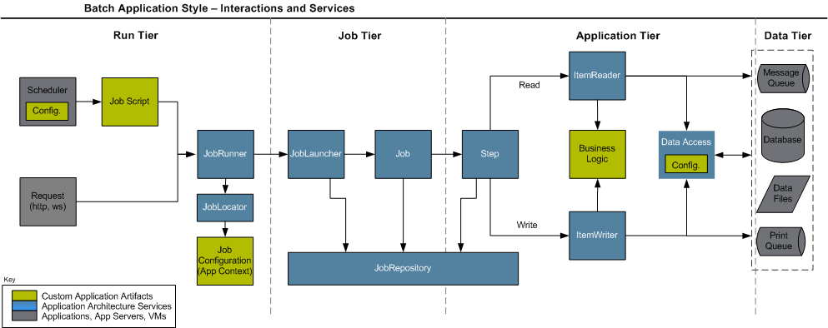

Figure 6: Spring Batch Framework

Certain jobs generate files to be transferred to FDSH, Softheon Services, and Commonwealth departments. These files are generated and transferred to those servers using the CA (Certification Authority) API (Application Programming Interface) Gateway. The files are stored in an Elastic File System (EFS). There are inbound files from these external interfaces, which are picked up by other batch jobs and the file content (data) is processed. There are jobs which extract data to be sent to MassHealth and MMIS.

There is an Argent server configured for the scheduling of production batch jobs. Agents run on the production batch servers and are controlled by the Argent server. There is one Argent agent running on each of the Production Batch Servers and controller by the Argent server.

On the Commonwealth network there is a gateway configured to receive/send files from/to Optum, viz. MOVEit. The MOVEit platform is a secure file transfer server/service that provides a secure at-rest and in-transit solution for sharing, transferring files and data. It provides a secure way to perform automated (scheduled) system-to-system file transfers and it also supports manual (user-performed) login transfers.

#### Interaction

Real-time interactions happen between the MA HIX application and external interfaces like FDSH, MH, CCA, etc. via CA API Gateway whereas time-based and event-based interactions happen through the AxWay Server.

Batches interact with different layers like Data Layer, Interface, and Cloud Management Service.

* + Data Layer
    - Database
  + Interface Layer
    - JBoss Fuse / CA API Gateway – For real-time interaction in a request/response model
    - AxWay – To push/pull files from external interfaces
    - MQ Server – To send documents to EDM / MH document storage system
  + Cloud Management Services
    - Argent Scheduler (AS) – To Schedule the jobs
    - Elastic File Systems (EFS) – To read/store file to be received/sent to other systems

#### Scheduling

All jobs are scheduled using Argent Scheduler. Argent centralized job scheduler provides a load-balanced, redundant, dependency supported tool that uses a powerful calendaring mechanism to prioritize jobs and alert on failures. It also provides a single point of control, to view manage composite workloads to fine-tune performance and to handle exceptions. Also, jobs can be run at any time by an authorized person manually.

Different jobs run at different time and are scheduled using Argent Scheduler to run half-hourly, hourly, daily/nightly, weekly and monthly, etc. and there are jobs that are run on-demand. Jobs are numbered and sometime sequenced in Argent Scheduler based on the product vendor recommendations. Every job is a member of a stream. A stream can have more than one job and are chained together. Scheduling can be done at either level.

The frequency and schedule of jobs is a Design, Development, and Implementation (DDI) function. This is not an Optum O&M responsibility.

All jobs that are run on demand are run by the Optum O&M team per the batch schedule developed in conjunction with and approved by the Commonwealth business teams to meet their business needs. On demand job schedule is confirmed on the Daily Operations call for the coming nighttime activities.

As requested by the business, and in coordination with Optum O&M and the Optum product team, scheduled jobs may be put on hold to meet a business need.

**Column Definitions**:

Job ID: Unique number used to identify the job in the database

Batch Job: Business friendly batch identifier

Location: Folder location of the batch job is stored

Dependency (JobStream Level): Identifies job dependencies if applicable

Release: Release when job was introduced

Start Time: Start time of the scheduled job, if applicable

Frequency: Time(s) when batch jobs are executed as applicable

Table 6 – Batch Schedule

| **Job ID** | **Batch Job** | **Location** | **Dependency (JobStream Level)** | **Release** | **Start Time** | **Frequency** |
| --- | --- | --- | --- | --- | --- | --- |
| 9 | MIIS Post Elig XML Generation | batch-common | none | R3 - Go live (2014) | 0:01 | Every Day, Repeat Job Every 10 Minutes Until 23:59 |
| 3 | Enrollments 834Xml Generation | batch-common | none | R3 - Go live (2014) | 0:01 | Every Day, Repeat Job Every 30 Minutes Until 23:59 |
| 10 | MIIS Post Elig WS Call | batch-common | none | R3 - Go live (2014) | 0:05 | Every Day, Repeat Job Every 10 Minutes Until 23:59 |
| 7 | Effectuation Status Transfer Job | batch-common | none | R3 - Go live (2014) | 0:10 | Every Day, Repeat Job Every 30 Minutes Until 23:59 |
| 14 | Generate XML for Notices | batch-common | 10 | R3 - Go live (2014) | 0:10 | Every Day, Repeat Job Every 5 Minutes Until 23:59 |
| 13 | Medicaid Notices Pdf Generation and Batch Processing | batch-common | 14 | R3 - Go live (2014) | 0:13 | Every Day, Repeat Job Every 5 Minutes Until 23:59 |
| 8 | Enrollment Dell WS Call | batch-common | none | R3 - Go live (2014) | 0:15 | Every Day, Repeat Job Every 30 Minutes Until 23:59 |
| 21 | Send notices XMLs to DELL | Transfer job | 11 | R3 - Go live (2014) | 0:30 | Every Day |
| 11 | Notices Batch Process | batch-common | 14, 193 Notice generation | R3 - Go live (2014) | 0:30 | Every Day |
| 19 | Mark PDF batch number in the database. | batch-common | 13 | R3 - Go live (2014) | On Hold | On Hold |
| 17 | Generate final Individual notice PDFs for Print Vendor | batch-common | 19 | R3 - Go live (2014) | On Hold | On Hold |
| 18 | Create final large notice file for the Print Vendor. | batch-common | 17 | R3 - Go live (2014) | On Hold | On Hold |
| 20 | Send notices files to MH | Transfer job | 18 | R3 - Go live (2014) | On Hold | On Hold |
| 29 | Auto Enrollment | batch-common | none | R5 | 1:50 | Every Day, Repeat Job Every 2 Hours Until 23:59 |
| 25 | Re sequence Eligibility Modification | batch-common | 27 | R5 | 15:00 | Every Day |
| 24 | QAB to QLP Eligibility Pick Up | batch-common | none | R5 | 15:00 | Every Day |
| 28 | Re-run PD for re-sequence Eligibility | batch-common | none | R5 | Job is not defined in production yet | Job is not defined in production yet |
| 23 | Post Partum Eligibility Pick up | batch-common | none | R5 | 15:00 | Every Day |
| 27 | Child Born to MH Mother Eligibility | batch-common | 24 | R5 | 15:00 | Every Day |
| 36 | Eligibility Identification for Maximus | batch-common | none | R6 | 0:20 | Day 1 Of Every Month |
| 37 | Generate Individual Maximus XML | batch-common | 36 | R11.1 | 0:45 | Day 1 Of Every Month |
| 38 | Grouped XML Generation for Final MAXIMUS Call | batch-common | 37 | R11.1 | 1:00 | Day 1 Of Every Month |
| 101 | Send the Maximus file through ECG to MH | Transfer job | 38 | R6 | 0:20 | Day 1 Of Every Month |
| 34 | MA21 Partial disability | batch-common | none | R6 | 3:00 | Every Day |
| 31 | Age Out Member Pickup Job | batch-common | none | R6 | 22:00 | Day 24th Of Every Month |
| 32 | Age Out Member Group Splitting Job | batch-common | 32 | R6 | 22:30 | Day 24th Of Every Month |
| 33 | Re calculate Premium Billing | batch-common | none | R6 | On Hold | On Hold |
| 39 | Pregnancy Indicator | batch-common | none | R6 | 15:00 | Every Day |
| 40A | Job To identify the Eligibility for Renewals | batch-common | none | R6.5 | On Demand | On Demand |
| 40B | Job To Renew Eligibility identified for renewals | batch-common | 40A | R6.5 | On Demand | On Demand |
| 43 | Generate Preliminary Notices for Renewal Eligibility | batch-common | 40B | R6.5 | On Demand | On Demand |
| 47 | Job to pick and populate, all Unaccepted Prelim Eligibility for conversion to Final Eligibility after expiration of Acceptance date | batch-common | 43 | R6.5 | On Demand | On Demand |
| 48 | Job to convert all Unaccepted Prelim Eligibility in Control table to Final Eligibility after expiration of Acceptance date | batch-common | 47 | R6.5 | On Demand | On Demand |
| 42 | Job to identify and populate the control table with the eligibility records for which APTC has to be determined | batch-common | none | R6.5 | On Demand | On Demand |
| 41 | Job to determine the APTC for eligibility records in control table | batch-common | 42 | R6.5 | On Demand | On Demand |
| 44 | Check Renewed Eligibility For Auto Enrollment and insert Notices For Auto Enrollments | batch-common | 48,41 | R6.5 | On Demand | On Demand |
| 45 | Generate Auto Enrollment Notices | batch-common | 44 | R6.5 | On Demand | On Demand |
| 46 | RESEND DELL RECORDS | batch-common | none | R6.5 | On Demand | On Demand |
| 59 | Generates the PA notices | batch-common | none | R7 | 0:20 | Every Day, Repeat Job Every 1 Hour Until 23:59 |
| 52 | This job will identify the record eligible for PA | batch-common | none | R7 | 0:25 | Every Week On Sun |
| 53 | This job will mark the eligible record for PA | batch-common | 52 | R7 | 0:25 | Every Week On Sun |
| 54 | Scan the marked PA eligible records and generate the referral file | batch-common | 53 | R7 | 0:25 | Every Week On Sun |
| 102 | Transfer the referral file to HSM | Transfer job | 54 | R7 | 0:25 | Every Week On Sun |
| 55 | Calculate Payment Amount and generate XML string for the records in PA_PAYMENT_CNTRL | batch-common | none | R7 | 1:15 | Every Day |
| 56 | Identify records to populate in PA_PAYMENT_CNTRL table | batch-common | 55 | R7 | 1:15 | Every Day |
| 57 | Identify records from PA_PAYMENT_CNTRL table with INITIAL_PAYMENT=0 and generate the payment XML | batch-common | 56 | R7 | 1:15 | Every Day |
| 58 | Groups the payment XMLs generated in the PA_PAYMENT_CNTRL table and generate group XML files. | batch-common | 57 | R7 | 1:15 | Every Day |
| 103 | Transfer the PA file to MA21 | Transfer job | 58 | R7 | 1:15 | Every Day |
| 61 | Identification of policies whose next pay month is equal to or has exceed coverage end date month. | batch-common | 58 | R7 | 4:00 | Every Week On Mon,Tue,Wed,Thu,Fri |
| 49 | CUSTOM_PLAN_lOAD | batch-common | none | R7 | On Demand | On Demand |
| 50 | Benefit Explanation Re-ordering Job for 2016 | batch-common | none | R7 | On Demand | On Demand |
| 51 | Custom Benefit Explanation Update Job | batch-common | none | R7 | On Demand | On Demand |
| 60 | NCP CareTaker Population BatchJob | batch-common | none | R7 | -On Hold | On Hold |
| 68 | CCA Termination Notice Generation Job | batch-common | 29 | R7.1 | 0:40 | Every Day, Repeat Job Every 2 Hours Until 23:59 |
| 62 | Enrollment Term Identification Job | batch-common | none | R7.1 | On Demand | On Demand |
| 63 | Enrollment Term Process Job | batch-common | none | R7.1 | On Demand | On Demand |
| 64 | PA TIMECLOCK EXPIRY Job | batch-common | 14 | R7.1 | 14:00 | Every day |
| 69 | Retrieve case resolution job | batch-common | none | R7.2.3 | 0:05 | Every Day, Repeat Job Every 1 Hour Until 23:59 |
|  |  | Transfer job |  |  |  |  |
| 66 | Close case Identification of Cases job | batch-common | 69 | R7.2.3 | 13:00 | Every Day |
| 67 | Close case job | batch-common | 66 | R7.2.3 | 14:00 | Every Day |
| 65 | Docs mailed to DHS job | batch-common | None | R7.2.3 | On Hold | On Hold |
| 70 | Advance PD data migration Job | batch-common | NA | R7.2.3 | On Hold | On hold |
| 75 | Unzip RRV Batch Response zip file | batch-common | none | R8.0.5 | 1:00 | Every Day ,Repeat Job Every 2 Hours Until 23:59 |
| 71 | Select eligibilities for Medicaid renewal | batch-common | none | R8.0.5 | On Demand | On Demand |
| 72 | Create TDS entries for members for account | batch-common | none | R8.0.5 | On Demand | On Demand |
| 73 | Aggregate member level TDS records to generate aggregated request file | batch-common | 72 | R8.0.5 | On Demand | On Demand |
| 74 | Generate RRV batch zip file | batch-common | 73 | R8.0.5 | On Demand | On Demand |
| 77 | Call VLP service for renewal records | batch-common | MA1MA101 Resource Dependency | R8.0.5 | On Demand | On Demand |
| 78 | RRV Factor Verification Job | batch-common | none | R8.0.5 | 1:00 AM CST | Every 2 Hours, 24*7 |
| 83 | Medicaid Renewal Notice records Identification Job | batch-common | none | R8.0.5 | On Demand | On Demand |
| 84 | Medicaid Renewal Notice XML generation Job | batch-common | none | R8.0.5 | On Demand | On Demand |
| 80 | Medicaid Renewal Time Clock Expiry Records Identification Job | batch-common | none | R8.0.5 | On Demand | On Demand |
| 81 | Medicaid Renewal Time Clock Expiry Processing Job | batch-common | none | R8.0.5 | On Demand | On Demand |
| 105 | Transfer the RRV File | Transfer job | 74 | R8.0.5 | On Demand | On Demand |
| 76 | RRV Response Save Job | batch-common | none | R8.0.5, R9.0.4 | 0:01 | Every Day, Repeat Job Every 2 Hours Until 23:59 |
| 82 | Call DOR service for renewal records | batch-common | MA1MA101 Resource Dependency | R8.0.5, R9.0.4 | 0:30 | Every Day, Repeat Job Every 2 Hours Until 23:30 |
| 91 | RRV SSA response deceased identification batch job | batch-common | none | R9.0.4 | 0:01 | Every Day, Repeat Job Every 2 Hours Until 23:30 |
| 92 | RRV SSA response deceased identified records processing batch job | batch-common | none | R9.0.4 | 0:30 | Every Day, Repeat Job Every 2 Hours Until 23:30 |
| 93 | Discard premium assistance override amount Job | batch-common | none | R9.0.4 | 5:00 | First Monday of Every Month |
| 43 | Preliminary renewal notice generation | batch-common | 40B | R9.0.4 | On Demand | On Demand |
| 78 CCA | RRV Factor Verification Job | batch-common | none | R9.0.4 | 1:30 AM CST | Every 2 hours, 24*7, Currently DRAFT |
| 79 CCA | Preliminary Eligibility Determination Job | batch-common | none | R9.0.4 | On Demand | On Demand |
| 88 | CCA Renewal Reprocessing batch Job | batch-common | none | R9.0.4 | On Demand | On Demand |
| 89 | RRV-FDSH fallback records identification batch job | batch-common | none | R9.0.4 | On Demand | On Demand |
| 90 | RRV-FDSH fallback records processing batch job | batch-common | 89 | R9.0.4 | On Demand | On Demand |
| 94 | CCA Renewal Finalization batch job | batch-common | none | R9.0.4 | On Demand | On Demand |
| 95 | RRV SSA response deceased identified records processing batch job | batch-common | none | R9.0.4 | On Demand | On Demand |
| 97 | FTR Reconcile Records | batch-common | none | R9.0.4 | On Demand | On Demand |
| 100 | Snap Data Consumption Express Lane renewal | batch-common | none | R10 | 6:00 | Every Day |
| 96 | Assister Upload Job | batch-common | none | R10 | On Hold | Kept On Draft R30 |
| 121 | Assister Generate Invitation Code Job | batch-common | 96 | R10 | On Demand | On Demand |
| 98 | Assister Email Invite Job Handler | batch-common | 121 | R10 | 00:15 | Every Day, Repeat Job Every 30 mins Until 23:30 |
| 128 | FTRO Dissociate Expired FTR Clock Job | batch-common | none | R10 | On Hold | On Hold |
| 71EXPRESSLANE/STREAMLINE/ALL | EXPRESSLANE Renewals | batch-common | 100 | R10 | On Demand | On Demand |
| 127 | FTRO Time clock Expiry Pick Up Job | batch-common | none | R10 | On Hold | On Hold |
| 22 MH/CCA/MIX/NE | RFI Time Clock Selection | batch-common | none | R10 | 13:00 | Every Week On Tue,Thu |
| 124x | PDM MMIS Call Control Processing Job | batch-common | none | R10.2.2 | 0:45 | Every Day, Repeat Job Every 2 Hours Until 23:30 |
| 122 | PDM Eligibility Identification Job -MH_ONLY | batch-common | none | R10.2.2 | On Demand | On Demand |
| 122 | PDM Eligibility Identification Job - MIX | batch-common | none | R10.2.2 | On Demand | On Demand |
| 122 | PDM Eligibility Identification Job - CCA_ONLY | batch-common | none | R10.2.2 | On Demand | On Demand |
| 123 | PDM RRV Request Initiation Job | batch-common | 122 | R10.2.2 | On Demand | On Demand |
| 125 | PDM Response Processing Job | batch-common | 124 | R10.2.2 | On Demand | On Demand |
| 126 | PDM Process Action Job | batch-common | 125 | R10.2.2 | On Demand | On Demand |
| 139 | Dedup Populate Action job | batch-common | none | R10.3 | On Demand | On Demand |
| 140 | Dedup Cleansing Action Implementation job | batch-common | 139 | R10.3 | On Hold | On Hold |
| 141 | Dedup SEP Action Implementation job | batch-common | 139 | R10.3 | On Hold | On Hold |
| 132 | HSN timed out records pickup Job | batch-common | none | R11.0 | 6:00 | Every Week On Sat |
| 129 | TMA Change Notice Job | batch-common | none | R11.0 | 9:00 | Day 2 Of Every Month |
| 130 | TMA Period expiration Job | batch-common | 129 | R11.0 | On Demand | On Demand |
| 131 PROCESS_CRITERIA | Custom PD for population target to sync with HUB data (Eligibility Identification Job) | batch-common | none | R11.0 | On Demand | On Demand |
| 131 PROCESS_RECORDS_FOR_RRV_INITIATION | Custom PD for population target to sync with HUB data (Initiate RRV request Job) | batch-common | 131 PROCESS_CRITERIA | R11.0 | On Demand | On Demand |
| 142 | Audit Data Relocation Job | batch-common | none | R11.0.4 | 10:00 & 22:00 | Every Day,At10:00 & 22:00 |
| 162 | Disability Info SSN Encryption Job | batch-common | none | R11.0.4 | On Hold | On Hold |
| 37/ Individual XML generation (HIX Batch) | Generate Individual Maximus XML | Hix Batch (Remove Old job 37 from batch-common) | 36 | R11.1 | 0:20 | Day 1 Of Every Month |
| 38(Group XML Generation/Hix Batch) | Grouped XML Generation for Final MAXIMUS Call | Hix Batch (Remove Old job 38 from batch-common) | 37 | R11.1 | 0:20 | Day 1 Of Every Month |
| 154 | Generate Caseload Report | batch-common | 58 | R12 | 4:00 | Every Day |
| 108 | Transfer Jobs for Generate Caseload Report | Transfer job | 152 | R12 | 4:00 | Every Day |
| 152 | Generate Override Report | batch-common | None | R12 | 4:30 | Day 1 Of Every Month |
| 153 | Generate Extended Pay Policy Report | batch-common | None | R12 | 5:00 | Day 1 Of Every Month |
| 109 | Transfer Jobs for Generate Extended Pay Policy Report | Transfer job | 153 | R12 | 5:30 | Day 1 Of Every Month |
| 110 | Transfer Jobs for Generate Override Report | Transfer job | 154 | R12 | 5:45 | Day 1 Of Every Month |
| 24-HIX BATCH | QAB to QLP Eligibility Pick Up: resequenceQabToQlpJob | Hix Batch | None | R12 | 15:00 | Every Day |
| 131 | 131 PROCESS_CRITERIA PA_AID_CATEGORY_EJ_EK sh ./batch 131 PROCESS_CRITERIA PA_AID_CATEGORY_EJ_EK & | batch-common | None | R12 | On Hold | On Hold |
| 131 | 131 PROCESS_RECORDS_FOR_PD PA_AID_CATEGORY_EJ_EK sh ./batch 131 PROCESS_RECORDS_FOR_PD PA_AID_CATEGORY_EJ_EK & | batch-common | None | R12 | On Hold | On Hold |
| 131 | 131 PROCESS_CRITERIA PA_AID_CATEGORY_EM_DISABLED sh ./batch 131 PROCESS_CRITERIA PA_AID_CATEGORY_EM_DISABLED & | batch-common | None | R12 | On Hold | On Hold |
| 131 | 131 PROCESS_RECORDS_FOR_PD PA_AID_CATEGORY_EM_DISABLED | batch-common | None | R12 | On Hold | On Hold |
| 131 | 131 PROCESS_CRITERIA ONE_MH_MEM_WITH_PA_CALCULATE_PA_AMT | batch-common | None | R12 | On Hold | On Hold |
| 131 | 131 PROCESS_RECORDS_FOR_PD ONE_MH_MEM_WITH_PA_CALCULATE_PA_AMT | batch-common | None | R12 | On Hold | On Hold |
| 131 | 131 PROCESS_CRITERIA PA_AID_CATEGORY_GENERIC_QUERY | batch-common | None | R12 | On Hold | On Hold |
| 131 | 131 PROCESS_RECORDS_FOR_PD PA_AID_CATEGORY_GENERIC_QUERY | batch-common | None | R12 | On Hold | On Hold |
| 161 | Non Serff Template Processing | batch-common | None | R12 | On Demand | On Demand |
| 163 | External Service Error Report Generator job | batch-common | None | R12 | On Demand | On Demand |
| 170 | Security-sensitive Property Value Encryption Job for Property file | batch-common | None | R12 | ON HOLD | On Hold |
| 143 | Eligibility Protection Expiration Pick Up | batch-common | None | R12 | On Demand | On Demand |
| READ_BO_CSV_JOB - Admin | Read Admin Closure Update csv file | batch-common | Upload CSV File | R12.1 | On Hold | On Hold |
| PROCESS_BO_CSV_JOB - Admin | Process Admin Closure Update csv file | batch-common | READ_BO_CSV_JOB - Admin | R12.1 | On Hold | On Hold |
| READ_BO_CSV_JOB - Address | Read Address Closure Update csv file | batch-common | Upload CSV File | R12.1 | On Hold | On Hold |
| PROCESS_BO_CSV_JOB - Address | Process Address Closure Update csv file | batch-common | READ_BO_CSV_JOB - Address | R12.1 | On Hold | On Hold |
| dorReferralRecordJob | Job to generate DOR COMET data | Hix Batch | none | R13.0 | On Hold | On Hold |
| 72 (rrvCreateTDSJob) | Create TDS entries for members for account in elg tracker | Hix Batch | 71 | R13.1 / R14.0 | On Demand | On Demand |
| byPassApplicationReport | Job to create MWS ByPass Report | Hix Batch | none | R14.0.2 | 1:00 | Day 1 Of Every Month, At 01:00, Day 16 Of Eve |
| 111 | Transfer the ByPass Application Report | Transfer job | byPassApplicationReport | R14.0.2 | 2:00 | Day 1 Of Every Month ,At 02:00, Day 16 Of Every |
| exclusionRePdApplicationReport | Job to create MWS RePD Report | Hix Batch | none | R14.0.2 | 3:00 | Every Day |
| 112 | Transfer the Exclusion RePD Report | Transfer job | exclusionRePdApplicationReport | R14.0.2 | 4:00 | Every Day |
| formularyUpdate - HIX BATCH | Job to update medicine list by calling external vendor API | Hix Batch | none | R14.0.2 | On Demand | On Demand |
| importExternalDocumentData | Job to upload MWS document data | Hix Batch | none | R14.0.2 | On Hold | On Hold |
| mwsQueueReceiver | Job to start MWS Message Receiver Listener | Hix Batch | none | R14.0.2 | On Demand | On Demand |
| 39 (resequencePregnancyStatusUpdateJob) - HIXBATCH | Pregnancy Status Update | Hix Batch | none | R14.0.2 | 15:00 | Everyday Day at 15:00 |
| 107 | MWS Monitoring Job | Optum Monitoring Job | MWS Queue Listener Job | Post R14.0.3 | 0:15 | Every Day, Repeat Job Every 30 Minutes Until 23:55 |
| 171 | Eligibility Reinstatement Job - O&M Job, which is also previously used as job 160 | batch-common | none | R14.1.1 | On Demand | On Demand |
| 172 | Eligibility Reinstatement Rerun Job - O&M Job, which is also previously used as job 161 | batch-common | 171 | R14.1.1 | On Demand | On Demand |
| 400 Notice Flattening Identify | NOTICE_XML_UTILITY_JOB - Identify | batch-common/notice-batch-utility | none | R16.0 / Notice Batch Utility | On Demand | On Demand |
| 400 Notice Flattening Process | NOTICE_XML_UTILITY_JOB - Process | batch-common/notice-batch-utility | 400 Notice Flattening Identify , Notice Batch jobs | R16.0 / Notice Batch Utility | On Demand | On Demand |
| 174 | Disability Info Resequence Job | batch-common | 34 (No TWS Dependency) | R17.0 | 4:00 | Every Day |
| 400 MMIS_XML_UTILITY_JOB IDENTIFY_MMIS_XMLS | MMIS Utility Identify Job | batch-common | none | R17.0 | On Demand | On Demand |
| 400 MMIS_XML_UTILITY_JOB PROCESS_MMIS_XMLS | MMIS Utility Process Job | batch-common | 400 MMIS_XML_UTILITY_JOB IDENTIFY_MMIS_XMLS | R17.0 | On Demand | On Demand |
| 106 | Monitoring job for batch job 173 | Optum Monitoring Job | 173 (No TWS Dependency) | R17.0 | 0:01 | Every Day, Repeat Job Every 30 Minutes Until 23:59 |
| 173 | Process control data to generate high level changes for an eligibility | batch-common | none | R17.0 | On Demand | On Demand |
| 180 | Age out Batch job | batch-common | none | R18.0 | On Demand | On Demand |
| 181 | Renewal Skipped Eligibility Identify PD Job - SkippedEligibilityIdentificationJobHandler | batch-common | none | R18.0 | On Hold | On Hold |
| 182 | Renewal Skipped Eligibility Determination PD Job - SkippedEligibilityDeterminationJobHandler | batch-common | 181 | R18.0 | On Hold | On Hold |
| 184 | User Deactivation Control batch job | batch-common | none | R18.3 | 0:30 | Every Day |
| 183 | AVR File generation batch job | batch-common | 113 | R19.A | 0:30 | Every Day |
| 113 | AVR transfer Job | Transfer job | 183 | R19.A | 1:00 | Every Day |
| 91 | RRV SSA response deceased identification batch job | batch-common | none | R19.A.2.0 | 0:01 | Every Day, Repeat Job Every 2 Hours Until 23:30 |
| 91 CCA | RRV SSA response deceased identification batch job for CCA | batch-common | none | R19.A.2.0 | On Hold | On Hold |
| 185 | CSI identification batch and insert into control table | batch-common | none | R21 | On Hold | On Hold |
| 186 | CSI Calculation batch | batch-common | 185 | R21 | On Hold | On Hold |
| 187 | Flat file generation | batch-common | 186 | R21 | On Hold | On Hold |
| 189 | Flat file merge | batch-common | 187 | R21 | On Hold | On Hold |
| 114 | Transfer CSI Merge File | Transfer job | 189 | R21 | On Hold | On Hold |
| 190 | CSI MMIS Error File Processing Job | batch-common | none | R21 | On Hold | On Hold |
| 188 - HRA_RE_SEQUENCE | Resequence Identification batch job | batch-common | none | R21 | On Hold | On Hold |
| 188 - MEC_APTC_RESEQUENCE | Resequence Identification batch job | batch-common | none | R21 | On Hold | On Hold |
| 188 - MEC_MEDI_RESEQUENCE | Resequence Identification batch job | batch-common | none | R21 | On Hold | On Hold |
| 188 - HRA_APTC_PRELIM_RE_DETERMINATION | Resequence Identification batch job | batch-common | none | R21 | On Hold | On Hold |
| 188 - HRA_APTC_FINALIZED_REDETERMINATION | Resequence Identification batch job | batch-common | none | R21 | On Hold | On Hold |
| 193 | SEP_VERIFIED_NOTICES_GENERATION | batch-common | none | R22 | 0:01 | Every Day |
| 191 | SEP TIME CLOCK EXPIRY PICKUP JOB | batch-common | none | R22 | Job is not defined in production yet | Job is not defined in production yet |
| 192 | SEP TIME CLOCK EXPIRY PROCESSING JOB | batch-common | 191 SEP TIME CLOCK EXPIRY PICKUP | R22 | Job is not defined in production yet | Job is not defined in production yet |
| 193 | SEP_WARNING_SELECTION | batch-common | none | R22 | Job is not defined in production yet | Job is not defined in production yet |
| 193 | SEP_WARNING_PROCESSING | batch-common | none | R22 | Job is not defined in production yet | Job is not defined in production yet |
| dorInterfaceRecordJob | Job to send DOR COMET data to DOR webService | Hix Batch | none | R22 | On hold | On Hold |
| AUDIT_DATA_PROCESSING | Eligibility Audit Data Processing Job | 0 | 0 | R22.5 | 0:35 | Every Day, Repeat Job Every 1 Hour Until 23:59 |
| 79 | Preliminary Eligibility Determination Job | batch-common | none | R23 | On Demand | On Demand |
| 193 CCA_PREMIUM_INCREASE_PROCESSING | MA Notices Job | batch-common | 29 | R24 | 0:05 | Every Day, Repeat Job Every 2 Hours Until 23:59 |
| 196 LUMP_SUM_INCOME_MONTH_CHANGE | Scheduled Resequence Pickup - LUMP SUM INCOME MONTH CHANGE | batch-common | none | R24 | 11:00 | Day 1 Of Every Month |
| 193 RFI_REMINDER_SELECTION | MA Notices Job | batch-common | None (before job 11) | R24 | 23:30 | Every Day |
| 193 RFI_REMINDER_PROCESSING | MA Notices Job | batch-common | 193 RFI_REMINDER_SELECTION | R24 | 23:35 | Every Day |
| 197 | MA 21 Disability Coverage File processing batch | batch-common | none | R24.0.3 | 4:00 | Every Day |
| 199 | SNAP Flat File Generation batch job | batch-common | none | R25 | 18:00 | Every Day |
| 115 | Transfer job for the SNAP file to DTA | Transfer job | 199 | R25 | 18:30 | Every Day |
| 198 BATCH_DETERMINED_APPLICATION | Notice Integration Generation Job: 198 | batch-common | 193 UI_DETERMINED_APPLICATION | R25 | 3:06 CST | Repeats every 10 min until 20:59 |
| 198 CALLBACK_PROCESSING | Notice Integration Job 198 : CALLBACK_PROCESSING | batch-common | none | R25 | 3:01 CST | Repeats every 30 min until 20:59 |
| 198 NOTICE_STATUS_RECON | Notice Integration Job 198 : NOTICE_STATUS_RECON | batch-common | none | R25 | On Demand | On Demand |
| 198 ONM_NOTICE_MAINTENANCE | Notice Integration Job 198 : ONM_NOTICE_MAINTENANCE | batch-common | none | R25 | On Demand | On Demand |
| 198 UI_DETERMINED_APPLICATION | Notice Integration Generation Job: 198 | batch-common | none | R25 | On Demand | On Demand |
| 201 | Working Disabled Protection Expiry | batch-common | None | R26 | On Draft | On Draft |
| 205 | Insufficient Document Notice Job | batch-common | None | R26 | 19:10 | Every Day |
| 206 | CCA SEP Insufficient Document Notice Job: 206 | batch-common | None | R26 | 19:30 | Every Day |
| 204 | Identify members for auto enrollment | batch-common | None | R26 | 22:00 | Day 22 of Every Month At 22:00, Day 23 of Every Month |
| 200 | Retry Suspended eligibility batch job | batch-common | None | R26 | 3:01 | Every Day, Repeat job every 4 hours until 23:55 |
| 202 ONE_TIME_DEDUCTIBLE | MA21DisabilityServiceJobHandler: ONE_TIME_DEDUCTIBLE | batch-common | None | R26 | Job is not defined in production yet | Job is not defined in production yet |
| 202 ONE_TIME_DEDUCTIBLE_FILE_TRANSFER | MA21DisabilityServiceJobHandler: ONE_TIME_DEDUCTIBLE_FILE_TRANSFER | batch-common | 202 ONE_TIME_DEDUCTIBLE | R26 | Job is not defined in production yet | Job is not defined in production yet |
| 202 MET_ONE_TIME_DEDUCTIBLE | MA21DisabilityServiceJobHandler: MET_ONE_TIME_DEDUCTIBLE | batch-common | None | R26 | Job is not defined in production yet | Job is not defined in production yet |
| Archival Step1 - Identify Records Job :DB_ARCH_RECORD_IDENTIFY | Archival Step1 - Identify Records Job | batch-common | None | R26 | Job is not defined in production yet | Job is not defined in production yet |
| Archival Step2 - Copy Records Job : DB_ARCH_RECORD_COPY | Archival Step2 - Copy Records Job | batch-common | None | R26 | Job is not defined in production yet | Job is not defined in production yet |
| Archival Step3 - Delete Records Job : DB_ARCH_RECORD_DELETE | Archival Step3 - Delete Records Job | batch-common | None | R26 | Job is not defined in production yet | Job is not defined in production yet |
| 207 | Continuous Disability Review (CDR) Not Disabled Pickup | batch-common |  | R27 | Job is not defined in production yet | Job is not defined in production yet |
| 208 | Continuous Disability Review (CDR) file consumption | batch-common |  | R27 | DRAFT | Job is not defined in production yet |
| 209 | Continuous Disability Review (CDR) Member Matching Job | batch-common |  | R27 | Job is not defined in production yet | Job is not defined in production yet |
| 210 | IDR File Generation | batch-common |  | R27 | 1 AM CST | Every week on Tuesday |
| 211 | CDR File Generation | batch-common |  | R27 | Job is not defined in production yet | Job is not defined in production yet |
| 212 | Reset Disability Status | batch-common |  | R27 | 6 AM CST | 1st DAY OF EACH MONTH |
| 213 | Communication Preference Change Notice | batch-common |  | R27 | 18:00 CST | Every day |
| 116 | Transfer IDR File | Transfer job | 210 | R27 | 03:00 CST | Every week on Tuesday |
| 117 | Transfer CDR File | Transfer Job | 211 | R27 | Job is not defined in production yet | Job is not defined in production yet |
| 220 MMIS Flat File Jobs | MEMBER_IDENTIFICATION_JOB | batch-common |  | R29 | OnDemand | OnDemand |
| 220 MMIS Flat File Jobs | MMIS_DATA_POPULATION_JOB | batch-common | MEMBER_IDENTIFICATION_JOB | R29 | OnDemand | OnDemand |
| 220 MMIS Flat File Jobs | MMIS_FLATFILE_GENERATION_JOB | batch-common | MMIS_DATA_POPULATION_JOB | R29 | OnDemand | OnDemand |
| 120 | Transfer Job for MMIS Flat File | Transfer Job | MMIS_FLATFILE_GENERATION_JOB | R29 | OnDemand | OnDemand |
| 219 ADDRESS_OUTREACH_DATA_LOAD_JOB | ORM- ADDRESS_OUTREACH_DATA_LOAD_JOB | batch-common |  | R29 | 20:00 | Weekly on Sun |
| 219 ADDRESS_OUTREACH_FILE_GENERATION_JOB | ORM - ADDRESS_OUTREACH_FILE_GENERATION_JOB | batch-common |  | R29 | 20:30 | Weekly on Sun |
| 219 ADDRESS_OUTREACH_RESPONSE_FILE_CONSUMPTION_JOB | ORM - ADDRESS_OUTREACH_RESPONSE_FILE_CONSUMPTION_JOB | batch-common |  | R29 | 12:00 | Daily |
| 119 | Transfer ORM File | Transfer Job | 219 ADDRESS_OUTREACH_FILE_GENERATION_JOB | R29 | 20:30 | Weekly on Sun |
| formularyUpdate -f FORMULARY_PROVIDER | Job to update provider/medicine/facility list by calling external vendor API |  |  | R29 |  | 5:00AM CST/ TBD |
| formularyUpdate -f PROVIDER | Job to update provider/medicine/facility list by calling external vendor API |  |  | R29 |  | 5:00AM CST/ TBD |
| formularyUpdate | Job to update provider/medicine/facility list by calling external vendor API |  |  | R29 |  | 5:00AM CST/ TBD |
| IPPTA PRE_SAMPLING 2024 | Generates pre-sampling data in DB and excel sheet | batch-common | None | R31.0 | ONDEMAND | ONDEMAND |
| IPPTA POLICY 2024 | Generates report data in DB and excel sheet as per selected records in presampling | batch-common | IPPTA PRE_SAMPLING 2024 | R31.0 | ONDEMAND | ONDEMAND |
| IPPTA TAX_FILING 2024 | Generates reports for IPPTA | batch-common | IPPTA PRE_SAMPLING 2024 | R31.0 | ONDEMAND | ONDEMAND |
| IPPTA MEMBER_DEMOGRAPHICS 2024 | Generates reports for IPPTA | batch-common | IPPTA PRE_SAMPLING 2024 | R31.0 | ONDEMAND | ONDEMAND |
| IPPTA VERIFICATION_EVENTS 2024 | Generates reports for IPPTA | batch-common | IPPTA PRE_SAMPLING 2024 | R31.0 | ONDEMAND | ONDEMAND |
| IPPTA VERIFICATION_INCONSISTENCY 2024 | Generates reports for IPPTA | batch-common | IPPTA PRE_SAMPLING 2024 | R31.0 | ONDEMAND | ONDEMAND |
| IPPTA ELIGIBILITY_EVENTS 2024 | Generates reports for IPPTA | batch-common | IPPTA PRE_SAMPLING 2024 | R31.0 | ONDEMAND | ONDEMAND |
| IPPTA SEP_MANUAL 2024 | Generates reports for IPPTA | batch-common | IPPTA PRE_SAMPLING 2024 | R31.0 | ONDEMAND | ONDEMAND |
| IPPTA REDETERMINATION_EVENTS 2024 | Generates reports for IPPTA | batch-common | IPPTA PRE_SAMPLING 2024 | R31.0 | ONDEMAND | ONDEMAND |
| IPPTA PLAN_MANAGEMENT 2024 | Generates reports for IPPTA | batch-common | IPPTA PRE_SAMPLING 2024 | R31.0 | ONDEMAND | ONDEMAND |
| 221 SADP_FILE_INGESTION_JOB | SADP File Ingestion job | batch-common | none | R32.0 | ONDEMAND | ONDEMAND |
| 221 SADP_MEMBER_MATCH_JOB | SADP Member Match job | batch-common | 221 SADP_FILE_INGESTION_JOB | R32.0 | ONDEMAND | ONDEMAND |
| 221 SADP_RENEWAL_INITIATION PROCESS_WITH_CSV | SADP Renewal Initiation Job - Run During Prelim | batch-common | 221 SADP_MEMBER_MATCH_JOB | R32.0 | ONDEMAND | ONDEMAND |
| 221 SADP_RENEWAL_INITIATION PROCESS_WITH_RESEQUENCE | SADP Renewal Initiation Job - Run During Propagation | batch-common | 221 SADP_MEMBER_MATCH_JOB | R32.0 | ONDEMAND | ONDEMAND |
| 221 SADP_REN_INIT_FILE_GENERATION | SADP Renewal Initiation CSV File Generation Job | batch-common | SADP Renewal Initiation Job - Either prelim/propagation window jobs | R32.0 | ONDEMAND | ONDEMAND |
| 221 SADP_AUTO_TRAN_JOB | SADP Auto Transaction Entry Creation Job | batch-common | 221 SADP_REN_INIT_FILE_GENERATION | R32.0 | ONDEMAND | ONDEMAND |

All batch details updated as of R32.0(August 2025)

#### Data Flow Diagram

Due to the nature of MA HIX, there are several integration points which perform a variety of needs to the overall MA HIX solution. For the MA HIX Project, external interfaces are aligned to the contractual scope of the Optum Contract. This section organizes the various external interfaces into three general categories below:

* ***Eligibility Verification Services***: These are services, such as the synchronous FDSH services, which query external data sources to obtain specific information used in Program Determination. The FDSH also provides asynchronous services used for periodic data matching and annual renewals which are batch oriented. In addition to FDSH services, the Commonwealth has enhanced its eligibility verification capability by being able to query various state and other external based systems such as Lexis/Nexis.
* ***Account Transfer Services***: These systems are integral to MA HIX and are the Softheon and MMIS system. The Softheon QHP Service is used to process QHP enrollment and perform billing activities (Financial Management System), whereas the MMIS system performs similar duties but for the Medicaid population. These integration points are bi-directional in that accounts can “transfer” between QHP and MMIS, however, PD is performed as integrated by the hCentive system.
* ***Other External Processing Subsystems***: These services perform specific processing functionality for MA HIX such as identity management, notice generation, and the daily data extract (DDE) used for the Commonwealth’s reporting requirements.

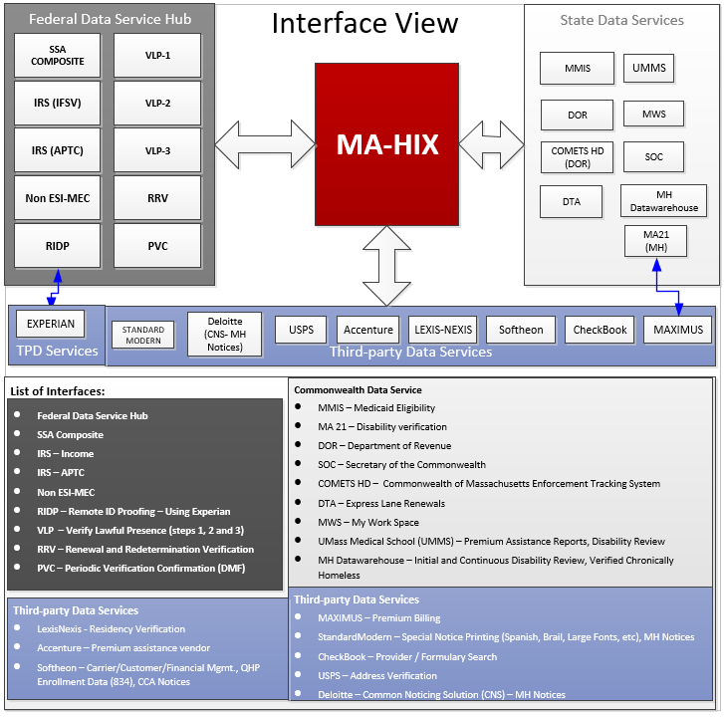

Figure 7: Data Flow – Interface View

The data that is collected from the applicant through the portal is stored in the tables in the database. There are automated processes that wrap the data and the data is sent to the external interfaces. The data that is received is stored back in the tables. Similar data flow happens when the batches are executed. Since the data is updated or moved from one table to another with the Java program itself, and each java program has its own logic behind it, there is no separate data flow diagram. The high-level flow of data between the portal and the batches to the database is shown in the Figure 8.

#### Data Sources

##### Data Exchange with external interface

Data is exchanged between the MA HIX application and other external interfaces as described below. Since the data is sensitive, they’re exchanged using secure channels. A lot of interfaces that belongs to the federal data hub and the commonwealth data hub include both Personal Identifiable Information (PII) and the Federal Tax Information (FTI). The following diagram depicts the type of information that is exchanged between MA HIX and the interface.

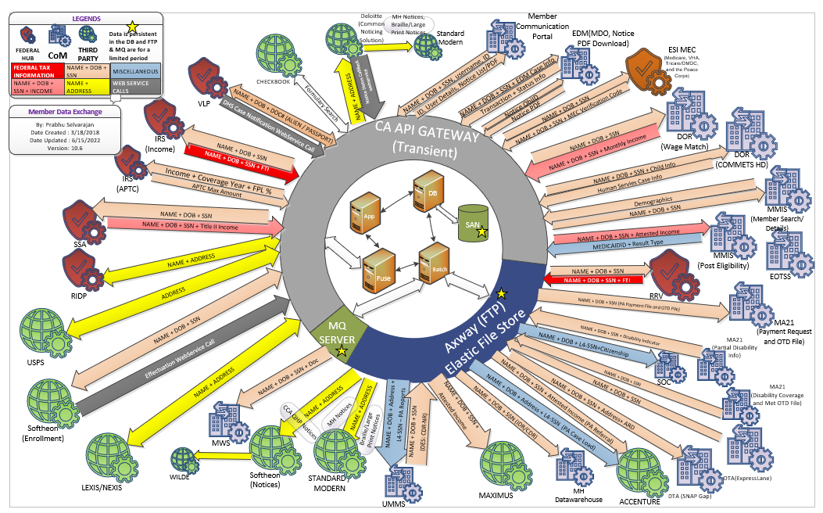

Figure 8: Interface and Member Data Exchange

##### Federal Data Services Hub (FDSH) Services

These services are provided through the FDSH and used during program determination. As part of application intake FDSH services are called. In addition, several FDSH services are used for annual and periodic data matching that MA HIX performs.

###### Internal Revenue Services (IRS) Income Family Size Verification (IFSV)

This interface triggers processing when MA HIX submits a valid request to Verify Household Annual Income and Family Size of an applicant or qualified individual as part of a new application or self-reported update for an eligibility determination in an insurance affordability program.

###### Non-Employer Sponsored Insurance (ESI) Minimum Essential Coverage (MEC)

This interface triggers processing when MA HIX submits a valid request to FDSH to Verify Non-ESI MEC as part of a new application or self-reported update for an eligibility determination in an insurance affordability program.

###### Social Security Administration (SSA)

The SSA Composite Service is used to access the SSA system to perform several verifications and to gather additional information for households identified as having health insurance needs from the Exchange. This service is accessed when the Individual is entering SSN information for themselves and their household members along with any Title II income. Title II is part of Periodic Data Matching (PDM) and Renewal and Redetermination Verification (RRV). Also, the service is accessed by the periodic data matching process and the automated streamline renewal process.

###### Remote Identity Proofing (RIDP) Precise Identity

With the RIDP service MA HIX can choose the level (2 or 3) of questioning for the identity proofing service. The RIDP v2 Service does not generate questions for Applicants the service cannot match. Experian matches applicants through matching logic to ensure accurate access, compilation, evaluation, and return of Applicant information. The level determines the difficulty of the questions the Experian service generates for the Consumer. A lower level indicates less difficult questions. The system responds with appropriate success/failure code back to MA HIX.

###### Verify Lawful Presence (VLP)

The VLP service, currently in v37 is used to retrieve immigration or citizenship status from DHS (Department of Homeland Security) for use in determining eligibility for enrollment in a QHP. The VLP Service passes information to the DHS SAVE Program only for applicants who provide a valid documentation type with corresponding documentation numbers, as appropriate, and who fall into the following categories:

- The applicant attests to be a naturalized or derived citizen.

- The applicant attests to have eligible immigration status.

Verify Lawful Presence (VLP) step 2 Service is invoked by MA HIX in v37 when DHS requires more time to validate a case. If the case is not resolved for lawful presence in step 1 or step 2, MA HIX will invoke step 3, based on the DHS response.

Prior to VLP v37, HUB used to initiate step 2 & 3. Starting from v37 no longer auto-initiation is done by the HUB on behalf of MA HIX. MA HIX must build and call new Web methods to invoke Step 2 and Step 3 based on the Step 1 response as specified in the ICD.

###### Renewal and Redetermination Verification (RRV)

RRV service is used for Open Enrollment, MH Renewals and well as PDM as the RRV service includes income required for Medicaid programs as part of an integrate eligibility system. RRV shares information MA HIX needs to determine individuals who are eligible for program redeterminations (MH Renewals, CCA Renewals, PDM). If an application (according to MA HIX’s selection and bypass criteria) is eligible for program redeterminations, then MA HIX system will be sending the application information to the RRV service via the HUB as a request to perform verification against the SSA, IRS and Medicare Trusted Data Sources (TDS). The RRV request batch file will consist of a manifest file and one or more request file for each of the TDS. The services will respond according to the request sent by RRV to MA HIX. MA HIX will receive the response from each service as it arrives and will proceed in generating a program determination for Redeterminations once all service responses have been received.

###### Periodic Verification Confirmation (PVC)

PVC service will be used for Periodic Data Matching (PDM) to request the deceased status and date of death for a member to terminate a deceased member’s benefits retroactively based on the date of death. The PVC request batch file will consist of a manifest file and one or more request file for DMF. HUB will respond according to the request sent by MA HIX/IES. MA HIX/IES will receive the response from HUB as it arrives and will proceed to process the response file.

##### Commonwealth Data Services

The following are Commonwealth data services that interact with, send, receive, or use data from MA HIX.

###### MA21

MA HIX needs to determine if certain individuals are eligible for MassHealth programs based on their disability status. The MA HIX needs to utilize the following sources to consider individual disabled for the purposes of eligibility determination:

* Federal disability information from FDSH
* Title II Disability Income check is received from FDSH (SSA)
* Periodic disability data received from MA21, and
* Disability verification entered through the Agent Portal by an agent using Back Office functionality

For the above determination, MA HIX receives the disability data from MA21 daily and it is uploaded into the database.

MA HIX needs to display MA21 disability coverage of a member on the HIX portal (Agent, Individual and Assister). HIX will use the data provided by MA21 in the disability coverage file and match the member and display the coverage details.

For the above display, MA HIX receives the disability coverage data from MA21 on a daily basis and it is uploaded into the database.

MA HIX/IES needs to consume the 'Met one-time deductible' status of a member from MA21. HIX/IES will use the data provided by MA21 in the 'Met OTD' file, match the member and apply this information in the program determination. MA HIX/IES receives the 'Met OTD' data from MA21 on a daily basis and it is uploaded into the database.

MA HIX/IES needs to send the 'One-time deductible' information of a member to MA21. HIX/IES will send the calculated member data in the 'OTD' file. MA HIX/IES sends the 'OTD' data to MA21 daily.

###### Department of Revenue (DOR)

The DOR data is to be used by the MA HIX Eligibility System to facilitate eligibility determination. Current income (employer-reported wages) information from the State supplements Modified Adjusted Gross Income (MAGI) information when the income information is not verified (either because IRS data is not available or because IRS data is not reasonably compatible) via the FDSH in the eligibility determination process.

For the above verification, as a State-Based Marketplace (SBM), MA HIX initiates a Wage Match Service request to the DOR for verification of current income. The DOR perform operations for each activity and return the underlying dataset.

###### DOR – Commonwealth of Massachusetts Enforcement Tracking System (COMETS)

Commonwealth of Massachusetts Enforcement Tracking System (COMETS), the integrated system for managing child support, requires accurate data to track these children and to manage activities related to supporting them. COMETS can accept SOAP based Web-Services and responding back. To support this portion of the law and to reduce the burden on the citizens, MA HIX sends data to COMETS, whenever there is a trigger of certain activity on the eligibility data, either done manually or triggered based on the periodic data matching activity. This helps DOR to evaluate the case and enforce payment from noncustodial parents.

The jobs related to DOR COMET are dorReferralRecordJob and dorInterfaceRecordJob. dorReferralRecord Job runs starts 12:01 AM CST and run every 30 min and generated XML file. dorInterfaceRecord Job starts 12:15 AM CST and runs every 30 min and makes WebService calls to transfer the XML file. If there are any DOR outages, then dorInterfaceRecord Job is put on hold until outage is over. The first instance of the job after the outage will transfer all XML files generated during the outage window.

As of 3/1/23, DOR COMETS interface was disabled at request of MassHealth. Optum O&M team is manually monitoring for good cause established for open referral units for identified scenarios to notify MassHealth business operations so DOR can be contacted. Details are in PIM-113445.

###### Medicaid Management Information System (MMIS)

MA HIX conducts the Medicaid and CHIP verifications through the External Member Web Service interface provided by state-owned MMIS. This service supports the validation of MEC eligibility of an applicant for the Medicaid and CHIP programs in the state of MA.

The External Member Web Service is called in the following scenarios:

* New applications at the Health Insurance Marketplace:

The External Member Web Service is initiated when an individual requests financial assistance through a Health Insurance Marketplace and attests that he/she is not eligible for any of the public MEC health plans.

* Changes in eligibility for other public MEC:

If the eligibility determination for any MEC plan changes (e.g., loss of Medicaid coverage occurs), the Requestor may call the External Member Web Service to verify that the person is not eligible for that MEC source. This service is invoked when an individual self-report a change in eligibility for that specific MEC source.

The Post Eligibility Service will be called in the following scenario:

* Transmitting the enrollment information for Medicaid/CHIP assignment:

If the eligibility determination for a member changes where a member is enrolled in a Medicaid/CHIP program, the Requestor may call the Post Eligibility Web Service to update the member record. This service is invoked when an individual is deemed eligible for Medicaid/CHIP from the MA HIX portal.

###### Health Safety Net (HSN)

The Health Safety Net (HSN) is a program for Massachusetts residents who are not eligible for health insurance or can't afford to buy it. The Health Safety Net replaced the Uncompensated Care Pool (also called Free Care) on October 1, 2007. The goal of the Safety Net is to make sure that all Massachusetts residents can get health care when they need it, regardless of income. For low income residents, the Health Safety Net (Free Care) pays for medically necessary services at Massachusetts community health centers (CHCs) and hospitals. The Safety Net pays all the cost, or part of the cost, depending on age and income. The Safety Net also helps families with medical hardships that do not have enough income to pay their medical bills.

Covered entity can use the Health Safety Net to pay for services that are not covered, like:

* Dental Services not covered by their Commonwealth Care plan
* MassHealth Limited, Healthy Start, or the Children’s Medical Security Plan
* Private Insurance (like deductibles and coinsurance, but not co-pays, except for Medicare covered entities)

###### Transfer Eligible Supplemental Nutrition Assistance Program (SNAP) members to Department of Transitional Assistance (DTA)

As a part of Single Streamline Application (SSAP) flow, the system already captures member information. This information includes demographic, income and additional information of the member. Member information along with information related to Supplemental Nutrition Assistance Program (SNAP) sent by DTA, is captured, to identify the SNAP eligibility determination.

The intent of this initiative is to introduce new questions related to SNAP in the SSAP flow for HIX.

HIX will capture and share client information along with other information to the other system(s) such as Beacon.

Starting R25, MA HIX will send a SNAP file to BEACON system on a daily basis that will provide Department of Transitional Assistance (DTA) with Head of Household (HOH) information who opt to send their data for SNAP coverage.

###### Automatic Voter Registration (AVR)

When a qualified person of the Commonwealth applies for health coverage through the MA HIX, a provision is added to the application to register as a voter. Only opted to register, a verified living citizen who is above 16 with proper residence address in the Commonwealth, qualifies to be selected to be sent to the Secretary of the Commonwealth (SOC). A batch process selects all newly registered individuals daily and a file is created and placed on the CA API gateway to be picked up by SOC.

###### My Workspace (MWS)

MWS Document Processing Integration

During the enrollment process, Medicaid applicants are requested for proof documents so that their coverage can be established or to be continued. Applicants generally have 30-90 days to send the document back to MassHealth. MH captures the information using the My Workspace (MWS) application and the documents are scanned and managed by MH’s Electronic Document Management (EDM) system. The MWS system is integrated with HIX in a near real-time manner, so that members are not re-determined unnecessarily, no additional notices are generated, and system is kept up-to-date with the applicants’ information.

IBM Messaging Queue (MQ) Series is used by MH for keeping their distributed applications in sync, which is used as an integration middleware service for other dependent systems.

MA HIX use virtual machines in the production environment with IBM MQ Series installed, so that it can subscribe to the MassHealth MQ and establish a reliable failsafe messaging interface. Once the message hits the queue, hCentive’s java batch utility will process the queue and updates the applicant’s information in MA HIX. The utility will hook on to the Message Queue using JMS and establishes a near real-time updates on the applicant’s RFI requests.

Managed Documents Online (MDO)

Users can upload the documents online on the HIX portal and it will transmit the document back to MWS to load on to the document management system (EDM). The channel for getting the status is also used for sending back the document.

As part of this process, the application server scans the uploaded document as soon as it is uploaded for viruses/malwares using Symantec Endpoint Protection and quarantine if needed; HIX converts the documents to pdf format which is accepted by EDM. After it is sent to EDM, it gets scanned again for viruses before it is loaded into the DB, and user is notified in real time on the status of the upload and transmission.

In addition, users can view or download whatever they uploaded. Only with an elevated privilege, an agent or assister can remove the document that is uploaded.

###### Daily Data Extract (DDE)

The DDE is an extract of data from the MA HIX database which is provided to the MassHealth and CCA data warehouse per the approved frequency and requirements established in the design and development process with the Optum Reporting Team.

The DDE program is a java-utility that does the job of extracting the data from the MA HIX application and generates the necessary file or files. The DDE program is not a feature of the hCentive product.

The DDE design and development are not an Optum O&M responsibility. Optum O&M oversees the processing and delivery of the DDE and assists in triaging any delivery issues.

MH DDE iteration

The MH DDE iteration contains two subsets (Table and JSON) of files with sensitive FTI/PII filtered out and they consume in their data warehouse.

As of February 2021, MH DDE files are generated and delivered once per week to MH on Sundays. CCA DDE iteration

The CCA DDE iteration contains a series of Table files (with sensitive FTI/PII information filtered out) that they consume in their data warehouse.

As of February 2021 the DDE is generated and delivered daily to CCA.

Disability Evaluation Services (DES):

MA HIX/IES need to send information to DES as part of the Initial Disability Review (IDR) file for members who self-declare they are disabled but are not verified as disabled via the current HIX logic (FDSH, MA21, MA, BL, or DA).

Additionally, MA HIX/IES system does not have the ability to periodically review a member’s medical impairment(s) to determine if the member continues to have a disabling condition. The Continuous Disability Review (CDR) process allows for MassHealth to review the member's medical impairment and if the MassHealth program determines the member is no longer disabled. The member's MassHealth eligibility is redetermined based on the existing disability hierarchy and aid cat hierarchy. With this update in the system, HIX will is enabled to perform continuous review for a member’s medical impairment(s) established though Back-office as MA (DES Disabled) to determine if the member continues to have a disabling condition through Disability Evaluation Service (DES). CDR would ensure that the member's disability benefits are reviewed, and appropriate action is taken by the system if the member does not complete/return their CDR and is no longer deemed disabled by DES

Verified Chronically Homeless (VCHL):

MA HIX/IES considers a member received on the VCHL file as chronically homeless and, if applicable, grants them continuous eligibility for Medicaid benefits for a configurable amount of time if they have established coverage in Medicaid Standard, CarePlus, CommonHealth, Family Assistance, or limited coverage. MH Datawarehouse sends the VCHL file on a weekly basis and MA HIX/IES will receives and processes the file.

Omnibus Returned Mail (ORM):

As part of the updates in the Omnibus Bill/Consolidated Appropriation Act (CAA), there are a few updates suggested which indicate that the exchange should make a good faith effort before terminating the member's coverage when the renewal notice mail is returned to the exchange. Previously, the MA HIX/IES system terminates the member’s coverage and does not provide any additional opportunity to reinstate the coverage if the member contact is established after the termination of the benefits. To be compliant with this regulation update, below changes have been implemented with Release 29 in the exchange:

* The state agency will make a good faith effort to contact the member by using more than one modality (electronic, mail, phone.)  in case returned mail was received by the state agency.

MA HIX/IES needs to send outreach request file to MH DW and process outreach response file from MH DW for all three modalities (Robocall, SMS, and Email)

##### Private Data Services

These systems are neither federal nor Commonwealth-based services that interact with, send, receive, or use data from MA HIX.

###### Accenture

Premium Assistance functionality enables the MA HIX (MassHealth) the capability to identify members that might be eligible for Premium Assistance, allow for new Back Office UIUX screens, and to calculate Premium Assistance amounts. There are two different types of reports sent to Accenture.

Premium Assistance Case Load Report

Premium Assistance (PA) reports are designed to provide the operation data, viz. Premium Assistance Caseload, the Overridden Policies, and the Extended Potential Pay Policy Report. Due to the historical data constraints outlined in the Business Requirements Document, the system provides current member demographic and policy data when a request for historical premium assistance payment data is made. Depending on the nature of the report, it is generated either manually or automatically. This report is sent to University of Massachusetts.

Premium Assistance Referral Report

Premium Assistance will also allow for the system to send out extracts to two external systems. For members that might potentially qualify for Premium Assistance, the system will send out a referral file via secured file transfer to a third-party vendor (Accenture) for review. Earlier this was managed by HMS. Also, upon completion of the Premium Assistance calculations the system shall send out “payment” file to MA21 system via secured file transfer for additional processing. Please reference the ICD for detailed information regarding this interface.

###### Maximus

MA HIX needs to determine Premium Billing Family Group (PBFG) for the purpose of assessing the premium amounts billed to eligible families receiving MassHealth coverage. The PBFGs are determined in the system as defined by the MassHealth (MH) rules.

MA HIX will generate a monthly Premium Billing household/member invoice file and send to the premium billing Vendor - Maximus. This file contains the PBFG/Account demographic, SSN, Name, date of birth, gender, member eligibility and premium billing information used for invoicing, accounting and customer service

###### Lexis-Nexis

The National Institute of Standards and Technology (NIST) Special Publication 800-63-2, entitled “NIST Electronic Authentication Guideline – Information Security,” provides guidance to federal and state organizations seeking to decrease their vulnerability to fraud. Proofing identity and authenticating an individual occurs at four varying degrees of confidence, referred to as “levels of assurance” (LOA) 1-4.

LOA2 and LOA3 identity proofing require that a combination of applicant registration verification elements be applied, including a valid government ID number, and a utility or financial account number (e.g., checking account, savings account, loan or credit/debit card). These requirements are achieved through matching records in valid databases. Additionally, these verifications confirm that name, date of birth, address, ID number, financial account number, and other personal information in valid database records are consistent with the application, and that they are sufficient to uniquely identify any individual.

MA-HIX solutions, delivered securely via XML, use a quiz-based approach leveraging Lexis-Nexis Instant Verification data. Users attempting to access HIX are presented with a series of configurable questions that determine the identity exists in the Lexis-Nexis database and the individual owns that identity. These questions are based upon that person’s records but limited to the Lexis-Nexis data repository. The service validates that the first name, last name being submitted by the user is actually associated with the entered address.

###### Softheon

To support the MA HIX eligibility, enrollment and billing functionality, the MA HIX and Softheon Enrollment and Billing (ENB) systems have two bi-directional web service integration points:

*Enrollment Service:* The Enrollment XML provides the Softheon with the necessary information from MA HIX to generate invoices for the enrollment, perform billing functions, and transmit the effectuated applications to carriers via Electronic Data Interface (EDI) 834 transactions.

*Effectuation Service:* The Softheon system transmits the information for effectuated enrollments to MA HIX. The Effectuation Service allows MA HIX to record enrollment effectuation information from the Softheon system and display effectuation status to users on several portals.

The Information Exchange between MA HIX and Softheon involve a client application request for a service. The client application request travels as a Simple Object Access Protocol (SOAP) request. The SOAP request contains data as a payload processed at the service end-point where the service deploys. Upon completion, the service sends a response back to the requester. The response travels back to requester as a SOAP response.

Data is exchanged between the two systems through a web service call using custom XML schemas. The receiving system performs schema validation and sends a synchronous response back to confirm successful receipt or to indicate a failure.

A transactional message exchange pattern that requires synchronous responses supports the data transfer between MA HIX and Softheon.

###### Payment Portal

After the users logs into the system and submits an application, a redirect link is provided to make payments. As of R23, a payment redirect link is added on the "My Enrollments" page which can be accessed by the user anytime the user logs into the portal and was at least eligible once in the system.

To avoid typographic errors, entered by the user during the payment, the enrollee information is sent to the payment portal using a Security Assertion Markup Language (SAML) message, whenever the user clicks on the payment redirect link. Also, the payment portal is available for any user, self or anyone on behalf of someone.

System will validate the request and generates a SAML message and sends it back to the browser and the link redirects the message to Softheon. With SAML message exact data of the applicant is sent to Softheon for processing. With SAML message, shared certificate authenticates the origin and destination.

###### United States Postal Service (USPS)

Throughout the MA HIX application, there are fields where applicants are expected to fill in residential, mailing, employer and other addresses in order to validate certain aspects of eligibility. In an effort to improve the quality of customer address data, reduce the number of new address validation RFIs, and increase the likelihood that paper mail is sent to correct addresses, USPS based Address Standardization functionality checks all manually entered addresses. The focus of this functionality is to improve address data presentation and to perform standardization on the eligibility application, the user interface related improvements are system wide.

The USPS service takes in the address as input and generates an output response that provides either a single, standardized version of that address, or a detailed error message indicating why a standardized version of that address could not be found. The user can choose the standardized address, their original address, or exit the UI pop-up and modify the address again. When a user chooses the standardized address or the original address and continues to the next page, the system remembers the user selection and UI pop up will not show up again if that page is revisited (unless an update to the address is made).

###### Managed Care Organization (MCO) Shopping

Almost half of all beneficiaries in MassHealth (Medicaid) are enrolled in managed care programs. On the Eligibility Results page, a MassHealth MCO/PCC (Primary Care Clinician) enrollment link is provided for qualifying eligibilities. This link can be access by user at any time. Information regarding this link is provided on applicable approval notices.

###### CheckBook

Provider Search

In order to assist the user in selecting medical or dental plans with preferred providers or facility/hospitals, there are UI screens where the user can search plans that include the user’s preferred providers/facilities or providers/facilities that meet criteria specified by the user. Functionalities include the following:

* Provider search and facilities/hospitals just before and during medical and dental plans selection.
* Modals [UI] to assist any user in selecting plans that include the user's preferred providers or providers that meet criteria specified by the user.
* Web services to deliver and request data from service vendor (CheckBook).
* Facilitate anonymous browsing as well as in post-eligibility
* Allow users to search for plans that include providers that meet the user's preferred criteria (such as language spoken), not just a specific provider identified by the user.

Formulary Search

Formulary Search is a Decision Support System (DSS), that can be used by an applicant optionally, can be used to search for a specific drug and find the plans that cover that drug. User can search for more than one drug that they need and later find the plans to see the cost, and their cost sharing component.

The service is provided by CheckBook which is currently used also for Provider Search.

The formulary data that is retrieved from CheckBook is stored in memory for auto suggestion while typing, but the information is not tied to the applicant. This is an additional feature developed to help users to search the plans in which the specific drug is covered. Separate UI is developed to help the user to search for a specific drug; this is an auto-complete feature. The data is not used for enrollment, not tied to the member and it is not passed to any downstream systems.

###### University of Massachusetts Medical School

Premium Assistance (PA) reports are designed to provide UMMS the operation data, viz. Premium Assistance Caseload, the Overridden Policies, and the Extended Potential Pay Policy Report. Due to the historical data constraints outlined in the Business Requirements Document, the system provides current member demographic and policy data when a request for historical premium assistance payment data is made. Depending on the nature of the report, it is generated either manually or automatically. This report is also sent to Accenture.

###### Member Communication Portal (MCP):

Members of MassHealth and CCA will be able to access Integrated Eligibility & Enrollment (IE&E) member communication portal where they can view information about program eligibility and enrollment information sourced from HIX, MA21 and MMIS respectively.

MA HIX will host REST API services that MCP can invoke to perform Account Linking, Retrieve User Details, List of Notices and HIX Generated Notice PDFs, Get and Update Communication preferences.

##### Other External Processing Subsystems

This section highlights major subsystems of the architecture.

###### Notices

Notices are documents sent to applicants or enrollees about critical information from the MA HIX service. During eligibility determination, which can be performed during manual application submission or as part of a renewal process, the hCentive system provides a number of triggers which will generate various notices. A daily batch job is then run to merge all these notices to then forward to one of several print vendors for printing and mailing. The hCentive application generates eligibility notices only; enrollment notices are performed by the Softheon Services and are explained in CCA’s Softheon contract. The hCentive Eligibility Notices fall into two categories: CCA Notices and MassHealth Notices and these have different flows and leverage different printing vendors. The hCentive system organizes all notice data into XML structures for processing and depending upon the notice type will be processed for MH or CCA. HIX also supports notice generation in Spanish language.

* HealthConnector (CCA) Notices are forwarded to the Softheon Services in XML format to be processed. These notices are oriented around household level messages (in contract to individual member notices). The Softheon Notices processing engine, Correspondence Lite, then processes the XML and converts into PDF to then merge and forward to the Wilde printing vendor. Currently, HealthConnector eligibility notices as well as enrollment notices can only be viewed through the Softheon CSR Portal and is not available through the hCentive Agent Portal.
* MassHealth Notices are done on an individual level as compared to ConnectorCare’s household notice orientation. The hCentive system converts the XML into PDF and then forwards along to either Executive Office of Technology Service and Security (EOTSS) Information Technology Division (ITD) for standard notice printing or to Standard Modern for Braille or Large Print notice printing. All notices generated for MassHealth can be viewed through the hCentive Agent Portal.

As part of R25, MA HIX will integrate with Common Noticing Solution (CNS) for MH Notices PDF generation and sending to Print vendor for printing. MA HIX will generate the notice XML, convert the XML to JSON format and send to CNS. CNS will process the request, generate the PDF, store in EDM and send to the Print Vendor. CNS will notify the status of the Notice to MA HIX through a callback webservice. MA HIX will also send request to Hold, Un-hold, Suppress or get the status for a Notice. MA HIX will download the PDF from EDM to display on the agent portal when the link is clicked.

The list of notices that are currently generated out of HIX

* MassHealth CarePlus Approval Notice
* MassHealth Limited Approval Notice
* MassHealth Children’s Medical Security Plan (CMSP) Approval Notice
* MassHealth Family Assistance Approval Notice
* MassHealth Health Safety Net (HSN) Approval Notice
* MassHealth Standard Approval Notice
* Request for Additional Information
* MassHealth Termination Notice
* MassHealth CommonHealth Approval Notice
* MassHealth Denial Notice
* MassHealth Premium Assistance Confirmed Access
* MassHealth Premium Assistance Approval Notice
* MassHealth Premium Assistance Termination Notice
* Voter Registration Form
* MassHealth Renewal Form
* Mixed Household Cover Letter
* MassHealth Admin Review Cover Letter
* MassHealth Express Lane Cover Letter
* MassHealth TMA 10-month change notice
* MassHealth TMA Approval Notice
* MassHealth Job Update Notice
* CCA Termination Notice
* CCA Tax Liability Notice
* CCA Denial Notice
* CCA SEP Decision Notice
* CCA RFI Notice
* CCA Approval Notice
* CCA Renewals Preliminary Eligibility Notice
* CCA Final Renewal Notice
* CCA RIDP Notice
* CCA PDM Notice

###### Optum ID/AIKYAM/MA Login

Optum ID is an Identity/Access Management software product (COTS) – This is a highly configurable suite of products which will be used for self-registration, end-user roles, account management, and access permissions, with services to support the entire user lifecycle.

Users logon to the system using appropriate security credentials. Optum's IDM (Optum ID) authenticates and authorizes users to access appropriate webpages in the system. The system supports anonymous browsing and therefore certain webpages require no authentication. Anonymous browsing is used to see various plans and options available before a user buys a plan.

#### Data Refresh

Commonwealth vendor Smartronix is responsible for all data refreshes.

#### Reporting Requirements

hCentive product system reporting requirements are a DDI function and not an Optum O&M responsibility. Optum O&M team delivers many reports on regular basis, reporting on various statistics. The Optum O&M team also works on ad hoc report requests from the Commonwealth business teams (see "Report Requests" section) raised via ticketing system which is tracked under the Production Incident Management (PIM) project in JIRA.

##### Daily Reports

###### Softheon Notices Control Report

Daily Softheon Notice Control report contains count of notices per notice type (like Approval, Denial, RFI, etc.) generated per eligibility year. This report is distributed via email.

###### MMIS Post Eligibility Transaction Report

Daily MMIS Post Eligibility Transaction report contains counts of total Transactions Processed as of that day, Transactions in that day, Transactions Processed in that day, number of HIX Error Transactions, number of MMIS Error Transactions. This report also includes any MMIS related PIMs opened for error transactions, CAT issues, linking issues. This report is distributed via email.

###### Daily High Priority deck

Daily High Priority deck contains slides discussed in daily 4pm call which includes high priority ticket pending with Optum, MH & CCA, Weekly Batch Summary and Backlog, Batch Transaction Dashboard, Prod Batch Schedule, MH ITD Notices Trend. This report is distributed via email.

###### HIX to CNS Notice Control Report

Daily summary of HIX notices sent to CNS and its breakdown by notice type. Delivered via email to MassHealth and CNS teams for control reporting and identifying any potential discrepancies.

###### E-delivery control report

Daily high level summary of Communication Preference transactions and Communication Preference Change Notices. Delivered via email to MassHealth, CNS, and IE&E teams for control reporting and identifying any potential discrepancies.

###### E-delivery detailed control report

Daily detailed summary of Communication Preferences received from all sources and Communication Preference Change Notices generated. Delivered via email to IE&E team to compile with data from all E-delivery systems for IE&E reporting.

###### Copy of the file that is sent to DTA of MassHealth applicants who checked the SNAP question on their MH application (PIM-131258)

Copy of file that is sent to DTA of MassHealth Applications who check the SNAP question on their MH Application.

###### RRV Dashboard

Detailed dashboard of the full lifecycle of the MassHealth and Mixed Household renewal process.

##### Weekly Reports

###### PIM Remediation Report

PIM remediation tracker is shared with Commonwealth business teams on weekly basics showing number of tickets resolved/ closed, triaged, pending triage and pending inputs from MH/ CCA. This report is uploaded to the Commonwealth SharePoint and a link distributed via email.

###### DDE Performance/Control Report

Weekly DDE report is sent to Project team with count is DDE files generated, their total size, and how many were sent to each agency (CCA, MH, Axway). This report is distributed via email.

###### Premium Assistance (PA) Reports

Scripts are run proactively to monitor any potential PA related issues. If an issue is identified, then an Incident PIM is opened and follows PIM Remediation process as described in Triage Process section.

###### Operational Efficiencies

Weekly report providing current status, weekly activities, and plans for Operational Efficiency Activities by the Operations and Maintenance team. Slides are included in weekly program status meeting and highlights shared.

###### Weekly Production Validation Report

Report outlines current status of all defect ALMs which have been deployed in production and require validation and/or monitoring in production prior to closure. Report breaks down ALMs by which agency needs to take action, as well as projected and actual date Optum completes validation and / or monitoring to assign to business for approval to close. Slides are included in the weekly Program Status Meeting and Release Planning Team meeting.

###### Weekly Member Resolution (MR) report

Report provides weekly counts of Member Resolution tickets opened and closed. Also provides break-down by agency of open tickets.

###### MMIS Linking Error Report

Report provides member demographics to MMIS team for manual processing.

###### RFI Timeclock Report

Report emailed with each execution of RFI Timeclock batch. Report provides application and member counts for all processed populations, as well as counts for downstream services such as MMIS and notices.

###### Weekly PPF report for EDM (PIM-95841)

Weekly report provided to EDM for indexing of PPFs.

###### MassHealth RRV Timeclock Report

Member level report for MH RRV Timeclocks.

###### Weekly report for MH for the cases where BackOffice verified NCP RFI with “Pregnant Mother” and RFI generated again on Re-Run (PIM-60588)

Weekly member level report for MH for the cases where BackOffice verified NCP RFI with “Pregnant Mother” and RFI generated again on Re-Run

##### Monthly Reports

###### Operational and Technical Services (OTS) Monthly Reports

Below are the Monthly Reports that are uploaded to the COM SharePoint on the 10th business day of every month per the terms of the OTS contract that went live on July 1, 2024

* Monthly Key Performance Metrics (KPM) Report
* Monthly OTS MA Login Monthly Availability Report

###### OTS Monthly Staffing and Work Performed report

Monthly Staffing report is uploaded to the Commonwealth SharePoint and currently includes the following information:

* Staff Member Name
* Title
* Work Activities time is entered to
* Hours total
* Resources who charged to Defect Related & Client Requested Workaround or Exclusion
* Total of FTEs entered for Defect Related and Client Requested Workaround or Exclusion
* Staffing Breakdown (FTE)
* Optum O&M Organizational chart

###### Assister Portal Monthly Report

Assister Portal report is distributed via PIM-103561 each month or on demand if requested by MH or CCA. Report will include following details:

* First_Name
* Last_Name
* Username
* Business_Email
* Assister_Business_Id
* Organization_Id
* Organization_Name
* Role
* Account_Creation_Date
* Last_Login_Date
* Active

###### Adult Disability Function- (PIM-112475)

Report to find duplicate record where First , LAST & DOB is same and SSN is null – 90758

###### SEP BO Dashboard report request - member under 150% FPL (PIM-93894)

Monthly report for CCA on Special Enrollment Periods.

###### MH RFI Expiration Report weekly and Monthly Status (PIM-99910)

Report of RFI Notices generated for the month broken down by date and type.

###### Medicare Savings Program(MSP) eligibility for members who are in CommonHealth Aid Category 53 (PIM-167541)

Member level report for MassHealth to determine MSP eligibility for members who are in CommonHealth Aid Cat 53.

###### Members who are Transitional Medical Assistance (TMA) eligible Aid Cat 18 and should not have been assess a premium. (PIM-42624)

Member level report for members who are Transitional Medical Assistance (TMA) eligible Aid Cat 18 and should not have been assess a premium.

##### Quarterly Reports

###### OTS Quarterly KPM Report

The OTS Quarterly KPM report is uploaded to the COM SharePoint.

###### OTS Quarterly Staffing report

Staffing report is uploaded to the COM SharePoint and currently includes the following details:

* Information on the OTS staffing for the Quarter being reported on per OTS contract requirements
* Name of resource, Responsibilities, telephone number, email address SSN(only for those staff who have DOR access, is resource designated as Key Personnel in the OTS contract
* Any changes in staffing are called out, such as resources who have left OTS, and those who have been onboarded during the Quarter.

##### Ad hoc Report Requests

Other than above reports generated from monitoring and control reports Optum O&M creates ad hoc reports based on Business requests. Such requests are raised as PIM ticket with PIM type as Technical Request. In the last three years between August 2022 & August 2025, an average of 101 new reports per year were requested by the Commonwealth.

Example: “*List of Assisters who entered the application in HIX and uploaded a document to MDO in the past month*.”

##### Reporting Dashboard – AWS QuickSight

To reduce the effort required to meet the reporting needs of the Commonwealth, Optum O&M proposed migrating to on-line dashboard style reporting to replace reports currently be generated manually to be distributed manual via email, attached to JIRA PIMs, or used in various reports to the Commonwealth.

AWS QuickSight is a cloud-based Business Intelligence Service which is connected to the MAHIX Database as per below diagram.

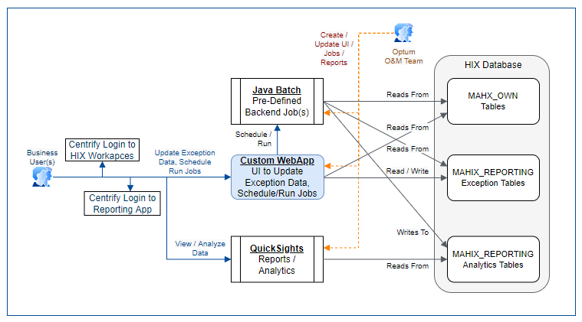

Figure 9: AWS QuickSight integration

Optum O&M creates dashboards using SQL queries, and the Commonwealth Users are able to access dashboard, filter for date ranges, and download reports for analysis and distribution.

As of September 30, 2025 the following reports are only available in QuickSight and are not manually generated or distributed by Optum O&M.

* Batch Transaction Dashboard – Enrollment
* Batch Transaction Dashboard – Job 25
* 500 Error report
* L2 Error report (weekly)
* HIX E-Delivery Daily Control Dashboard
* MAHIX RRV Dashboard
* PDM Select, Timeclock, and Job Updated form Dashboard with historic data
* Softheon Daily Notice Report
* L1, L2, L3 Error Trends
* MR JIRA Dashboard
* Batch Schedule
* HSN Timeclock Runbook
* RFI Report Dashboard
* Daily Login Counts for HIX Portal
* Batch schedule for RRV Batches
* Continuous Eligibility for Justice Involved Runbook
* Weekly Backlog Counts
* MMIS Daily Report

##### CMS outcome Metrics

CMS has introduced outcome based metric reporting which MAHIX needs to be provide on a regular basis. Optum OM is supporting the development of metrics for the requested outcomes. The final proposed workbook has been submitted to CMS with the following outcomes:

* Applications (5 Metrics)
* Automatic Enrollment (2 metrics)
* Electronic Verifications (2 metrics)
* Notices (2 metrics)
* Enrollment (2 metrics)
* Annual Renewals (2 metrics)
* Emergency Medicaid (1 metric)
* Retroactive Eligibility (1 metric)

##### Improper payment Pre-testing and Assessment (IPPTA) Reporting

As part of the payment Integrity Act of 2019, which requires federal executive agencies to identify all programs and activities with outlays exceeding a statutory threshold amount that may be susceptible to significant improper payments, the Department of Health and Human Services (HHS) determined that advance payments of premium tax credits are susceptible to significant improper payments and are subject to additional oversight. State Based Exchanges (SBEs) will need to submit data to CMS for review. A batch job has been implemented in HIX to support IPTTA reporting.

#### Key Performance Measures (KPMs)

##### OTS Key Performance measures

Optum reports on Key Performance Measures (KPMs) as defined by Appendix A of the OTS contract. Below are the KPMs assigned to the Optum O&M team.

Table 7 – Operations and Support KPMs

| Operations and Support KPMs | | | | | | |
| --- | --- | --- | --- | --- | --- | --- |
| **KPM ID** | **Assessment Period(s)** | **Summary** | **Description** | **Target** | **Measure** | **KPM Credit** |
| OS-001 | Monthly, from Start of First KPM Term. | 24X7 Support | Contractor will provide 24X7 Priority Level 1 (P1) and Priority Level 2 (P2) support for incidents. | Response Times for business hours:  Potential P1&  P2 – 10 minutes  Response time for non-business hours* response time for an alert would be 20 minutes.  P1 – 20 minutes  P2-30 minutes  *If Client notifies Contractor the response time will match business hours response time | Response time is measured as the time elapsed from when a support ticket is submitted to Contractor or contractor is reached through other means such as email/phone call to when Contractor initially responds to the support ticket in a non-automated manner (e.g., an automated e-mail response acknowledging submission does not count for the purposes of calculating response time.) | $500 per half hour for every half hour after the initial response time window in which Contractor does not provide an initial non-automated response. |
| Exception | | None | | | | |
| OS-002 | Quarterly from the Start of First KPM Term. | Incident Ticket Resolution | Resolve support tickets in the time agreed to between Client and Contractor | P1 – 98% resolved w/in 2 hours of ticket creation  P2 – 98% resolved within 8 hours of ticket creation | Time (in hours) elapsed between the ticket creation and when the ticket was resolved.  Percentage Resolved = (# of tickets for given priority level resolved within the defined response timeframe/ total number of tickets for a given priority) x 100 | $5,000/quarter for P1 and P2 that do not meet the 98% resolution threshold. $10,000/quarter if the P1 or P2 percent resolved is less than 93%. |
| Exception | | This KPM applies only to those P1 and P2 incidents that, in the Client’s sole determination, do not require any action of another HIX Program Vendor to resolve. | | | | |
| OS-003 | Quarterly from the Start of First KPM Term. . | Issue Notification | The Contractor will notify Client of any issues of which it is aware, or it should have been aware of, including any issues with any user interface (UI) or system interface. | 100% notification within 10 minutes of being aware or should have been aware of any P1 issue and 30 minutes of being aware or should have been aware of any P2 issue. | Time elapsed from discovery (actual knowledge) of a P1 or P2 Incident until it is communicated to Client in a manner agreed to between the Parties.  In cases where Contractor should have known, discovery is the point at which the Contractor should have known. | $500 per hour for every hour after the initial response time window in which Contractor does not communicate the issue to Client. |
| Exception | | None | | | | |
| OS-004 | Quarterly, from the Start of First KPM Term. | Standard Operations Reporting | Contractor will produce and deliver daily, weekly, monthly and quarterly reports as defined in Appendix F to the Contract within the timeframes specified by the PMO as required and/or otherwise approved by Client in writing. | 100% of reports are produced and submitted to the Client in accordance with the timeframes specified by the PMO as required and/or otherwise approved by Client in writing and communicated to Contractor in writing. | Reports will be provided via the agreed upon method which will include a time stamp feature to ensure that the Targets are met. | $500/Business Day for each Business Day that a report is late during the previous quarter. |
| Exception | | None | | | | |
| OS-005 | Per Security Incident | Security Incident Notification | Security Incidents shall be made known to the Client. | 100% of all discovered Security Incidents shall be disclosed to Client, at the latest, within 1 hour of incident discovery | Time in hours elapsed from discovery (actual knowledge) of the Security Incident to the time at which the Incident is communication to Client | $1000/hour/incident when notification exceeds the 1-hour initial notification window. |
|  |  |  |  |  |  |  |
| Exception | | None | | | | |
| OS-007 | Quarterly Start of First KPM Term. | Systems Operation Support - Job Scheduling | Execute scheduled production batch jobs, in accordance with defined schedules as per the scheduler/requirements/business prioritized requests; | All Daily, Weekly, Monthly, Quarterly,  job scheduling and, execution, | Successfully execute 100% of all scheduled production batch jobs timely | $500/ business day for each missed or failed job execution in the previous calendar quarter. |
| Exception | | This doesn’t apply to batch jobs which run multiple times during the day and run successfully during subsequent execution.  If Contractor is unable to obtain access to Client or any resources (including personnel and documentation) of any other HIX Program Vendors necessary for the successful performance on this KPM, Contractor shall provide documentation to such effect and shall escalate immediately to the Client’s Project Manager. | | | | |
| OS-008 | Monthly,  From  Start of First KPM Term. | Systems Operation Support – Backup scheduling and processing | Ensure that the latest DDE Production backups are properly scheduled and run | 97% of all jobs/month run within the timeframe; 100% of all jobs/month completed prior to the next reporting cycle | (# of successful jobs run divided by the total number of jobs in a given reporting cycle) x 100 | $1,000 per backup not generated per agreed-to schedule. TBD |
| Exception | | None | | | | |
| OS-09 | Quarterly, from Start of First KPM Term. Term | Root Cause Remediation Support | Contractor will perform root cause analysis, including the production of After-Action reports, for all P1 and P2 Incidents, as set forth in Attachment A, Model Contract, Section 2.8.D | Root Cause Analysis (RCA) for all P1 and P2 issues shall be completed within 5 business days after P1 or P2 Incident ticket opened, unless otherwise agreed to in writing by the Parties | 100% of the time | Beginning on the 6th Business Day after the P1 or P2 Incident ticket is opened, $1,000  per  Business Day that the RCA remains incomplete for P1 & P2 Incident |
| Exception | | If failure to meet the Target is solely the result of the Client’s or another HIX Program Vendor’s actions or failure to act, and the Contractor is able to demonstrate that it took all reasonable steps to address such action or inaction in a timely manner (including but not limited to escalating to Client’s Project Manager), such failure will not be counted against the Contractor for the purposes of calculating the KPM Credit. | | | | |

### Security and Privacy Overview

Please refer to Optum Technical Services Manual.

## Operations and Maintenance Activity Roles and Responsibilities

Table 8 – Roles and Responsibilities

| Role | Function | Organization/Functional Area |
| --- | --- | --- |
| Application Software Installation(s) | Release Management | Optum Implementation and Technical Services (ITS) Team |
| Application(s) Administration | Operations and Maintenance | Optum O&M team |
| Scripts (Scheduled execution) | Batch job execution via Argent scheduler | Optum O&M team |
| Triage Management Team – Level 1 | Level 1 call center support for customer interface. | MassHealth/CCA |
| Triage Management Team – Level 2 | * + - * 1. Incident Triaging, classification & assignment         2. - Communication with State call center and MassHealth/CCA on PIMs.   – Level 2 support for state call center and MassHealth/CCA on PIMs. | Optum O&M team |
| Functional Data Validation & Fixes | * + - * 1. Data Corrections and Workaround execution in production | Optum O&M team |

Table 9- Optum O&M Roles and Responsibilities

| Optum O&M Team | Function |
| --- | --- |
| Member Resolution (MR) | Interacting with CCA business team and CCA third party Financial Management System FMS) and call center vendors to process member resolution cases as outlined in this document. |
| MMIS | Interacting with MH business MMIS business and technology teams in processing of MMIS cases as outlined in this document. |
| Batch | Execution, monitoring, and business requested reporting for on demand batch jobs. |
| Triage | Triage, research, and identify root cause if applicable for potential production incidents raised through PIM tickets in JIRA as described in this document. |
| Reporting | Coordinates the production and delivery of Optum O&M specific reports for Commonwealth business. |
| L Errors | With Softheon, L Error team address L0, L1, L2 & L3 errors identified and reported by Optum, Softheon, CCA from the MA HIX FMS interface. |
| Access Requests | When requested, provision Agent Portal and Assister Portal user roles as per Commonwealth business requests. |
| JIRA Ticket Management | * + - * 1. Reviews all PIM JIRA tickets opened, labels as appropriate, and assigns to appropriate team if needed. |
| Validation | Performs validation for proposed workarounds and data corrections prior to requesting business approval for production run.  Validates testing results prior to sending to business for review and approval. Validates completeness of fix (Data Correction or Code Fix) prior to closing, assigning to business to close as appropriate. |
| On-call support | Support outside of MOCC contracted hours for any P1 or P2 production issues. Provide triage support for and P1 & P2 production issues during business hours. Coordinate with Commonwealth Project Team to engage SMX and other vendor resources as needed. |
| Application check-out | Perform application check-out after production maintenance or production deployment activity. |

The MOCC monitors and executes the daily operational activities needed to manage the MA HIX application and the supporting infrastructure. Typical activities for a MOCC engineer include:

* + Analyze events
  + Perform troubleshooting and incident response
  + Communicate with site technicians or third parties responsible for resolution
  + Track issues through to resolution

### Meetings Hosted by Optum O&M

#### Daily Operations call

Optum O&M team hosts daily (Monday to Friday) call to discuss high priority items, Urgent Medical Need tickets, and other items as requested by Commonwealth business and project. Attendees include MH, CCA, Project, and Optum leadership and teams.

The purpose of the meeting is:

* Review the status High Priority PIMs and Urgent Medical Needs PIMs on the High Priority Deck
* Review the Daily operations call Agenda. This includes those PIMs and issues that the MH/CCA/Project OM or Optum have requested to be discussed
* Review notice counts as of 3pm ET
* Discuss the batch schedule for the evening or weekend
* Discuss any upcoming planned deployments or maintenance
* Review MH RRV and PDM counts if applicable.
* Review any new ALM opened since previous meeting
* Review upcoming weekend maintenance on Fridays

**Sample Agenda:**

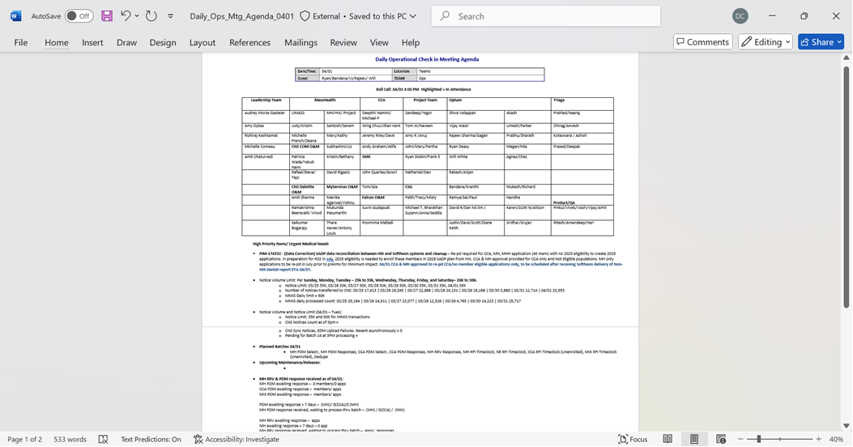

Figure 10: Daily Ops Agenda

### Optum O&M Operating hours

As defined in OTS Contract, business hours are 6am to 7pm Eastern Time Monday through Friday.

**Optum O&M hours of operation:**

6am to 7pm Monday through Friday and on an on-call basis outside of business hours only for Priority Level 1 and 2 Incidents.

**MOCC Hours of Operation:**

7am to 7pm Monday through Friday. No MOCC support on weekends and holidays

## Operation Procedures

### Operations Sequence

#### Incident Management

The primary goal of the Incident Management process is to restore normal service operation as quickly as possible and minimize the adverse impact on business operations, providing the best possible levels of service quality and availability are maintained.

##### Key Terminology

Table 10 – Key Terminologies

|  |  |  |
| --- | --- | --- |
| Terms | Definition | Example |
| Incident | An Incident is any event which is not part of the standard operation of a service and which causes, or may cause, an interruption to, or degradation in, the quality of that service. | Users are reporting Gateway timeout error intermittently while working on online application. |
| Workaround | A Workaround is a method to reduce or eliminate the impact of an Incident or Problem for which a full resolution is not yet available. | Terminate a long running job so that system resources are not drained and thus letting users to complete online application. |
| Problem | A Problem is an unknown underlying cause of one or more Incidents. | Certain jobs demand heavy system resources to complete, the jobs need to be optimized to eliminate impact to the application. |
| Solution | A Solution is a permanent method of removing the impact of an Incident. The solution is the "final fix" to the Incident. | Jobs that demand heavy system resources are tuned for performance improvement and planned to run during off peak hours so that user experience is not impacted. |
| Service Request | A Service Request is a client request for new or addition to current service or for information in general. | Add a new user to system or reactivate a user. |

##### The Relationship between Incident and Problem Management

The focus and purpose of the Incident Management Process is to restore service as quickly as possible, or to remediate imminent service disruption before it impacts end users. Incidents are potential indicators of application defects, infrastructure issues, or other problems that warrant further investigation to identify root cause(s). The Problem Management process leverages data and information captured during Incident Management to assist in establishing root cause. If an Incident reoccurs, each report of the Incident is linked to the Problem Management Records.

##### Incident Priority Guidelines

Section 1. Definitions under the OTS contract provides the following definitions for each priority level:

Table 11 – Priority Definition

|  |
| --- |
| **Priority Level 1 (P1)** means an Incident that (a) has caused the MA HIX System to go down or otherwise become unavailable, (b) has caused the MA HIX System to fail to perform an Essential Function for a substantial segment of the User population, as determined by Client provided monitoring tools or Client call center inbound call volume, or (c) has caused, or has potential to imminently cause a Security Incident; and, in each case of (a), (b) and (c), for which no workaround is immediately available. |
| **Priority Level 2 (P2)** means an Incident that (a) prevents a large number of Users from accessing or using (i) the MA HIX System or (ii) any of the Essential Functions of the MA HIX System are affected such that there is significant impact on the Essential Functions, and (b) involves a Workaround to achieve the required results exists but is unacceptable on a long-term basis. Any Incident causing the MA HIX System to fail to meet any applicable accessibility requirements (as described in this Contract) shall be Priority Level 2; A Priority Level 2 Incident may be escalated by Client at its discretion. |
| **Priority Level 3 (P3)** means an Incident that (a) impacts a non-critical system or component of a MA HIX System for a limited number of Users, or (b) impacts the ability of one or a limited number of Users to access and use a primary function of the MA HIX System ; but, in each case of (a) and (b), for which there is a Workaround acceptable to the Commonwealth to achieve the required result. A Priority Level 3 Incident that is persistent or that affects a significant set of Users may be escalated by Client at its discretion. |
| **Priority Level 4 (P4)** means an Incident that (a) impacts a single User’s ability to access and use a function of the MA HIX System and (b) for which a Workaround acceptable to the Commonwealth to achieve the required result is available. A Priority Level 4 Incident that is persistent or “high volume” may be escalated by Client at its discretion. |
| **Priority Level 5 (P5)** means a Service Request that does not result from a Priority Level 1, Priority Level 2, Priority Level 3 or Priority Level 4 Incident. A Service Request may be escalated to a higher Priority Level at the Client’s discretion. |

Note: Incidents impacting single user can be only as high as P3.

##### Non-Security MA HIX Incidents Workflow

An Incident is reported by Commonwealth or Optum and a JIRA ticket is opened. As per initial Optum O&M triage, if the reported incident is determined to be an application issue then Optum O&M takes ownership of the issue and conducts full triage, following the established Optum Incident Management process and opens war room if required. Optum O&M will then work the issue until resolution. Optum O&M team, as part of initial triage, will analyze alerts from any monitoring tools and available application logs in addition to information provided from end users.

During the initial triage, if Optum O&M determines the issue to be an Infrastructure issue then Optum O&M opens a CAMS ticket and requests Smartronix to triage the issue. Optum O&M also requests Smartronix to join the war room to provide update on Smartronix triage and resolution.

If Smartronix identifies an infrastructure issue, they will open a CAMS ticket, triage and work the issue until resolution following Smartronix’s Incident management process. Smartronix will communicate its activity to Massachusetts Operations Command Center (MOCC) and Commonwealth per the Smartronix approved P1/ P2 incident communication process.

After initial triage, where it is undetermined as to whether it is a Managed Application Incident or an Infrastructure Hosting System Incident, Project team will assign an Incident manager. Project team will coordinate with AWS/ Smartronix or any other third-party to receive required assistance, infrastructure logs and other infrastructure related information to assist in triaging the Incident. This process will take place in a war room/ high priority incident triage call setup by MOCC for P1/ P2 JIRA ticket. Communication of triage and resolution will be handled by MOCC as per MOCC’s P1/ P2 Incident communication process.

For P3/ P4 Incidents, if Optum O&M and/or Smartronix is unable to determine if the issue is application or infrastructure then Project team will make the determination.



Figure 11: Non-Security MA HIX Incidents Workflow

##### Optum Communication of P1/P2 Incidents

Communications of P1/P2 Incidents during business hours is not an Optum O&M responsibility. If an Incident is determined potentially to be a P1 or P2 ticket by Optum, then the following steps are followed by MOCC team:

* + If a ticket is not already created, **open a PIM ticket in JIRA** as P3 (it can be upgraded to a P1 / P2 if Project or O&M team confirms the severity).
  + Send a Business Impact Notification (BIN) after conferring with the O&M Team.
  + Check monitoring tools and provide information to Support Teams.
  + Start a Teams Meeting
  + Prepare Notification
    - Verify the reported issue.
    - Meets the criteria for P1 / P2.
    - Send notification for P1 / P2 incidents
  + Ensure the JIRA ticket is updated with pertinent details.

In the event that a Priority 1 or 2 incident occurs in production over the weekends or during holidays Optum will send a group text to the distribution list below:

Table 12 – P1 P2 Weekend Distribution List

| **Name** | **Group** | |
| --- | --- | --- |
| Michelle Comeau | MH | |
| Santosh Reddy | MH | |
| Wing Chui | CCA | |
| Deepthi Namini | CCA | |
| Rishi Keshkamat | HIX Project | |
| Sandeep Rajankar | HIX Project | |
| Pavan Polisetty | HIX Project | |
| Amy Romero | HIX Project | | |
| Amit Chaturvedi | Optum | |
| Shiva Velappan | Optum | |
| Vijay Wazir | Optum |
| Rajeev Sharma | Optum |
| Ryan Deasy | Optum | |
| David Romero | Optum | |
| Keith Bengtson | Optum | |

MOCC will send out communication on P3 incidents during business hours only as requested by Commonwealth.

###### Sample of Business Impact Notification

|  |  |  |  |  |  |
| --- | --- | --- | --- | --- | --- |
| **Initial Business Impact Notification- Production Environment Only** | | | | | |
| ***\*Information based on initial triage. Impact may change after further investigation. Review Email updates for more information\**** | | | | | |
| **Is the HIX Application Accessible?** | Yes | No | Intermittent Issues | Location specific |  |
| **Portals Impacted** | Individual | Agent | Assister | Payment | N/A |
| **Banner Required?** | Yes | No | TBD |  |  |
| **Ticket Number:** |  | | | | |
| **Impact known at this time:** |  | | | | |

###### Sample of INITIAL MA HIX Incident Notification

Subject Line:  P3 - Alert | Production | The RIDP Verification Service is experiencing intermittent disruptions on: 2/21/2023 Since 11:27 PM ET | PIM-111289

Table 13 – Initial Incident Notification

|  |  |
| --- | --- |
| **ALERT** | |
| **Summary of Issue:** | On 2/21/2023 at 11:38 PM ET, CMS notified the MOCC that:  “Since 11:27 PM ET on Tuesday, 2/21/2023, the Remote Identity Proofing (RIDP) service provided through the Federal Data Services Hub has been experiencing intermittent disruptions.  CMS support teams are working diligently on the resolution and will notify you when this service is once again fully available.” |
| **Current Status and Impact:** | The Remote Identity Proofing (RIDP) service provided through the Federal Data Services Hub is experiencing intermittent disruptions.  Remote Identity Proofing is called upon submission of the first page of ID proofing when processing a new application for the Individual Portal, Assister Portal, and Agent Portal for Phone Applications. |
| **Start Time:** | 2/21/2023 | 11:27 PM ET |
| **Next Update:** | 2/22/2023 | 12:00 PM ET |
|  |  |
| **Banner:** | A banner has been placed on the MA Health Connector Home Page to alert customers of the services disruption. |
| **Service Level Owner:** | Vijay Wazir |
| **Ticket #:** | PIM-111289 (P3) |

###### Sample of ½ HOURLY UPDATE MA HIX Incident Notification

Subject Line:  P3 - Status | Production | The RIDP Verification Service is experiencing intermittent disruptions on 2/21/2023 Since 11:27 PM ET | PIM-111289

Table 14 – Half Hourly UPDATE Notification

|  |  |
| --- | --- |
| **ALERT** | |
| **Summary of Issue:** | On 2/21/2023 at 11:38 PM ET, CMS notified the MOCC that:  “Since 11:27 PM ET on Tuesday, 2/21/2023, the Remote Identity Proofing (RIDP) service provided through the Federal Data Services Hub has been experiencing intermittent disruptions.  CMS support teams are working diligently on the resolution and will notify you when this service is once again fully available.” |
| **Current Status and Impact:** | The Remote Identity Proofing (RIDP) service provided through the Federal Data Services Hub is experiencing intermittent disruptions.  Remote Identity Proofing is called upon submission of the first page of ID proofing when processing a new application for the Individual Portal, Assister Portal, and Agent Portal for Phone Applications. |
| **Start Time:** | 2/21/2023 | 11:27 PM ET |
| **Next Update:** | 2/22/2023 | 6:00 PM ET |
| **Banner:** | A banner has been placed on the MA Health Connector Home Page to alert customers of the services disruption. |
| **Service Level Owner:** | Vijay Wazir |
| **Ticket #:** | PIM-111289 (P3) |

###### Sample of RESOLVED MA HIX Incident Notification

Subject Line:  P3 - Resolved | Production | The RIDP Verification Service was experiencing intermittent disruptions on 2/21/23 Since 11:27 PM ET | PIM-111289

Table 15 – Resolved Notification

|  |  |
| --- | --- |
| **ALERT** | |
| **Summary of Issue:** | On 2/22/2023 at 3:17 PM ET, CMS notified the MOCC that:  “The Remote Identity Proofing (RIDP) service provided through the Federal Data Services Hub experienced disruptions from approximately 11:27 PM ET on Tuesday, 2/21/2023 until 3:38 PM ET on Wednesday, 2/22/2023.  The Remote Identity Proofing (RIDP) service provided through the Federal Data Services Hub is now fully available.” |
| **Current Status and Impact:** | Remote Identity Proofing is called upon submission of the first page of ID proofing when processing a new application for the Individual Portal, Assister Portal, and Agent Portal for Phone Applications.  The Remote Identity Proofing (RIDP) service provided through the Federal Data Services Hub is now fully available. |
| **Start Time:** | 2/21/2023 | 11:27 PM ET |
| **Resolved Time:** | 2/22/2023 | 3:38 PM ET |
| **Banner:** | The banner has been removed from the MA Health Connector Home Page. |
| **Service Level Owner:** | Vijay Wazir |
| **Ticket #:** | PIM-111289 (P3) |

##### P1& P2 Problem Management Reporting

Optum O&M team will provide slides for those P1/ P2 incidents that are determined to be Managed Application issues with following details:

* + Problem statement
  + Impact
  + Service restoration
  + Root cause (when available)
  + Preventative measure/ next steps

For P1, P2 issues determined to be caused by Infrastructure issues, SMX will provide Root Cause Analysis (RCA) per their contractual agreement with Commonwealth. For undetermined issues, Optum will provide analysis from Managed Application perspective. The issue can be resolved, and slide can be removed only when Commonwealth Project and Business teams approve that all next steps have been completed and no further action is required. If a P1/ P2 priority ticket needs a code fix for permanent resolution of the issue, then the Incident is moved to ‘Pending Release’ slide. Upon release deployment in Prod and successful Prod validation, issue is resolved in JIRA and the Incident is removed from the ‘Pending Release’ slide with Commonwealth approval.

##### P3s & Lower Priority Incidents Handling

###### Triage Process

Optum O&M team analyzes the ticket, develops the write-up, reviews the write-up internally and then shares the document with Commonwealth business teams for their review. The writeup document contains root cause, short-term solution to mitigate the issue as applicable, and permanent solutions to address the underlying issue. Short-term solution can be a Workaround (WA) and/ or Exclusion (EX). Upon Commonwealth business team approval on the proposed short-term solution, it is tested in the break fix environment, results are validated, shared with for approval to run in Prod. With Commonwealth business team(s) approval short-term solution is executed in Prod and continues to be run until permanent fix is deployed via Data Correction (DC) or defect fix or enhancement.

Step-by-step Incident process flow is given in the below Visio. An Incident may require a combination of a code fix, DC, WA and EX. Each process required happens in parallel and steps are outlined in those process flows.

All triage actions follow the same basic steps:

* Potential production issue is reported by Optum, Commonwealth, or third party in Commonwealth managed JIRA system in the PIM project.
* PIM is assigned to Triage team and Optum O&M triage team analyzes the issue and creates write up for a new issue or refers to existing PIM/ALM for known issue. PIM is assigned to the triage team member to develop write up. Analysis of an incident includes:
  + Data analysis of the member details provided in the PIM, to identify if this is a valid issue or if it is working as per the business rules.
  + If identified as a valid issue, the technical analyst (TA) continues to analyze further by reviewing the code and identify if this is a code issue, what the exact code issue is or if it’s a bad data in production then why the bad data exists.
  + Once this is established, the TA with help from DBAs creates SQL scripts to identify currently impacted population and if there is any potential (future) impacted population.
  + The TA identifies, creates scripts for resolution. The resolution can include a Data correction/Workaround/Exclusion.
* Write-up developed (if valid issue and not known issue), reviewed internally, and shared with the Commonwealth business teams for review and approval.
  + If not a valid issue / working as designed, details shared with business to explain.
  + If known issue, link to known issue.
* Commonwealth reviews write-up
  + If approved, process continues with any required incident management activities (workarounds or exclusions) and problem management (data corrections, code fix, and/or data migration). Code fixes and Data Migrations are not an Optum O&M activity or responsibility.
  + If additional questions or information is needed, Triaged team revises write-up, reviews internally, and shares with Commonwealth for approval.



Figure 12: O&M Incident Process Flow

Exclusion and workaround testing follow the same basic steps:

* Triage team develops and preforms internal review of query.
* Once business approved exclusion or workaround approach, query is tested in production like environment.
* Validation team reviews and validates production like results.
* Production like testing is provided to Commonwealth business teams for review and approval.
  + If there are questions or adjustments are needed, query is revised, reviewed internally, and validated before providing new testing to business
* Once business approves production execution, the workaround or exclusion is implemented in production as per agreement with Commonwealth business teams.

Workaround Process Flow

An Optum O&M workaround is a SQL script or set of steps/actions used to address a production issue to allow proper action to be taken on applications. A WA can be for a defect (ALM) or business need or Functional gap (HCR). A WA for a defect will be run at an agreed to interval until a code fix (ALM) is delivered in production, the business need ends, or an HCR is delivered. WA can also be run before a batch to correct records so that the records get correctly picked up and processed by the batch.

A WA will be discontinued only after underlying issue is resolved either via a defect fix or an enhancement.



Figure 13: Optum O&M Workaround Process Flow

Full details of steps can be found in the Optum O&M response to HIXIS-859 in the Commonwealth JIRA system.

Exclusion Process Flow

An Optum O&M exclusion is a SQL script to exclude a certain population from the selection criteria of a business process which is executed by a batch job or jobs. Populations may be excluded due to a defect, business need, missed requirement, or functional gap. EXs for a defect will be used in batch runs until a DC and/or code fix provides a permanent fix to the issue in production or a WA is developed to allow for the identified population to be processed through the business process batch job or jobs. EX will be removed on agreement with the business, so the members are included in the batch process. EXs for a business need, functional gap, or missed requirement will be used in batch runs until a code change is delivered for Change Request (CR), business need ends, or a WA is developed to allow for the identified population to be processed through the business process batch job or jobs.

An EX can be discontinued upon success implementation of code fix or a DC.



Figure 14: Optum O&M Exclusion Process Flow

Full details of steps can be found in the Optum O&M response to HIXIS-859 in the Commonwealth JIRA system.

#### Problem Management

Problem Management is the IT Service Management process of managing the life cycle of Problems from identification, investigation, documentation, and resolution. The purpose of Problem Management is to reduce the adverse impact of incidents that are caused by errors within the production environment, and to prevent recurrence of incidents related to those errors.

##### The Goal of Problem Management

The primary objective of Problem Management is to prevent problems and resulting Incidents from happening and to minimize the impact of Incidents that cannot be prevented.

##### Problem Management Process flow

Problem Management focuses on understanding or removing the underlying cause of the Incident and ensuring the Incident does not reoccur. A code fix process flow addresses the issue either by enhancing the system via Change Requests (CR) or by address the existing defect (ALM defect) by altering the code. Depending on the nature of a code change, it may also require a data migration. A Problem ticket is opened in Application Lifecycle Management (ALM) and follows the defect lifecycle to resolve the issue. Code fixes and data migrations are not an Optum O&M responsibility. Optum O&M triages an issue, and if determined to be a code issue, provides the necessary information for a code change to be made.

The DC process addresses the underlying issue by correcting the data. DC tickets are tracked via PIM in JIRA.

For each P1 & P2 Incident as they apply to Managed Applications, a Trouble Ticket (TT) JIRA Ticket is created to investigate root cause for Managed Application Incidents. Optum O&M will own such Managed Applications TT Tickets through final resolution or until the point that there is reasonable evidence that the resolution of the Problem Incident is solely within the responsibility of Client or a third party. As required, Project team coordinate with third party vendors and assist Optum in root cause analysis by providing log files and other hosting environment information to enable Optum to complete root cause analysis.

##### Root Cause Analysis

The Root Cause of a Problem is the identified, underlying cause or source of the Problem and of any Incidents caused by the Problem. Future Incidents are prevented by fixing the Root Cause. It is important to understand that the Root Cause is not the steps taken to restore service during an Incident. For example, terminating a long running job may restore the functionality of an application during an Incident, but terminating the job was not the root cause of the application failure.

Root Cause Analysis is included in the basic steps for triage. Analysis of an incident includes:

* Data analysis of the member details provided in the PIM, to identify if this is a valid issue or if it is working as per the business rules.
* If identified as a valid issue, the technical analyst (TA) continues to analyze further by reviewing the code and identify if this is a code issue, what the exact code issue is or if it’s a bad data in production then why the bad data exists.
* Once this is established, the TA with help from DBAs creates SQL scripts to identify currently impacted population and if there is any potential (future) impacted population.
* The TA identifies, creates scripts for resolution. The resolution can include a Data correction/Workaround/Exclusion.

Root Cause Analysis is included in the write-up of an issue provided to the Commonwealth business teams if applicable. The Commonwealth business teams have the opportunity to rate the write-up and included RCA. This data is collected by the Optum O&M team, reviewed internally for continuous improvement, and reported monthly.

##### Resolution

Once the Root Cause of a Problem has been identified, the next step in Problem investigation is to identify the actions to eliminate the risk of future impact for the Services impacted. If the actions taken to resolve the Problem were not successful, the Problem Stakeholders may decide to either resume Root Cause analysis or to inactivate the Problem. Once the fix for the defect is validated successfully in lower environment, the Problem is considered Resolved.

##### Data Corrections Process Flow

A Data Correction is a SQL script created to correct data fields which are causing Production (PROD) impact. DCs are a one-time task created to clean up data impacted by a defect or issue which was not a defect and has been addressed and is no longer occurring. In some instances, a DC may need to be run more than once if an impacted population or potentially impacted population was not considered and additional impacted records are identified during monitoring. If a DC needs to be run additional times because the original issue was not resolved as thought, the DC becomes a WA. DCs are managed in two different ways:

* **Optum O&M DC** - If a DC is not dependent on a code fix, then the DC process is managed by the Optum O&M teams. Optum O&M DC Process Flow is shown in the Figure 15 below:
* **Release Based DC** - If a DC is dependent on a code fix or new functionality, then the data correction process is managed through the Release process and is not the responsibility of the Optum O&M team. This is managed by the Release Management, Development, BA, and QA Teams. In some instances, due to the release timelines, a DC is not feasible to be ready by the Release deployment into Production. In this case, the DC will be handed over to the Optum O&M team by the Dev team. Details can be found in the Release based DCs process flow and related description.

A DC can be standalone fix for an Incident thus it has no release dependencies.

The Optum O&M Data Correction testing process follows the same basic steps as workarounds and exclusions.

* + Triage team develops and preforms internal review of query.
  + Once business approved data correction approach, query is tested in production like environment.
  + Validation team reviews and validates production like results.
  + Production like testing is provided to Commonwealth business teams for review and approval.
    - If there are questions or adjustments are needed, query is revised, reviewed internally, and validated before providing new testing to business
  + Once business approves production execution, the data correction is executed in production as per agreement with Commonwealth business teams.



Figure 15: O&M Data Correction Process Flow

Full details of steps can be found in the Optum O&M response to HIXIS-859 in the Commonwealth JIRA system.

##### Closure

Fix is deployed in Production along with the approved release package. After Production deployment, all the linked Incident tickets are validated and assigned to the reporter of the issue for closure. Once all the Incident tickets are closed TT can be closed. Closing a Problem involves updating the Problem record and communicating the resolution. If there is any doubt that the Problem has truly been resolved, the Problem should be left in a “Resolved” Status (rather than “Closed”) and monitored for a period.

### Operations Procedures

Other than system issues reported as Incident PIMs, Optum O&M team also works on the following types of regular and ad hoc request from business and project team. Such PIMs are service requests and tracked as Operational tasks. Below is the list of the most common service requests the O&M team undertake.

#### Access Requests

##### Agent Portal

###### User Access Provisioning – Agent and Assister

Agent Portal users require a role to be assigned to their credentials in order to perform necessary job functions.

HIX system will allow the Agent and Assister roles to be created, edited and managed through the Agent Portal with an elevated role assignment (ROLE_MANAGE_ACCESS).

Representatives from MassHealth and CCA business teams can assign roles and permissions if they have the ROLE_MANAGE_ACCESS permission. If MH or CCA submits and approved access requests in JIRA, Optum will provision the user based on the requestion and once completed, MassHealth or CCA business representative is notified of completion in the PIM. Business teams notify the end user.

Any back office agent/user with required permission lands on ‘Manage Agent Access’ page of Agent portal and will be able to perform the following capabilities:

* Adding new Agent and Assister users in the system.
* Viewing and editing the information for existing Agent and Assister users in the system.
* Activating and De-activating the Agent and Assister user access.
* Updating the Agent and Assister user roles.
* Uploading bulk information for Agents and Assisters in the system.
* View Agent and Assister user’s change history information in the HIX system.

Manage Agent & Assister Access Menu on Agent Portal

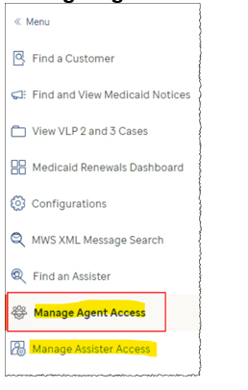

###### Role deactivation

An Agent Portal User with ROLE_MANAGE_ACCESS permission can remove a user’s role through the same UI. If MassHealth or CCA business teams request via a PIM the deactivation of an agent portal user's role. OM uses the provided information to remove the assigned role from the login and notifies the business representative in the PIM.

#### Member Resolutions

Member resolution cases are service requests to modify or update details regarding a user's Enrollment, Billing, or login credentials. A PIM is opened by CCA Customer Support, CCA Billing and Enrollment Technical Support, and sometimes from the CCA business team. The CCA call center vendor Accenture opens ticket for all above mentioned categories and Softheon Service, the CCA billing and enrollment vendor opens ticket for reinstatements that were autogenerated by the user. Optum O&M team handles below type of member resolution Tickets:

* + Reinstatement
  + Retro
  + Backward Retro (Failed Retro)
    - * Forward Retro
      * Retro term
  + Complex Retro
  + Premium correction
  + System Discrepancy
  + Application Submission
  + Enrollment Submission
  + Login

##### Reinstatement Requests

These are requests to reinstate member into previously enrolled plan. Limitations for such Reinstatement requests are as follows:

* To perform reinstatement on a member, the member should have at least 1 month of coverage during the year the reinstatement requested.
* Partial reinstatement is not possible as of today. Reinstatement is performed on entire household. For example, we cannot reinstate 2 members alone from a 4-member household
* Reinstatement will be done until the end of coverage year (12/31/YYYY) not any other date.
* Premium cannot be modified with reinstatement, meaning if member is paying $200 per month from 1/1/2020 – 3/31/2020, when we reinstate member will be paying $200 from 1/1/2020 – 12/31/2020.

Resolution steps for reinstatement requests are as follows:

* Optum O&M will send an XML transaction to Softheon to extend the current end date to end of the year with maintenance reason code 025. Optum O&M will update the coverage end date in MA HIX database so that the end of year coverage end date is displayed in MA HIX portal.
* Upon successful transmission Optum O&M will mark the ticket as resolved and assign back the creator.
* Accenture will validate the request on MA HIX portal and Softheon DB and close the ticket and if the issue is not resolved, assign back to Optum O&M with additional information.

##### Retro Requests

Retro requests are created if the member’s coverage start date needs to be changed. Retro requests are opened only when the request cannot be completed using Retro enrollment functionality provided in the Dashboard. There are two types of Retro requests:

**Backward Retro** (previously called Failed retro): Members coverage start date needs to be moved earlier than current start date Ex: Current coverage: 3/1/2020 – Open, New coverage: 1/1/2020 - Open

**Forward Retro**: Members coverage start date needs to move later than current start date. Ex: current coverage: 3/1/2020 – Open, new coverage: 5/1/2020 – Open

Limitations of Retro requests are as follows:

* Retro requests are created only for open span. Closed span can have a retro-enrollment applied under Complex retro.
* Partial retro is not possible as of today. Retro is performed on entire household. For example, we cannot retro 2 members alone from a 4-member household
* Premium cannot be modified with retro request like reinstatement.

Resolution steps for Retro requests are as follows:

* Optum O&M will send an XML transaction(s) with requested coverage start date to Softheon and update the coverage start date in MA HIX database so that the updated coverage start date is displayed in MA HIX portal.
* Upon successful transmission Optum O&M will mark the ticket as resolved and assign back the creator.
* Accenture will validate the request on MA HIX portal and Softheon DB and close the ticket and if the issue is not resolved, assign back to Optum O&M with additional information.

##### Retro Term Requests

Retro term requests are created if the member’s coverage end date needs to be changed to earlier date. Ex: current coverage 1/1/2020 – 12/31/2020, desired coverage: 1/1/2020 – 6/30/2020. Retro Term requests are opened only when the request cannot be completed using Retro enrollment functionality provided in the Dashboard.

Limitations of Retro Term requests are as follows:

* Partial retro term is not possible as of today. Retro term is performed on entire household. For example, we cannot retro term 2 members alone from a 4-member household
* Premium cannot be modified with retro term request like reinstatement.

Resolution steps for Retro Term requests are as follows:

* Optum O&M will send an XML transaction(s) with requested coverage end date to Softheon and update the coverage end date in HIX database so that the updated coverage end date is displayed in MA HIX portal.
* Upon successful transmission Optum O&M will mark the ticket as resolved and assign back the creator.
* Accenture will validate the request on MA HIX portal and Softheon DB and close the ticket and if the issue is not resolved, assign back to Optum O&M with additional information

##### Complex Retro Requests

Complex retro tickets are created if the member’s coverage or plan information needs to be modified and cannot be done in one transaction by either retro or reinstatement. Ex: member is enrolled in plan A from 1/1/2020-3/31/2020 and plan B from 4/1/2020 – 12/31/2020. Request is to have plan A from 1/1/2020 – 2/29/2020 and plan B from 3/1/2020-12/31/2020.

Resolution steps for Complex Retro requests are as follows:

* Optum O&M will send multiple XML transaction(s) with requested coverage dates (both Start and End date) for cases involving more than one plan to Softheon and update the coverage dates in MA HIX database so that the updated coverage dates are displayed in MA HIX portal.
* Upon successful transmission Optum O&M will mark the ticket as resolved and assign back the creator.
* Accenture will validate the request on MA HIX portal and Softheon DB and close the ticket and if the issue is not resolved, assign back to Optum O&M with additional information.

##### Premium Correction Requests

Premium correction tickets are created if any of member’s premium information needs to be corrected without changing members existing plan code or coverage period. Member’s coverage span cannot be modified with premium request.

Resolution steps for Premium Correction requests are as follows:

* Optum O&M will send a change transaction to Softheon with the requested premium amount after receiving approval from CCA and update the new premium detail in MA HIX database so that the update premium is displayed in MA HIX portal.
* Upon successful transmission Optum O&M will mark the ticket as resolved and assign back the creator.
* Accenture will validate the request on MA HIX portal and Softheon DB and close the ticket and if the issue is not resolved, assign back to Optum O&M with additional information.

##### MA HIX Application Submission Requests

Application Submission tickets are created when members are not able submit the eligibility. Ex: member get 500 error when he clicks on Submit button on Eligibility submission page

Resolution steps for Application Submission requests are as follows:

* For a known issue, Optum O&M will apply approved Workaround or Data correction.
* For a new issue, Optum O&M will follow established triage process.
* Once the issue is resolved, Optum O&M will resolve the PIM and assign back the creator.
* Accenture will validate the request on MA HIX portal and close the ticket and if the issue is not resolved, assign back to Optum O&M with additional information.

##### Enrollment Submission Requests

Enrollment Submission tickets are created when members are not able submit the enrollment. Ex: member get 500 error while navigation enrollment pages.

Resolution steps for Enrollment Submission requests are as follows:

* For a known issue, Optum O&M will apply approved Workaround or Data correction.
* For a new issue, Optum O&M will follow established triage process.
* Once the issue is resolved, Optum O&M will resolve the PIM and assign back the creator.
* Accenture will validate the request on MA HIX portal and close the ticket and if the issue is not resolved, assign back to Optum O&M with additional information.

##### Login Requests

Login tickets are created when members are having issues trying to access MA HIX application. Ex: forgot password/Username, password reset, update email on the account, receiving 500 error when trying to login.

Resolution steps for Login requests are as follows:

* Optum O&M team will look up member details in MA HIX database and MA login and perform corrections as required. Few of them are listed below:
  + Reset password
  + Reset security questions
  + Update username
  + Deactivate/Reactivate accounts
  + Change email ID
  + Reset retry count
  + Unlock account
* Once the issue is resolved, Optum O&M will resolve the PIM and assign back the creator.
* Accenture will validate the request MA HIX and close the ticket and if the issue is not resolved, assign back to Optum O&M with additional information.

##### System Discrepancy Requests

System Discrepancy tickets are created when data is mismatch between MA HIX portal and Softheon system. Ex: MA HIX is showing enrollment for the 3 members from a household from 1/1/2020 – 12/31/2020, but Softheon as showing 2 members from: 1/1/2020 – 12/31/2020.

Resolution steps for System Discrepancy requests are as follows:

* Any requests that does not satisfy as one of the above categories are reported under System Discrepancies. Optum O&M analyzes the data in both they systems (MA HIX and Softheon) and make necessary decisions to sync up data between the systems. This may require simple database update on HIX system or multiple XML transactions sent to Softheon to correct spans in Softheon web or both data updates and XML transactions.
* Upon successful update and transmission Optum O&M will mark the ticket as resolved and assign back the creator.
* Accenture will validate the request on MA HIX portal and Softheon DB and close the ticket and if the issue is not resolved, assign back to Optum O&M with additional information.

#### L Errors resolutions

A key responsibility of Optum O&M is to make sure that all data flows from one system/application/vendor to the appropriate downstream systems. Redundancy, fault tolerant applications, and utilities are built to handle system communications. However, there are scenarios when the data itself is not in the correct format for the downstream system to ingest. For the interface between MA HIX and the Softheon Services data format is primarily due end user errors, system validation errors, or unknown/unanticipated scenarios.

There are several stages where incorrectly formatted data can be blocked from proceeding. The following diagram depicts the enrollment cycle where information is sent to the carrier via the partner application (Softheon Services). Once the carrier enrolls the member, they send back the effectuation status back to Softheon Services and Softheon Services calls the web-service to load the data into a staging table. The effectuation status is then picked up by Job 7 (Effectuation Status Transfer Job) and it updates the MA HIX repository. There are four possible types of errors.

L0  Errors MA HIX failed to  generate 834 Enrollment XML.

L1 Errors 834 Enrollment XML failed to load in Softheon Services Staging environment.

L2 Errors 834 Enrollment XML failed to update/load in Softheon Services System.

L3 Errors Effectuation transactions sent by Softheon Services failed to load/process in MA HIX.

The diagram depicts the flow, in context of the events and the errors, how they’re handled, and not the entire data flow required for enrollment.

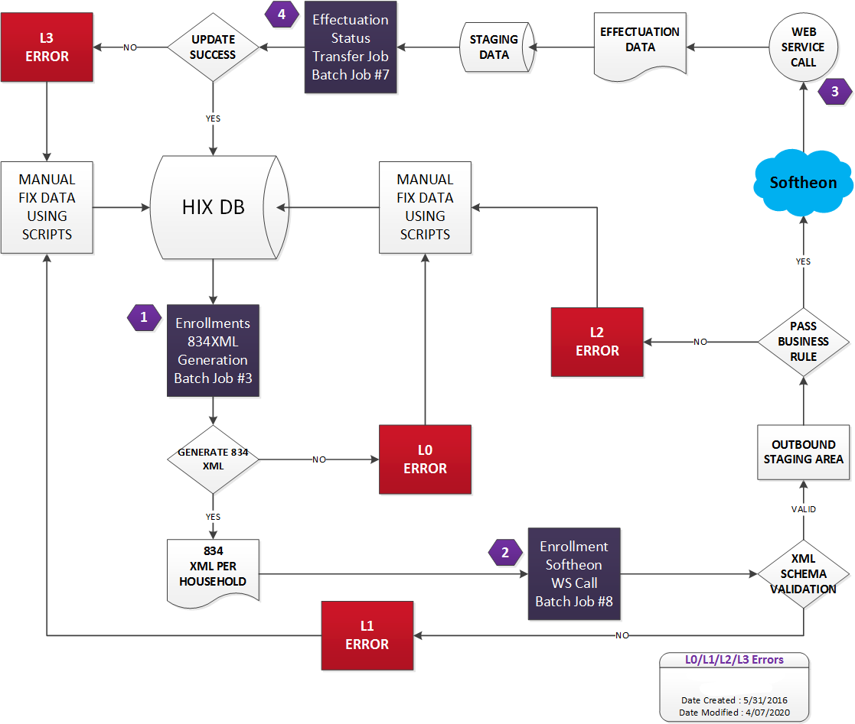

Figure 16: L Errors Process Flow

Transactions between MA HIX and Softheon Services are monitored daily by the Optum O&M team to identify errors and correct the data. If errors are caused by a defect in the MA HIX system, an ALM is opened for a code fix to prevent such data related errors.

##### L0 Errors resolutions

L0 errors are reported when Job3 (Enrollments 834Xml Generation) fails to generate 834 enrollment XMLs. Failed L0 errors are identified by looking into CURRENT_STATUS in BATCH_ENROLLMENT_XML_CONTROL table or through Job3 logs. Upon identifying such errors, a PIM is opened in JIRA and team begins triaging the issue. For a code issue, normal triage process is followed and an ALM is opened for defect and code is fixed or HCR is opened for code enhancement. For a data issue, team fixes the data like manually created transactions and reset the record for Job3. For a data issue, issues are typically resolved within 1 business day. L0 error take higher priority than L1, L2 & L3 errors.

##### L1 Errors resolutions

L1 errors are reported when one of two things happen:

* Job 8 fails to process record and there are error records in CURRENT_STATUS_DELL_XML in BATCH_ENROLLMENT_XML_CONTROL table.
* XML Schema validation fails after Job8 (Enrollment WS Call) and 834 enrollment XMLs fails to load in Softheon Services Staging environment.

Upon identifying such errors, a PIM is opened in JIRA and team begins triaging the issue. For a code issue, normal triage process is followed and an ALM is opened for defect and code is fixed or HCR is opened for code enhancement.

For data issue, team reaches out to Softheon via email to check if they received the control ID. If so, errored records are marked as completed. If not, errored records are reset for Job 8. For a data issue, issues are typically resolved within 1 business day. L1 error take higher priority than L2 & L3 errors but after L0 errors.

##### L2 Errors resolutions

L2 errors are reported when Business rules validation fails and 834 enrollment XMLs fails to load/ update in Softheon Services system. L2 errors are reported by Softheon to Optum O&M around Noon on workday via email. L2 Error report is compared against previous report and daily influx is identified. Team analyzes each error records, if it is a data issue from Optum side then Optum corrects the failed transactions and reset the transaction for Job3 and Job8. If the data issue is on Softheon side, then Optum request Softheon to either close or retrigger those failed error records. Resolved cases do not show up in next day Error report. For issues raised due to functional gap, Optum works with Softheon to share data and update respective system. For a data issue, L2 errors are typically resolved within 2-3 business days. L2 errors take higher priority than L3 errors but after L0 & L1 errors.

##### L3 Errors resolutions

Once enrollment data/ status changes from Softheon side then Softheon send that information to MA HIX in the form of Effectuation record. Job7 (Effectuation Status Transfer Job) process effectuation data by comparing it against enrollment data in MA HIX database tables and updates HIX enrollment tables. Optum runs scripts against EFFECTUATION_STATUS table to identify error records. If there are any error for an Active or Transitional enrollment, then Optum updates those error records to Ignore. Script is run daily on workdays and it take lower priority than L0, L1, L2 error handling.

#### MMIS Manual processing

MMIS is a state-owned system. MA HIX system calls MMIS system to verify member's MEC. MA HIX interacts with MMIS systems using MMIS Pre-eligibility Transaction and MMIS Post-eligibility Transaction API call. Tickets are reported during either of above transaction.

##### MMIS Pre eligibility transaction issues

The MA HIX system performs the MMIS pre-eligibility transaction to identify if any applicants are eligible for MEC through Medicaid or CHIP programs. If the MA HIX system receives an erroneous response as part of the MMIS Pre-Transaction call, then MA HIX system will utilize the information available in the MA HIX database from previous eligibility to determine the eligibility.

If any issue came during pre-eligibility transaction Optum O&M reports these in Daily MMIS reporting. Also, if there is any incorrect configuration in public MEC list, then it can contribute the PD issue. When MMIS search calls fail due to an outage or system issue, O&M follow a standardized recovery process to ensure data integrity:

* **Run MMIS Utility** After identifying failed MMIS search transactions, we execute the MMIS utility tool. This tool retrieves the current MMIS search responses for each affected transaction.
* **Compare Responses**  
   The utility compares the newly retrieved MMIS responses with the previously stored responses that were consumed by PD during the initial failure.
* **Identify Discrepancies**  
   If differences are found between the current and previously stored responses, those transactions are flagged for further action.
* **Rerun of Program Determination Required**  
   Applications with mismatched data are marked for REPD (reprocessing) to ensure consistency and accuracy in downstream systems.

##### MMIS Post eligibility transaction issues

The MA HIX system generates the MMIS Post-eligibility transaction to inform the MMIS system when an individual receives MH benefit, update previous benefits or terminate existing benefits.

MMIS Post transaction errors are categorized into below:

* **Cat 1** - Transactions that never got sent to MMIS. Mostly these are closing benefit issue.
* **Cat 2** - Transactions that failed in MA HIX because of an exception like JAX-B
* **Cat 3** - Transactions that went to MMIS but MMIS sent back an error code like E-2043 errors.

Beside above three category level issue, below issues are also reported:

* **PD/ Data issue**: If MA HIX has any PD issue then it might be possible MMIS transaction contains with incorrect information.
* **Date of death issues**: Optum O&M needs to correct date of death as provided by business and resend XML to MMIS.
* **Demographic updates**: Optum O&M needs to send MMIS transaction with updated demographic details as provided by business.
* **Benefits are not crossed over to MMIS**: Sometime due to an issue with MMIS, Commonwealth MMIS team requests Optum O&M resend transactions from MA HIX.
* **Linking/Unlinking issue**: If same Medicaid ID is assigned to multiple members or multiple Medicaid IDs assigned to same member.

##### MMIS issue tracking and resolution

To ensure proper transmission of determination details from MA HIX to MMIS, manual adjustments are required to xml transactions due to limitations of either the MMIS or MA HIX system. PIM requests are entered by MassHealth business team for Date of death updates, Demographic updates, Benefit are not crossed over to MMIS or Linking/Unlinking issue are manually addressed by Optum O&M team issue in same PIM. Issues related to Pre eligibility transactions, Cat errors and others are tracked under PIM Remediation process.

###### Scenario 1 (issue found through daily monitoring report)

* Everyday Optum O&M run cat 1, cat 2 and cat 3 impact queries and send the MMIS issue report to business and leadership team.
* If any new issue is reported, Optum O&M opens a PIM and assigns it for triaging. The new PIM will follow the PIM remediation process.
* If an issue is known Optum O&M follows approved resolution steps in the existing PIM.
* Optum O&M discusses issues with MMIS and MH team in MMIS weekly working session.
* Commonwealth MMIS team also prioritizes issues and tracks them in the MMIS Top priority meeting.

###### Scenario 2 (MMIS reported issue)

* Commonwealth MMIS team reports an issue (linking/unlink or any other issue).
* Optum O&M team opens a new PIM if it is a new issue.
* New PIM will follow the PIM remediation process.
* If issue is known Optum O&M follows approved resolution steps in the existing PIM or follow agreed steps to resolve linking/unlinking issues.
* Optum O&M discusses issues with Commonwealth MMIS and MH team in MMIS weekly working session.
* MMIS also prioritizes issue and track in the MMIS Top priority meeting.

###### Scenario 3 (MH team opened incident PIM)

* User or MH team reports an issue via PIM.
* Optum O&M team does the initial analysis.
* If issue is known, then PIM is linked with existing issue and Optum O&M follow resolution steps in the existing PIM.
* If a PIM request is for Date of death updates, Demographic updates, Benefit are not crossed over to MMIS or Linking/Unlinking issue then Optum O&M addresses issue in same PIM.
* PIM otherwise follows the PIM remediation process.
* If issue is known and it was triaged in PIM remediation process, then Optum O&M follows resolution steps in the existing PIM.
* Optum O&M discusses issues with Commonwealth MMIS and MH team in the MMIS weekly working session.
* Commonwealth MMIS team also prioritizes issues and tracks them in MMIS Top priority meeting.

###### Issue tracker

MMIS & Optum O&M team track MMIS issue in an excel sheet. Below figure 19 shows sample issue:

The MH, MMIS and Optum O&M teams track MMIS-related issues in Jira, labeling them as MMIS-Issue and MMISCleanup. Figure 19 below shows a sample issue

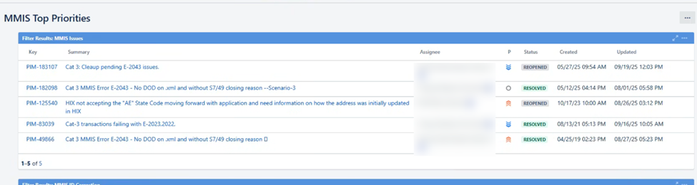

Figure 17: MMIS Issue Tracker

#### 5.2.5 Daily Data Extract (DDE) processing

The DDE is initiated by the Argent scheduler and made available to the MassHealth and CCA data warehouse per the approved frequency and requirements established in the design and development process with the Optum Reporting Team. Extraction is scheduled as two Argent Jobs, one to extract the data and another job that transfers the files, which is chained to the end of the extraction job.

The Optum O&M team checks the status of the DDE jobs daily and assists in triaging of any delivery issues. The diagram below shows a high-level view of the DDE file transfer process beginning with the batch job kicking off the generation of the DDE Table/Section files and then transfer to the Axway server for delivery to MassHealth & CCA.



Figure 18: DDE file transfer process

##### DDE – Daily Operations - CCA

The DDE is scheduled in Argent scheduler to run daily for the CCA iteration. Only if there are any exceptions/failures, are manual operational interventions required. These details are described in the sections below.

The morning of every business day, MOCC sends an email notification on the CCA DDE delivery status as part of delivery notifications (see screen shot):

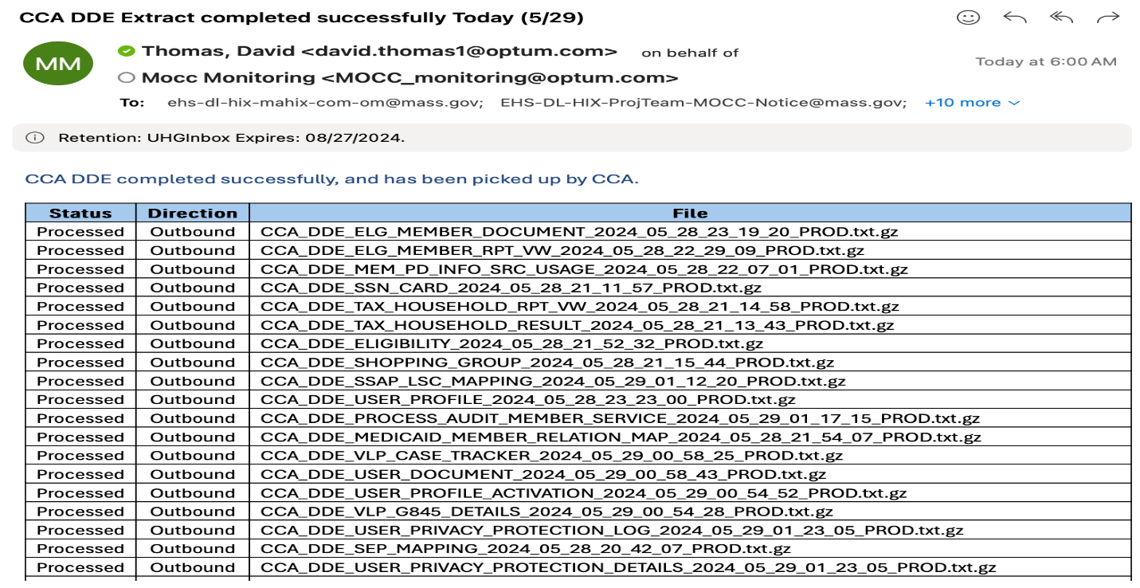

Figure 19: Sample CCA DDE Extract Delivery Email

##### DDE – Weekly Operations - MassHealth

On Monday mornings, MOCC sends an email notification on the MH DDE delivery status as part of delivery notifications (see screen shot):

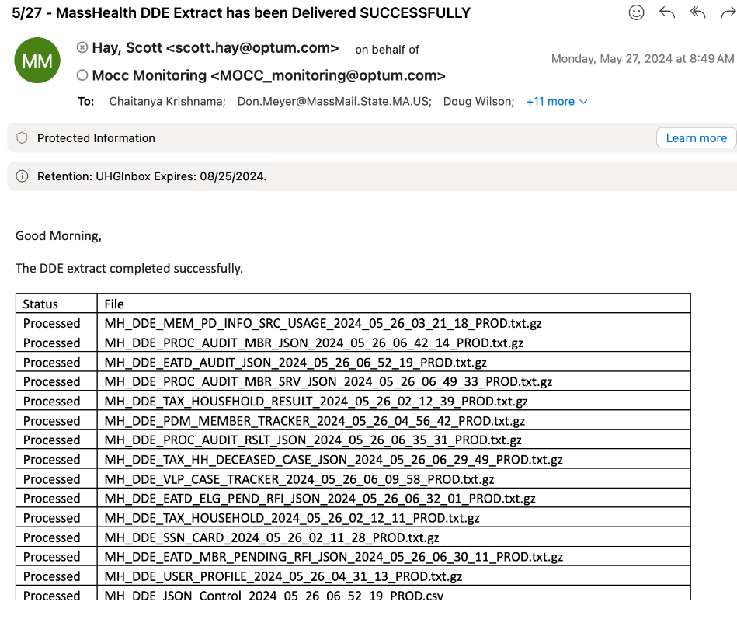

Figure 20: Sample MH DDE Extract Delivery Email

##### Daily Monitoring & Failure Handling

Optum’s O&M Team (supported also by Optum Reporting and the HIX Reporting Manager) monitors the DDE extract and transfer jobs. Argent Scheduler alerts are sent in case of failure with an exit code and message combination. In the event of an Argent Scheduler alert, Optum O&M resends affected files, or takes necessary steps base on exit code to regenerate and resend affected files.

Table 16 – DDE Batch Schedule

| **Error Code** | **Cause** | **Fix** |
| --- | --- | --- |
| 31 | Command File Creation/Rewrite Failure | Check if command file path exists. Optum O&M reruns process |
| 32 | Unable to read property file | Make sure the property file path is correct and is accessible. Optum O&M reruns process |
| 33 | List of views Failure | Make sure the table that contains list of all the sections/tables exists and is accessible. Optum O&M reruns process |
| 35 | One or More Iteration Fails | Program completes all iterations and then exists with error code. Review error.log for details.  Optum O&M reruns process |
| 36 | Merging or zipping of file fails | Program terminates with error code. Review error.log for details. Optum O&M reruns process |

##### DDE Data Issue Process Diagram

The diagram below shows a detailed view of the resolution process for potential data integrity issues discovered in the DDE file.

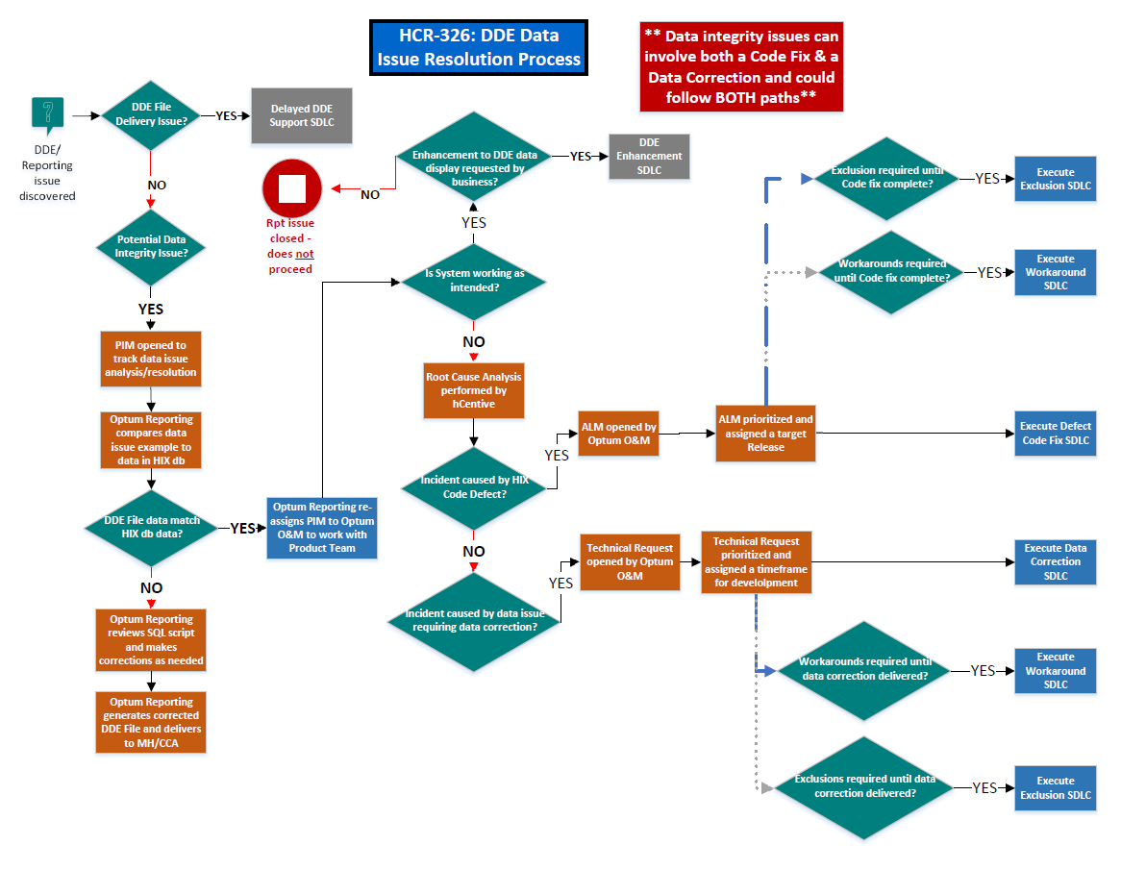

Figure 21: DDE Data Issue Process Diagram

##### DDE Late Delivery Process Diagram

The diagram below shows a detailed view of the resolution process for delays in the delivery of the DDE file to MassHealth and/or CCA.

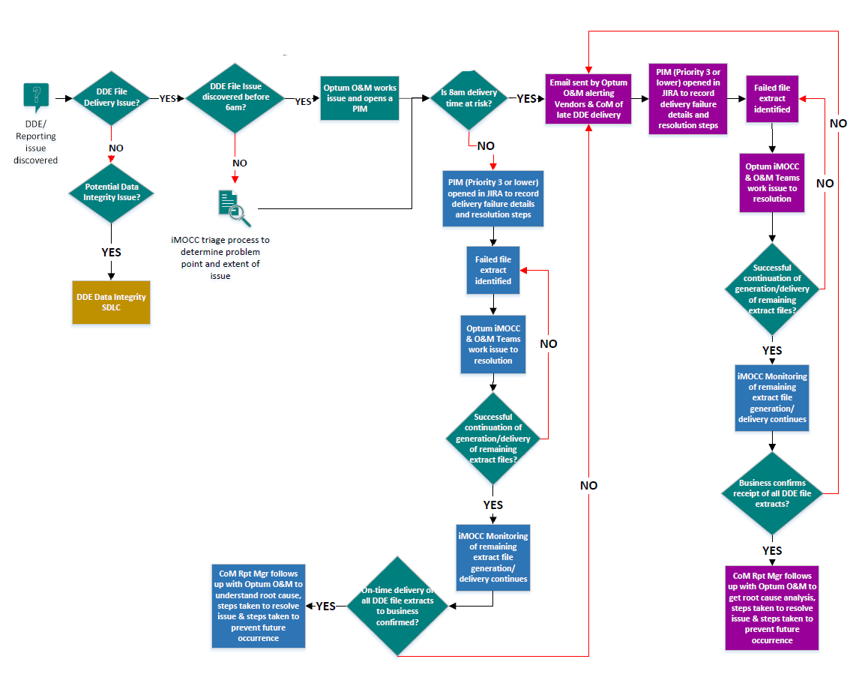

Figure 22: DDE Late Delivery Process Diagram

##### Weekly DDE File Tracking Report

The team has identified possible points of failures in the DDE process:

* Generation
* Transfer of completed file from batch server to AxWay
* Transfer from AxWay to MH via MoveIt

Optum O&M provides a weekly report of raw data that highlights times of the above activities every day. Also included in this report is the trend of the size of the DDE. The Reporting Manager receives the raw report data from Optum and appends it to a separate, running report that uses the data to produce a series of charts and tabular reports designed to highlight any potential issues listed above.

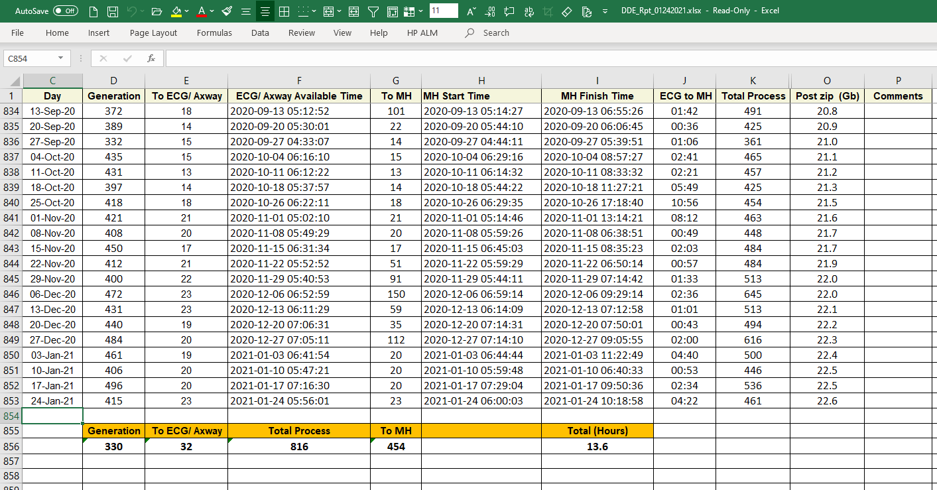

Figure 23: Sample MH DDE Report

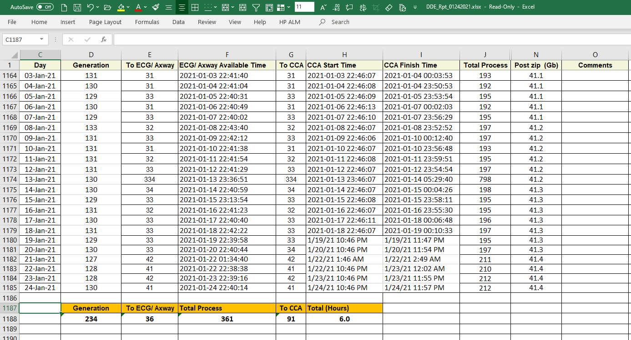

Figure 24: Sample CCA DDE Report

##### Daily Data Extract (DDE) Change Data Capture (CDC) processing

**Full File MA HIX DDE Process Overview:**

The existing MA HIX DDE process involves extracting data from the entire source table and generating individual text files. These files are then transferred to CCA, MH, and MDM for ingestion into their respective data warehouses on a daily or weekly basis. Due to the large volume of data in the MA HIX application, this approach is time-consuming and inefficient across the stages of data extraction, transfer, and ingestion.

**Modernization with CDC Implementation:**

To improve efficiency, EOHHS and Optum have implemented Change Data Capture (CDC) capabilities using the Informatica Data Integration tool, replacing the legacy MA HIX DDE process.

Under the new approach:

* DDE data files are extracted from the MA HIX IES database.
* The Informatica Data Integration tool identifies and captures only the changes in data, significantly reducing processing time and resource usage.
* These files are generated and delivered to CCA, MDM, and MH on a daily or weekly schedule.
* Before delivery, the files are compressed to optimize transfer and storage.

###### Daily Monitoring & Failure Handling:

* **Login/Launch Informatica**

Login to Centrify 🡪 Launch **Informatica PROD**

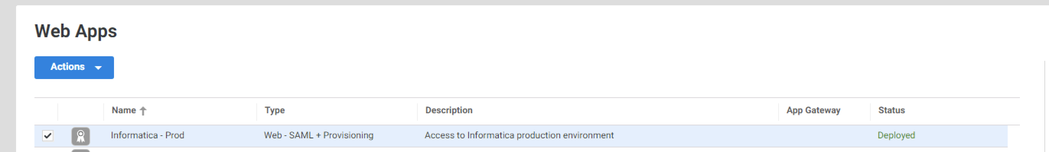

Figure 25: Launch Informatic PROD

* **Monitor Job Status**

To Monitor the status of running/completed Jobs, Select Monitor Service 🡪 Goto All Jobs

Select Monitor Service:

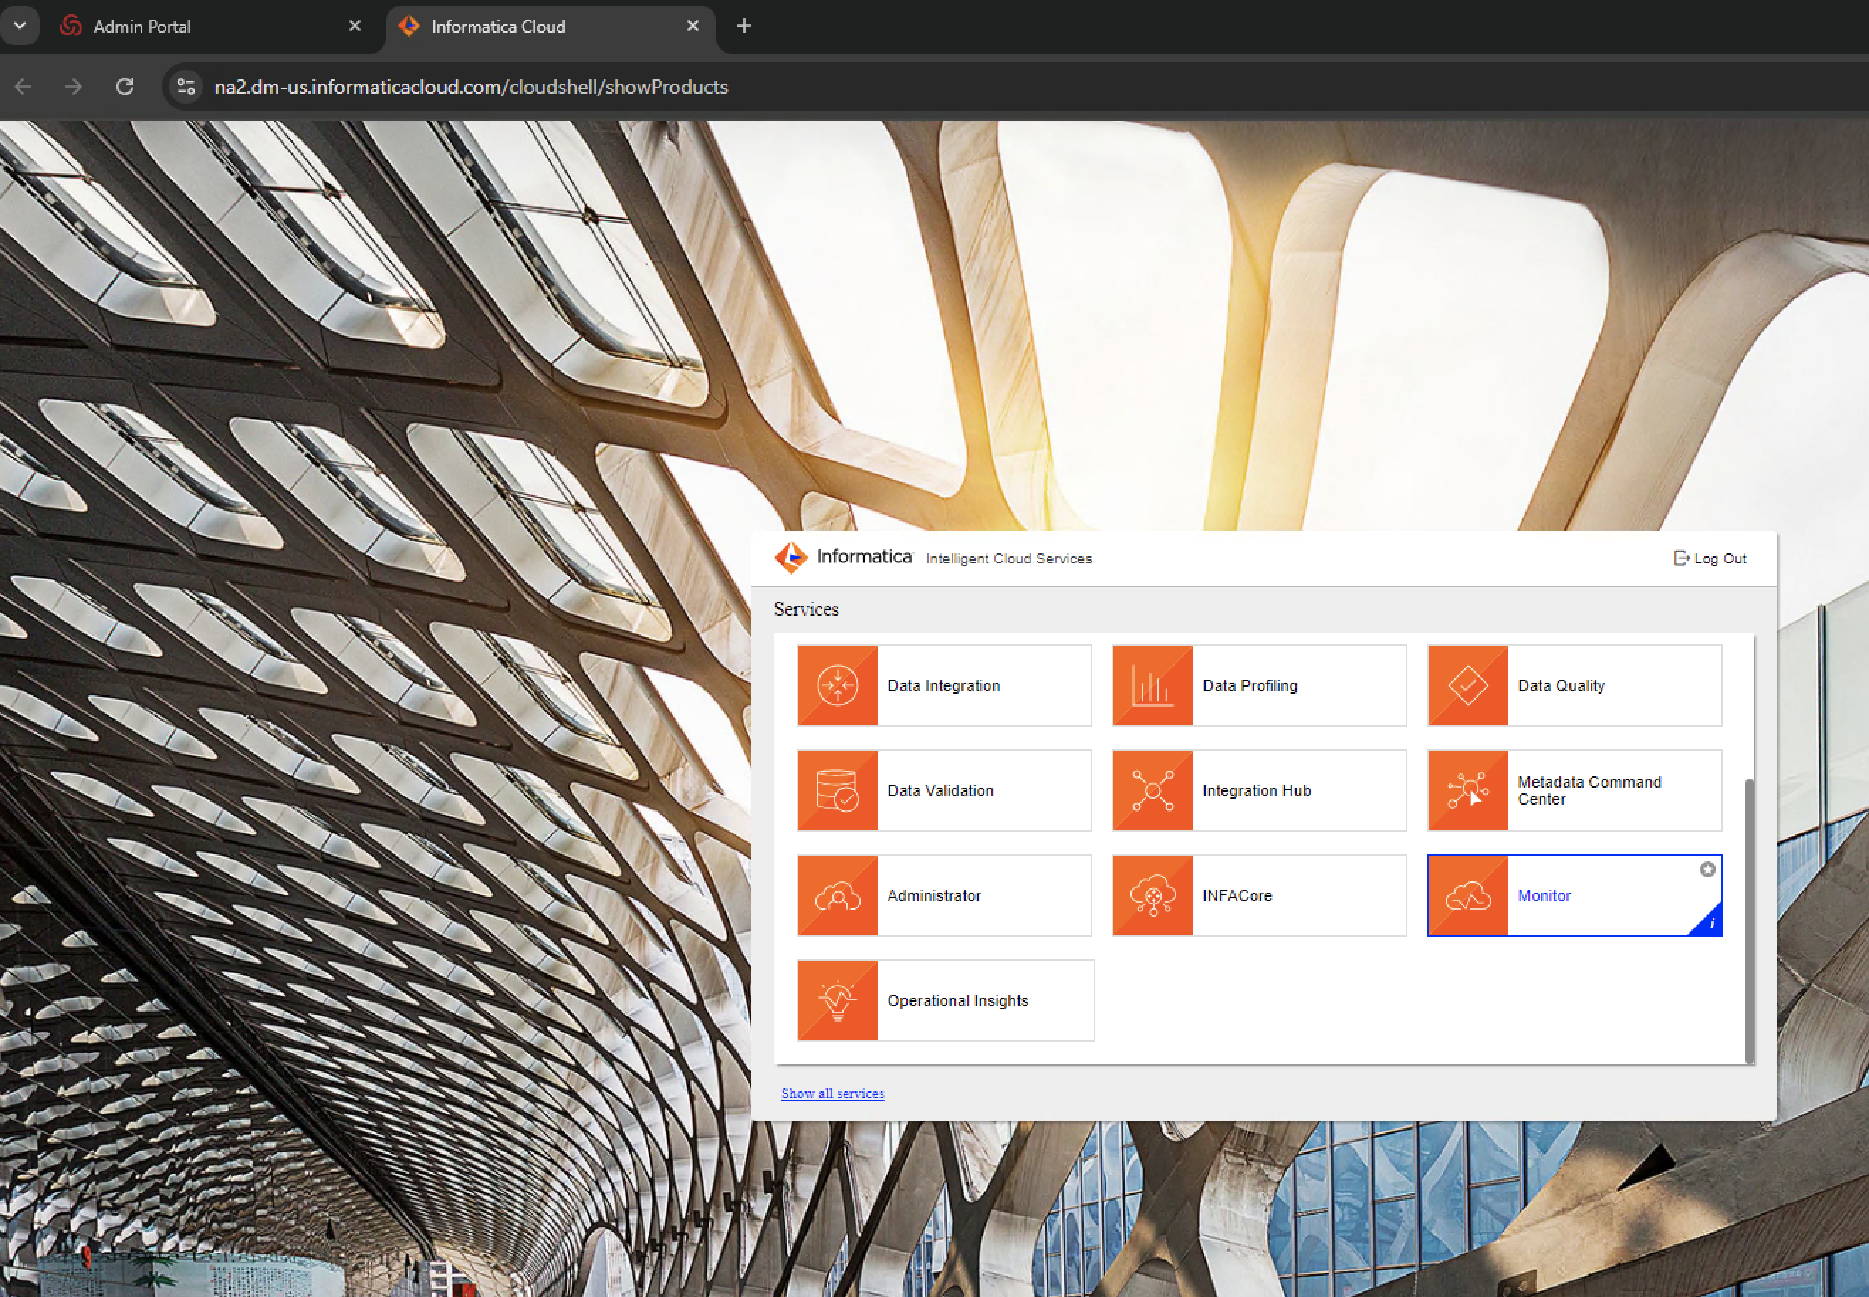

Figure 26: Informatic Select Monitor Service

* **Goto All Jobs:**

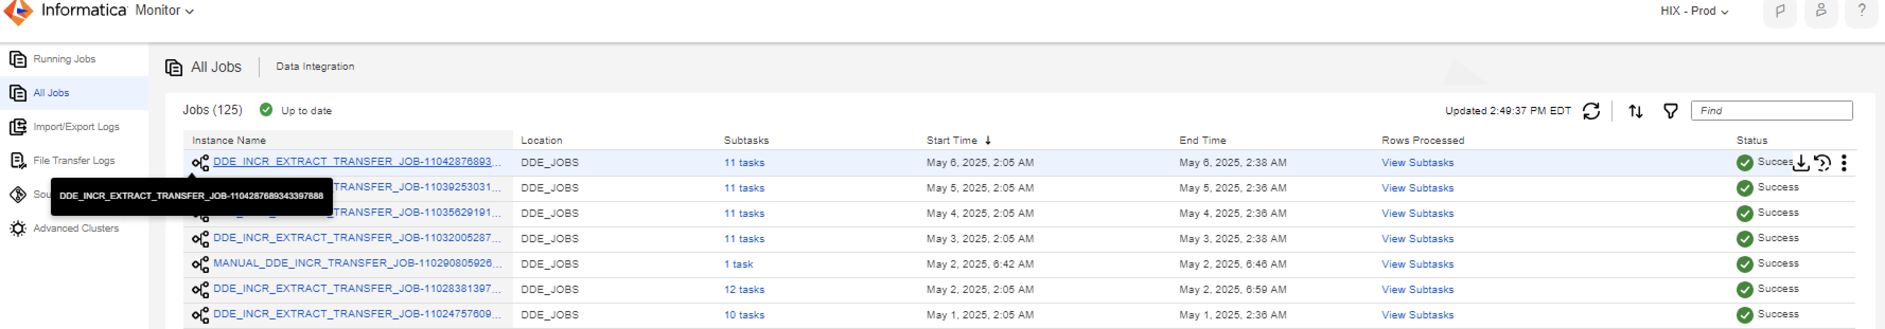

Figure 27: Informatic Goto All Jobs

* **Job Failure:**
  + - * If the job fails, the status will be marked as Suspended. Click on the Instance name to see at what step the job failed.



Figure 28: Informatic Job Failure

* + - * Download the failed task log to analyze the error.

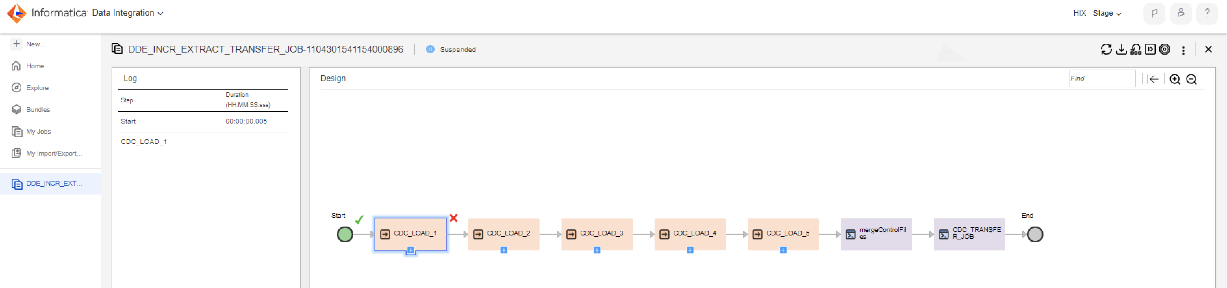

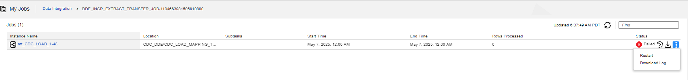

Figure 29: Informatic Analyze Failure

* **Restart:**
  + - * After the failure issue is fixed, resume from the failed task.
      * Resume from faulted Step: This action restarts the failed task and continues.

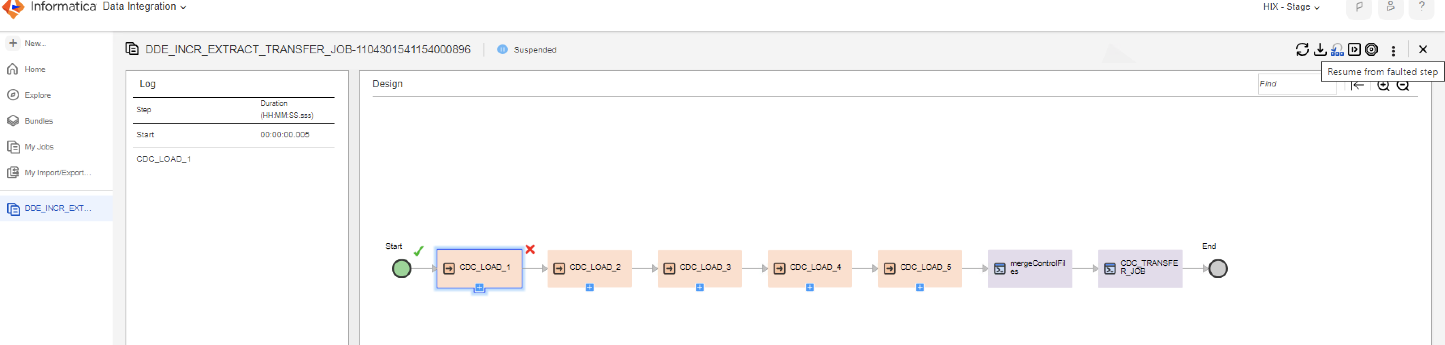

Figure 30: Informatic Restart

* + - * **List of Jobs**
  + After launching Informatica PROD, select Data Integration 🡪 Select DDE_JOBS folder
    - * (1) CDC DDE Daily Job 🡪 DDE_INCR_EXTRACT_TRANSFER_JOB (We are currently using only this job)
      * (2) FULL DDE Job 🡪 DDE_FULL_EXTRACT_TRANSFER_JOB
      * (3) Manual CDC DDE Transfer Job 🡪 MANUAL_DDE_INCR_TRANSFER_JOB
      * (4)_Manual Full DDE transfer Job 🡪 MANUAL_DDE_FULL_TRANSFER_JOB

**NOTE–** Above jobs 2,3 and 4 will be managed by Optum reporting team.

* + - * **Select Data Integration:**

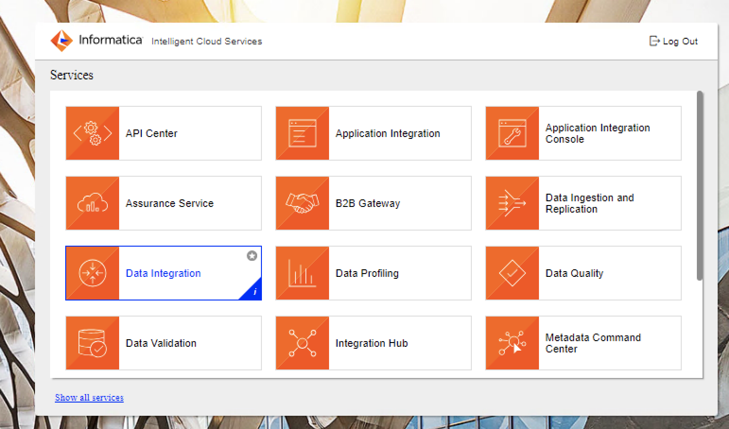

Figure 31: Informatic Select Data Integration

* + - * **Select DDE_JOBS:**

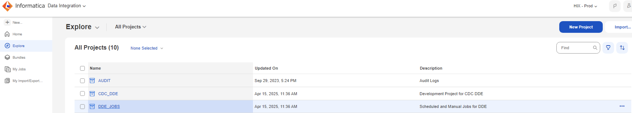

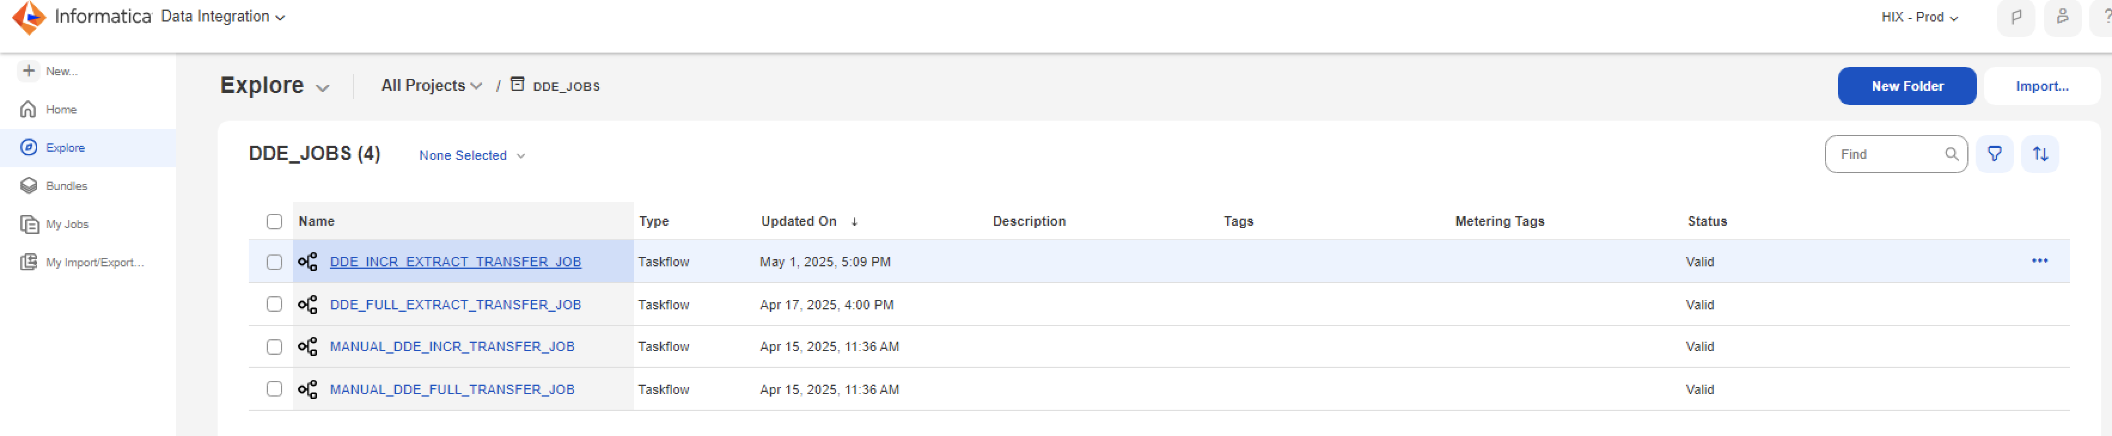

Figure 32: Informatic Select DDE Jobs

* + - * **Server Details**

All the DDE generated files will be **in cdc-app1.prd1.hix.internal**:/opt/informatica/extract base folder.

Please see below the folder structure.

* + FULL_DDE:
    - * Generated Data Files: /opt/informatica/extract/full_data_files
      * Transfer file: /opt/informatica/extract/full_data_files_transfer
      * Archived Files: /opt/informatica/extract/full_data_files_transfer_archive
      * Transfer Log:/opt/informatica/extract/logs/transfer
  + INCR_DDE:
    - * Generated Data Files:/opt/informatica/extract/cdc_data_files
      * Transfer file: /opt/informatica/extract/cdc_data_files_transfer
      * Archived Files: /opt/informatica/extract/cdc_data_files_transfer_archive
      * Transfer Log:/opt/informatica/extract/logs/transfer
* **Failure Scenarios**
  + - * In case of Job failure, the initial step it to check the below three processes are up and running on the server.
  + Informatica agent: ps -ef | grep MainApp
  + PWX Logger: ps -ef | grep pwxccl
  + PWX Listener: ps -ef | grep dtllst(Add a CAMS ticket example)

If any of the above processes are down, we need to open a ticket with Smartronix to debug the issue.

Sample Reference Ticket: CS0080085

* + - * If the log says issues with a table/column for a failed task, please reach out to DEV team to further debug the issue.
  + Listener down failure scenario: Please see the below screenshot of the error if the listener is down when the Job starts/running

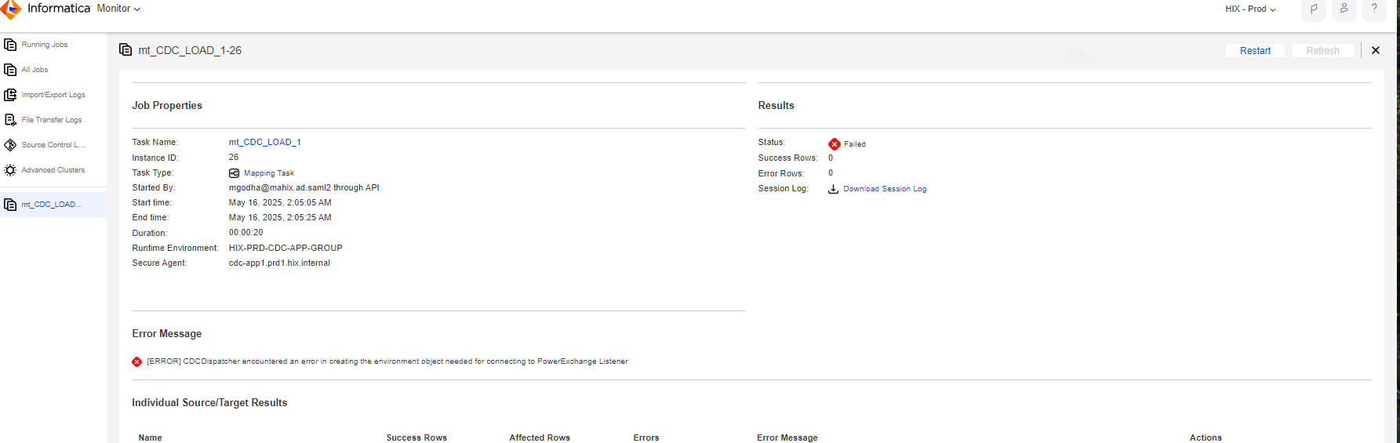

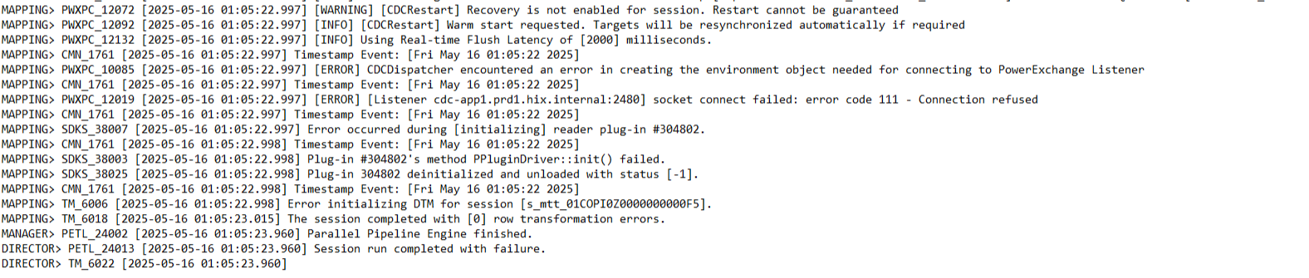

Figure 33: Informatic Failure Task

Open a ticket for Smartronix to bring the listener back up.

#### Open Enrollment

As part of Open Enrollment Process (also known as CCA Renewal), the system should be able to renew the current year plan to the renewal year plans for the CCA and mixed household population. System generates appropriate renewal notices during CCA renewal process including Pre-Populated-Form (PPF) notice for the mixed household members for whom MassHealth eligibility is downgraded and Preliminary Eligibility notice for the CCA enrolled population.

The CCA Renewal Process generally starts during August and all prelim applications need to be created within 10-12 days’ time window. This timeframe will be decided based on the population eligible for renewals. By September all prelims should be created, and appropriate notices should be sent to the users. With Pre-populated forms there is a 50 days window for applicants to respond, and if preliminary notice is generated then there is 30 days window for prelim period.

For finalization of applications for renewal year eligibilities, there is a schedule established of 20-25 days depending population size to be processed and any constraints provided by the business. By the end of the renewal end date finalization must be completed and all the applications must be finalized. According to the finalization, shopping groups must be created and APTC call should be made to get the APTC information. The amount of APTC that is received during this call should be communicated to the users via notices.

Optum O&M executes all OE batches in production and provides reporting.

Below is high level schedule for OE batches:

Table 17 – High Level OE Batch Schedule

|  |  |  |  |
| --- | --- | --- | --- |
| **Category** | **Est Start Date (+/- 5 days)** | **Est End Date (+/- 5 days)** | **Number of Days** |
| Preliminary Eligibility (Job 40A and 40B) | Aug-15 | Sep-10 | 25 |
| Plan Load | Sep-20 | Sep-20 | 1 |
| FTR Ping1 (Job 97 and 97B) (This batch was not applicable/executed for last 2 Open Enrollments per business request) | Sep-25 | Sep-28 | 4 |
| APTC (Job 41 and 42) | Sep-21 | Sep-24 | 4 |
| Final Eligibility (Job 94) Notice job 44 and 45 | Oct-1 | Nov-5 | 36 |
| Bypassed MH Pend  (Skipped from Prelim - RFI due date > 10/31) | Oct-28 | Oct-30 | 3 |
| Open Enrollment Start Date | Nov-01 | Nov-01 | 1 |
| Auto Enrollment (Job 29) | Nov-15 | Dec-6 | 21 |
| Failure to Reconcile (FTR) Ping2 (Job 97B) (not executed this year because tax filing date was extended due to COVID) | Dec-24 | Dec-26 | 3 |
| Close of Open Enrollment | Jan-23* | Jan-23 | 1 |

*Close of OE may be changed based on business request.

##### Open Enrollment (OE) Business Events

This section describes the flow of the batches that are run in Production for CCA Renewals:

###### Preliminary Eligibility Process

Preliminary Eligibility (Prelims) is the first step in CCA renewals activity. As part of the step, system selects all QHP only and Mixed Household application which have at least one submitted current year eligibility in the system. It compares application information against external data sources, creates a preliminary eligibility for following plan year (renewal year) and generates the applicable notices.

Preliminary Eligibility – Job Sequence

During Preliminary eligibility phase following jobs are run in this order:

* Job 40A: Job to Identify the Eligibility for Renewals
* Job 40B: Job to Renew Eligibility Identified for Renewals
* Job 88: CCA Renewal Reprocessing Batch Job
* Job 72: Create TDS entries for members for account
* Job 73: Aggregate member level TDS records to generate aggregated request file
* Job 74: Generate RRV batch zip file
* Job 105: Transfer the RRV file to Hub
* Job 89: RRV-FDSH fallback Records Identification Batch Job
* Job 90: RRV-FDSH fallback Records Processing Batch Job
* Job 75: Unzip RRV batch Response zip file
* Job 76: RRV Response Save Job
* Job 82: Call DOR service for Renewal Records
* Job 91 CCA: RRV-SSA Response Deceased Identification Batch Job
* Job 92: RRV-SSA Response Deceased Identification Records Processing Job
* Job 78: RRV Factor Verification Job
* Job 79: Preliminary Eligibility Determination Job
* Job 95: SSA Response Deceased Record Processing Batch Job
* Job 84: Medicaid Renewal Notice XML Generation Job

Prelims – Job Description

Batch Job 40A: Job to Identify the Eligibility for Renewals

This batch job performs application Identification to identify all the applications which are eligible for renewal.

1. **Start time:** This batch is started “on demand”.
2. **Frequency:** This batch is run based “on demand”.
3. **Dependency:** This batch has no dependency on any other batch.

Batch Job 40B: Job to Renew Eligibility Identified for Renewals

This batch job renews the eligibilities which are identified for Renewals.

1. **Start time:** This batch is started “on demand”.
2. **Frequency:** This batch is run based “on demand”.
3. **Dependency:** This batch is dependent on batch Job 40A.

Batch Job 88: CCA Renewal Reprocessing Batch Job

This batch job will reinitiate CCA Medicaid renewal process for all applications skipped by CCA renewal filters. This job is also run to select members for Stand Alone Dental process.

1. **Start time:** This batch is started “ON DEMAND”.
2. **Frequency:** This batch is run based “ON DEMAND”.
3. **Dependency:** This batch has no dependency on any other batch.

Batch Job 72: Create TDS entries for members for account

This batch job will pick up all the records in MED_RENEWAL_CONTROL table with status as ‘NOT_PROCESSED’ and process_id as null. For every member record picked, a TDS request member level XML will be generated.

1. **Start time:** This batch is started “on demand”.
2. **Frequency:** This batch is run based “on demand”.
3. **Dependency:** This batch has no dependency on any other batches.

Batch Job 73: Aggregate member level TDS records to generate aggregated request file

This batch job will pick up records (grouped by TDS type) which will then be aggregated into a single TDS file (as mandated by the RRV BSD. For every TDS type record present, one aggregated file should be created for that particular job chunk cycle.

1. **Start time:** This batch is started “on demand”.
2. **Frequency:** This batch is run based “on demand”.
3. **Dependency:** This batch is dependent on batch job 72.

Batch Job 74: Generate RRV batch zip file

By this batch job, the aggregated files (one per TDS) against the picked record will be archived as part of a single zip file.

1. **Start time:** This batch is started “on demand”.
2. **Frequency:** This batch is run based “on demand”.
3. **Dependency:** This batch is dependent on batch job 73.

Batch Job 105: Transfer the RRV file to Hub

This batch job sends the RRV Zip file to hub.

1. **Start time:** This batch is started “on demand”.
2. **Frequency:** This batch is run based “on demand”.
3. **Dependency:** This batch is dependent on batch job 74.

Batch Job 89: RRV-FDSH fallback Records Identification Batch Job

This batch job is used to identify the RRV requests whose RRV retry limits are exhausted and overall time out is reached or which are marked for manual intervention.

1. **Start time:** This batch is started “ON DEMAND”.
2. **Frequency:** This batch is run based “ON DEMAND”.
3. **Dependency:** This batch has no dependency on any other batch.

Batch Job 90: RRV-FDSH fallback Records Processing Batch Job

A new multiple instance supported batch job to process the records identified by the identification job. For technical failures or response code HX the records will be retried for 3 times (configurable), and after max retry limits those records will be marked FDSH_FAILED and factors will be marked unverified (for this case some changes might be required in batch 78) For HE response codes it will be treated as existing rules run for member data not available. For successful calls, the mappers will be implemented for all possible TDS type i.e.; SSA, IRS, MEC to map the FDSH data type to RRV data type so make it compatible for other RRV batch jobs. After successful conversion of FDSH data to RRV data it will be saved to RRV_TDS_REQ_RES_CTRL table column RES_XML and will be used by batch 78 for factor verification, also the record in table RRV_TDS_REQ_RES_CTRL will be marked as status ‘RESPONSE_RECEIVED’

1. **Start time:** This batch is started “ON DEMAND”.
2. **Frequency:** This batch is run based “ON DEMAND”.
3. **Dependency:** This batch has no dependency on any other batch.

Batch Job 75: Unzip RRV batch Response zip file

This batch job will unzip the RRV batch response zip file.

1. **Start time:** This batch is started at “01:00 AM CST”.
2. **Frequency:** This batch is run based once in every two hours.
3. **Dependency:** This batch has no dependency on any other batch.

Batch Job 76: RRV Response Save Job

This batch job processes the response file extracted in unzip file job and saves the corresponding XML.

1. **Start time:** This batch is started at “12:00 AM CST”.
2. **Frequency:** This batch is run based once in every two hours.
3. **Dependency:** This batch has no dependency on any other batch.

Batch Job 82: Call DOR service for Renewal Records

This batch job will call DOR service for the members against the records in MED_RENEWAL_DOR_CONTROL table. Upon successful execution of DOR, request and response is saved. In case of any error, the record is marked as such.

1. **Start time:** This batch is started at “12:30 AM CST”.
2. **Frequency:** This batch is run once in every two hours.
3. **Dependency:** This batch has no dependency on any other batch.

Batch Job 91 CCA: RRV-SSA Response Deceased Identification Batch Job

This batch job is to identify the eligibilities, which are under renewal process and only SSA response is received for all members of the eligibility.

1. **Start time:** This batch is started at “12:00 AM CST”.
2. **Frequency:** This batch is run once in every two hours each day including weekends.
3. **Dependency:** This batch has no dependency on any other batch.

Batch Job 92: RRV-SSA Response Deceased Identification Records Processing Job

A new multi Java Virtual Machine (JVM) instance supported batch job that will process the records identified by batch job 91. It will run the HOH and other deceased member rules and evaluates if renewal process is required to wait for other TDS responses i.e. IRS, MEC and VLP. If the other responses are not required then they will be marked as RESPONSE_NOT_REQRED status in RRV_TDS_REQ_RES_CTRL table, and the TDS value in MED_RENEWAL_CONTROL table will be updated accordingly.

1. **Start time:** This batch is started at “12:30 AM CST”.
2. **Frequency:** This batch is run once in every two hours each day including weekends.
3. **Dependency:** This batch has no dependency on any other batch.

Batch Job 78 CCA: RRV Factor Verification Job

This batch job will populate MED_RENEWAL_MEMBER_FACTOR for each member and for each request type (i.e. SSA, IRS, MEC) which state whether member factor is verified or not based on response data.

1. **Start time:** This batch is started “1:45 AM CST”.
2. **Frequency:** This batch is run once in every two hours each day including weekends.
3. **Dependency:** This batch has no dependency on any other batch.

Batch Job 79 CCA: Preliminary Eligibility Determination Job

This batch job will create new eligibility in the system which could be in submitted state or in pending state if any timeclock started for the new eligibility.

1. **Start time:** This batch is started “12:45 AM CST”.
2. **Frequency:** This batch is run once in every two hours each day including weekends.
3. **Dependency:** This batch has no dependency on any other batch.

Batch Job 95: SSA Response Deceased Record Processing Batch Job

This batch job is used to generate renewal notices for Mixed household, it will generate Cover Letter and Prepopulated form for the mixed household eligibilities. The batch will pick records from table populate the details in control table NOTIFICATION_CONTROL_DATA for processing.

1. **Start time:** This batch is started “ON DEMAND”.
2. **Frequency:** This batch is run once based “ON DEMAND”.
3. **Dependency:** This batch has no dependency on any other batch.

Batch Job 84: Medicaid Renewal Notice XML Generation Job

This Batch job generates RENEWAL and NONRENEWAL xml for Medicaid notices.

1. **Start time:** This batch is started at “12:10 AM CST”.
2. **Frequency:** This batch is run once in every two hours.
3. **Dependency:** This batch has no dependency on batch job 83.

###### Plan Load

This is an important process wherein the carrier plan information for the next year is loaded to the production database. This process usually is performed by the release team in parallel to a deployment of a ‘dot’ release.

High level process:

1. Receive finalized and approved templates from the carriers.
2. Convert templates to XMLs
3. Execute the batch jobs to load the content to the database in production.
4. Generate report and share with business for validation

###### Failure to Reconcile (FTR) PING1

In this phase, System identifies applications where households with at least one Financial Assistance (FA) flow - QHP eligible member in the preliminary determination exists and initiate RRV call to receive the FTR data from IRS for latest year available. This is run per business discretion.

FTR PING1 – Job Sequence

Following jobs are run in this order:

* Job 97A: FTR Reconcile (Failure to Reconcile) INITIATE Records
* Job 72: Create TDS entries for members for account
* Job 73: Aggregate member level TDS records to generate aggregated request file
* Job 74: Generate RRV batch zip file
* Job 105: Transfer the RRV file to Hub
* Job 75: Unzip RRV batch Response zip file
* Job 76: RRV Response Save Job
* Job 97B: FTR Reconcile (Failure to Reconcile) PROCESS Records

FTR PING1 – Job Description

Jobs specific to FTR Ping are described below; Jobs 72, 73, 74, 105, 75, 76 are described under Prelims.

Batch Job 97A: FTR Reconcile INITIATE Records

This batch Job initiates FTR for the application which will be renewed as part of renewal process. It is used to initiate RRV IRS call for the renewal applications.

1. **Start time:** This batch is started “ON DEMAND”.
2. **Frequency:** This batch is run based “ON DEMAND”.
3. **Dependency:** This batch has no dependency on any other batch.

Batch Job 97B: FTR Reconcile PROCESS Records

This batch Job process FTR responses for the FTR initiated applications. It is used to analyze the latest FTR ping data and apply changes to application if required.

1. **Start time:** This batch is started “ON DEMAND”.
2. **Frequency:** This batch is run based “ON DEMAND”.
3. **Dependency:** This batch is dependent on batch Job 97A.

###### Advanced Premium Tax Credits (APTC)

In this phase of the CCA renewals, APTC value is calculated for the renewal application based on the QHP Plans loaded into the system for the renewal year and the calculated APTC value is applied to the eligibility created in the Preliminary Eligibility phase.

APTC – Job Sequence

During APTC phase following jobs are run in this order:

* Job 42: Identify Eligibilities for APTC calculation
* Job 41: APTC Calculation Job

APTC – Job Description

Batch Job 42: Identify Eligibilities for APTC calculation

This batch job will identify and populate the control table with the eligibility records for which APTC has to be determined.

1. **Start time:** This batch is started “on demand”.
2. **Frequency:** This batch is run based “on demand”.
3. **Dependency:** This batch has no dependency on any other batch.

Batch Job 41: APTC Calculation Job

This job reads the records from the APTC_CALCULATION_CONTROL_DATA table and does an APTC calculation for those eligibilities. The APTC amount will be updated in the TAX_HOUSEHOLD_RESULT table.

1. **Start time:** This batch is started “on demand”.
2. **Frequency:** This batch is run based “on demand”.
3. **Dependency:** This batch is dependent on batch job 42.

###### Final Eligibility

In this phase of CCA renewals, System selects applications that are not yet finalized by user action and have an active renewal year preliminary eligibility. This process involves changing the status of eligibility from Prelim to submitted. This batch does not perform any PD. PD performed during prelim determination is finalized. Once prelim eligibility is finalized all the batches can pick this application for processing and all Back-Office function will be made available. Applicable notices are generated.

Final Eligibility – Job Sequence

During Finals phase following jobs are run in this order:

* Job 94: CCA Renewal Finalization Batch Job
* Job 14: Generate XML for Notices Job
* Job 44: Check Renewed Eligibility for Auto Enrollment and insert Notices for Auto Enrollments
* Job 45: Generate Auto Enrollment Notices
* Job 11: Notices Batch Process Job
* Job 21: Send Notice XMLs to Softheon

Final Eligibility – Job Description

Batch Job 94: CCA Renewal Finalization Batch Job

The purpose of this job is to finalize the prelim eligibilities if not finalize yet. This job also takes an optional parameter, which is used to prioritized finalization process based on application type pass to it.

1. **Start time:** This batch is started “ON DEMAND”.
2. **Frequency:** This batch is run once based “ON DEMAND”.
3. **Dependency:** This batch has no dependency on any other batch.

Batch Job 14: Generate XML for Notices Job

This batch job will pick up all the eligibilities for which CCA notices need to be generated and generates a Xml. This Xml will be stored in ELG_NOTICE_XML table. Also, this batch job will pick up all the eligibilities for which Medicaid notices need to be generated and generates a Xml. This Xml will be stored in ELG_MEDICAID_NOTICE_XML table.

1. **Start time:** This batch is started at “12:10 AM CST”.
2. **Frequency:** This batch is run every half an hour i.e. once is 30 minutes.
3. **Dependency:** This batch has no dependency on any other batches.

Batch Job 44: Check Renewed Eligibility for Auto Enrollment and insert Notices for Auto Enrollments

This job checks if an auto-enrollment can be done for the renewed eligibility.

1. **Start time:** This batch is started “on demand”.
2. **Frequency:** The frequency in which this batch is run is based “on demand”.
3. **Dependency:** This batch has no dependency on any other batch.

Batch Job 45: Generate Auto Enrollment Notices

This job generates the renewal auto enrollment notices.

1. **Start time:** This batch is started at “00:20 AM CST”.
2. **Frequency:** The frequency in which this batch is run is based “on demand”.
3. **Dependency:** This batch is dependent on batch job 44.

Batch Job 11: Notices Batch Process Job

This job will pick all the Notice XMLs from ELG_NOTICE_XML and then creates a single XML file. This batch job will only be processing the Notices which are not MEDICAID.

1. **Start time:** This batch is started at “12:30 AM CST”.
2. **Frequency:** This batch is run once a day including weekends.
3. **Dependency:** This batch is dependent on Batch Job 14.

Batch Job 21: Send Notice XMLs to Softheon

This job will send the CCA Notice XMLs generated by Batch Job 11 to Softheon. Softheon receives the Enrollment transactions and takes care of billing part and does the effectuation and provide effectuated XMLs to OPTUM so that OPTUM can update the details of effectuation on the database and UI.

1. **Start time:** This batch is started at “12:30 AM CST”.
2. **Frequency:** This batch is run once a day including weekends.
3. **Dependency:** This batch is dependent on Batch Job 11.

###### Bypassed MH Pend

In this phase, system created renewal year eligibility for application with MH pend member. Batch select all the application which meets all the below conditions:

* The application has been skipped by CCA renewal for MH pend filter in current renewal cycle
* Application do not have submitted renewal year eligibility
* Current year eligibility is CCA only or Mixed HH

Bypassed MH Pend – Job Sequence

During Bypassed MH Pend phase following jobs are run in this order:

* Job 181: Renewal Skipped Eligibility Identify PD Job
* Job 182: Renewal Skipped Eligibility Determination PD Job

Bypassed MH Pend – Job Description

Batch Job 181: Renewal Skipped Eligibility Identify PD Job

This batch job will identify the skipped eligibility during CCA/Mix Renewal due to MH Pending Filter.

1. **Start time:** This batch is started “ON DEMAND”.
2. **Frequency:** This batch is run once based “ON DEMAND”.
3. **Dependency:** This batch has no dependency on any other batch.

Batch Job 182: Renewal Skipped Eligibility Determination PD Job

This batch job will determine eligibility identified by job 181. This Batch job will pick records from SKIP_RENEWAL_REC_CNTRL_DATA data table where PROCESS_ID is null and STATUS is ‘NOT_PROCESSED’ and during this process the JOB will rerun the eligibility which is mentioned in ELIGIBILITY_ID column.

1. **Start time:** This batch is started “ON DEMAND”.
2. **Frequency:** This batch is run once based “ON DEMAND”.
3. **Dependency:** This batch is dependent on batch job 181.

###### Auto enrollment

In this phase, System identify application with renewal year submitted eligibility with CCA member in latest eligibility. System pick latest eligibility of the application for processing. System perform shopping group reconstitution using renewal rules. System perform plan mapping for the member and Auto enroll the member in mapped plan. Effectuation status transferred to Softheon.

Auto Enrollment – Job Sequence

During Auto Enrollment phase following jobs are run in this order:

* Job 29: Auto Enrollment
* Job 3: Enrollment 834 XML Generation job
* Job 8: Enrollment Softheon WS call
* Job 7: Effectuation Status Transfer Job

Auto Enrollment – Job Description

Batch Job 29: Auto Enrollment

This batch job generates a new enrollment record for existing enrollment information for a member in situations in which member undergoes redetermination but do not re-shop or not required re-shopping. Auto enrollment XML will be generated to notify Softheon of change in enrollment details for any individual that goes under redetermination.

1. **Start time:** This batch is started at “01:50 AM CST”.
2. **Frequency:** This batch is run once in every two hours.
3. **Dependency:** This batch has no dependency on any other batch.

Batch Job 3: Enrollment 834 XML Generation job

This batch job generates the Enrollment 834 XML for the records in the BATCH_ENROLLMENT_XML_CONTROL table.

1. **Start time:** This batch is started at “12:01 AM CST”.
2. **Frequency:** This batch is run once in every half an hour i.e. once in 30 minutes.
3. **Dependency:** This batch has no dependency on any other batch.

Batch Job 8: Enrollment Softheon WS call

This job picks up the entries processed by the batch job 3 and sends them to a Softheon system via web service call.

1. **Start time:** This batch is started at “12:15 AM CST”.
2. **Frequency:** This batch is run once in every half an hour i.e. once in 30 minutes.
3. **Dependency:** This batch is dependent on batch job 3.

Batch Job 7: Effectuation Status Transfer Job

Softheon does the effectuation and provide effectuated XMLs to OPTUM so that OPTUM can update the details of effectuation on the database and UI.

1. **Start time:** This batch is started at “12:10 AM CST”.
2. **Frequency:** This batch is run once in every half an hour i.e. once in 30 minutes.
3. **Dependency:** This batch has no dependency on any other batch.

###### Failure to Reconcile PING2

In this phase, System identifies applications where households with at least one FA flow - QHP eligible member in the preliminary determination exists and initiate RRV call to receive the FTR data from IRS for latest year available.

FTR PING2 – Job Sequence

Following jobs are run in this order:

* Job 97A: FTR Reconcile (Failure to Reconcile) INITIATE Records
* Job 72: Create TDS entries for members for account
* Job 73: Aggregate member level TDS records to generate aggregated request file
* Job 74: Generate RRV batch zip file
* Job 105: Transfer the RRV file to Hub
* Job 75: Unzip RRV batch Response zip file
* Job 76: RRV Response Save Job
* Job 97B: FTR Reconcile (Failure to Reconcile) PROCESS Records

FTR PING2 – Job Description

Job description are defined under FTR PING1.

###### Reports Generated for CCA Renewals

1. Member information reported generated out of smoke batch execution and shared with business for validation.
2. No Member Left Behind (NMLB) report is tracks all applications selected for prelims through entire CCA renewals process to ensure all members are processed. NMLB report is reviewed daily in the daily scrum calls. Sample report is attached below:

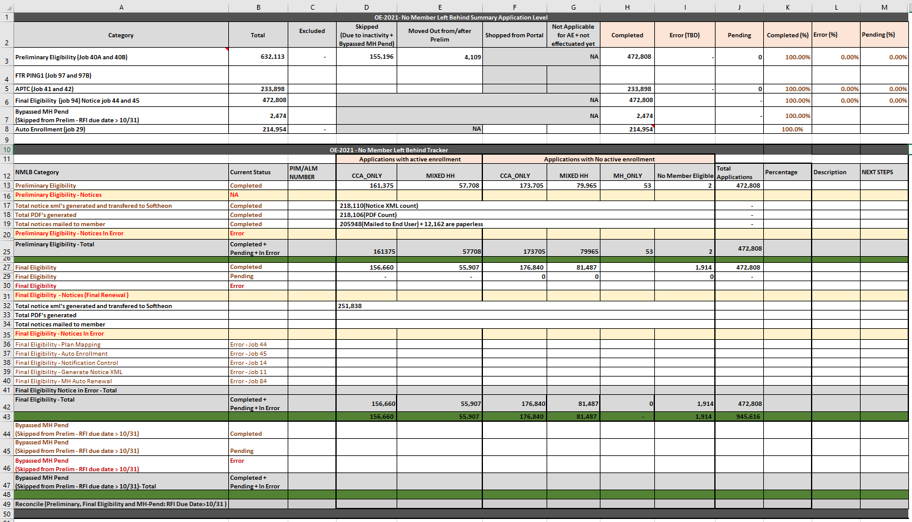

Figure 34: Sample NMLB Report

###### CCA Renewals Monitoring

Following meetings and reports are used to monitor OE activities:

1. Control reports are generated on daily basis during CCA renewals containing information about how many applications were picked, processed or failed. Failures are triaged and addressed as per established Incident and Problem Management processes. Control reports are delivered to the Commonwealth via email.
2. OE scrum calls – daily
   1. 30 min call; Tuesday to Friday usually at 10:30 am
   2. Teams invited – CCA, MH, Optum, Softheon and Commonwealth Project team
   3. Topics include review of open issues impacting renewals process, review of NMLB report and associated schedule.
   4. Meeting Agenda:
      * Roll Call
      * Review of Action Items
      * Optum Updates
      * Softheon Updates
   5. Meeting Template:

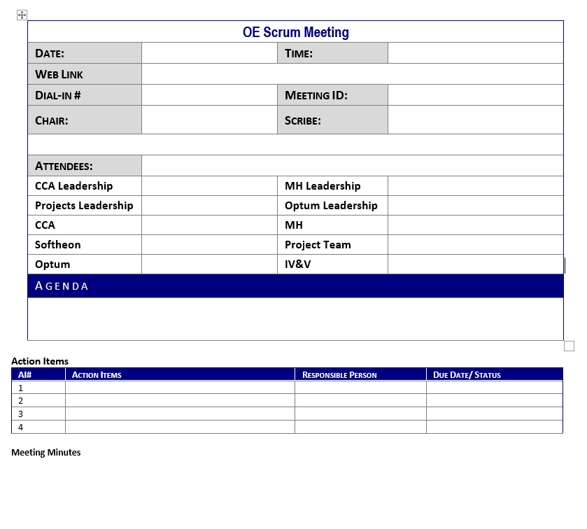

Figure 35: OE Scrum Meeting Minutes Template

1. Weekly OE CCA leadership calls – Thursdays
   1. This meeting is chaired by the Exec Director CCA; invitees based on CCA request comprising of CCA, MH, Projects, Optum, Softheon
2. Daily ops meeting
   1. For any urgent or special call outs, OE monitoring items are added to the agenda

### Production Control Procedures

#### Change management

Change Management is the IT Service Management process of managing a Change. A Change is defined as any deliberate action that alters the form, fit, or function of the system. This can include, but is not limited to: Hardware, network, software, application, environment, system, and desktops. Typically, any addition, modification, movement, or deletion that impacts the IT infrastructure or IT services is considered as a Change.

#### The Goal of Change Management

Goal of Change Management is to ensure that standardized methods and procedures are used for efficient and prompt handling of all Changes, in order to minimize the impact of Change-related Incidents upon service quality, and consequently to improve the day-to-day operations of the organization.

#### Change Management Process flow

Production Infrastructure Changes can originate from Optum, SMX, Commonwealth – for example OID Updates, property updates/bounces, more memory. Below are scenarios where Optum O&M team is involved in Change Management process.

##### Optum Change; SMX resource required

Infrastructure change request – memory, firewall rule, etc.

Table 18 – Optum Change; SMX resource required

|  |  |
| --- | --- |
| Communication | Initial communication: Release Calendar  MOCC sends out initial, starting and completed notifications. Sends to Commonwealth if the change is impacting. |
| Smartronix Resource Acquisition | We open a Jira ticket (HIXCR) and assign to Project team (Sandeep Rajankar). Commonwealth will then open a corresponding CAMS ticket (HIX Optum) with SMX.   * Optum will add to the Jira ticket:   + Requested turnaround time   + Environments   + What support is needed, and when |
| Ticket(s) | Optum opens internal ServiceNow ticket (non-impacting):   * Internal communications/informational * Internal Resources * Internal Approvals/Tracking |
| Implementation | Optum internal Teams Mtg is created if required  Optum manually monitors the CAMS ticket for SMX updates |
| Validation | Optum does validation. Validation differs per change type Release vs Refresh vs Infra. Portals, smoke test. |

##### Optum Change; no SMX resource required

Example: Informational (turn off monitoring)

Table 19 – Optum Change; no SMX resource required

|  |  |
| --- | --- |
| Communication | Initial communication: Release Calendar  MOCC sends out initial, starting and completed notifications. Sends to Commonwealth if the change is impacting. |
| Smartronix Resource Acquisition | NA |
| Ticket(s) | Optum opens internal ServiceNow ticket (non-impacting):   * Internal communications/informational only * Internal Resources * Internal Approvals/Tracking   Optum opens CAMs Request for informational purposes for SMX   * Production only |
| Implementation | Optum internal Teams Mtg is created if required |
| Validation | Optum does validation. Validation differs per change type |

##### SMX Initiated Request

Example: a property update, Axway update

Table 20 – SMX Initiated Request

|  |  |
| --- | --- |
| Communication | Smartronix notifies Release Management via CAMS  Smartronix receives approval from Commonwealth  RM updates Release Calendar and schedules the activity  MOCC sends out standard communication if there is impact |
| Smartronix Resource Acquisition | Smartronix assigns their CAMS ticket |
| Ticket(s) | MOCC creates a Jira ticket if there is an impact  Optum opens internal ServiceNow ticket (non-impacting):   * Internal communications/informational only * Internal Resources * Internal Approvals/Tracking |
| Implementation | RM schedule a Teams Mtg  RM monitors the CAMS ticket for SMX updates |
| Validation | Optum does validation. Validation differs per change type |

### Diagnostic and Problem Handling Procedures

Refer to section 5.5 Monitoring Procedures

### Monitoring Procedures

Optum O&M team proactively monitors several key aspects of the system and alerts respective teams if threshold levels are met for further investigation. Below table provides description of application functions and a brief description of what is monitored, frequency of monitoring and the team that performs the monitoring.

#### Monitoring RACIs

Table 21 – MOCC Monitoring & Alerts

| **MOCC Support Functionality** | | | | | | | | | | | | | | | | | | | |
| --- | --- | --- | --- | --- | --- | --- | --- | --- | --- | --- | --- | --- | --- | --- | --- | --- | --- | --- | --- |
| Function | Description | Frequency | Team | Tool | Automation | RACI (Responsible, Accountable, Consulted and Informed) Matrix | | | | | | | | | | | | | |
| Optum MOCC | Optum O&M | Optum ITS | Project O&M | Project Architecture | CCA Operations | MH Operations | CSG | Optum Leadership | Project Leadership | Accenture | Softheon | Smartronix | Axway |
| **JIRA Ticket Tracking** | MOCC receives notification of all newly created and modified JIRA tickets | Continuous | MOCC | Outlook | Automatic | RA | C I | I | I | I | I | I | I | C I | I |  |  |  |  |
| **Application Monitoring\*** | Live monitoring of performance degradation, traffic drops, traffic spikes, failure rates, and customized alerts | Continuous | MOCC/O&M | DTSaaS | Automatic | R | AC I | I | I | I | I | I | I | C I | I |  |  |  |  |
| **Vital Business Function (VBF) Monitoring** | Monitoring user experience as they navigate through VBF area of the application. | Continuous | Mocc | DTSaaS | Manual | RA | AC I | I | C I | C I | C I | C I | I | I | I |  |  | I |  |
| **Service Monitoring\*** | Live monitoring of response times, failure rates, service load spikes and drops, and custom alerts | Continuous | MOCC/O&M | DTSaaS | Automatic | RA | AC I | I | I | I | I | I | I | C I | I |  |  |  |  |
| **Database Monitoring\*** | Live monitoring of response times, failure rates, service load spikes and drops, failed connections and custom alerts | Continuous | MOCC/O&M | DTSaaS | Automatic | RA | AC I | I | I | I | I | I | I | C I | I |  |  |  |  |
| **Host/Server Monitoring\*** | Live monitoring of VM performance, network performance, disk performance, and custom alerts | Continuous | MOCC/O&M | DTSaaS | Automatic | RA | AC I | I | I | C I | I | I | I | C I | I |  |  | C |  |
| **MQ Monitoring\*** | Live monitoring of queue manager state, listener state, connectivity, and queue messenger health | Continuous | MOCC/O&M | DTSaaS | Automatic | R | A C I | I | I |  | I | C I | I | C I | I |  |  |  |  |
| **Key Actions & Requests** | High traffic actions and requests are flagged for additional monitoring to identify potential end user impact | Continuous | MOCC | Dynatrace | Manual | R | AC I | I | I | I | C I | C I | I | C I | I |  |  |  |  |
| **AIKYAM Notifications** | Synthetic scripts generate automatic email alerts when issues occur. When Optum TCC is notified of an issue with **AIKYAM**, and a War Room is initiated, an email paging system will notify MOCC | As required | MOCC | Outlook | Manual | RA | I | I | I | I | I | I | I | C I | I |  |  |  |  |
| **Synthetic App Monitoring** | Records navigation through web sites and saves to a script to be played back from internal or external agents to monitor application resiliency such as transaction response time and availability | As Required | MOCC/O&M | Dynatrace | Manual | RA | ACI | I | I | I | I | I | I | C I | I |  |  |  |  |
| **Batch Job Status** | Notify operators of change in batch job status | N/A | MOCC/O&M/DEV | Argent | Automatic | I | RA C I | AC | I | I | I | I | I | C I | I |  | C | C | C |
| **Server Logs Monitoring** | Provides server log data via email | N/A | MOCC/DEV | OpenSearch | Automatic | I | RAC I | I | I | I | I | I | I | C I | I |  |  |  |  |
| **Real User Monitoring** | Live monitoring of real-time user information | Continuous | MOCC | DTSaaS | Automatic | RA | C I | I | I | I | I | I | I | C I | I |  |  |  |  |
| **Session Replay** | Resource-intensive screen capture of user experiences. Reserved for advance triage in which an error is replicable and root cause is unknown | Upon request | MOCC/O&M | DTSaaS | Manual | RA | C I | CI | I |  |  |  |  | C I | I |  |  |  |  |
| **External Services Monitoring** | Live monitoring of all requests to Fed HUB and Commonwealth services | Continuous | MOCC/O&M | DTSaaS | Automatic | R | I | AC | I | I | I | I | I | C I | I |  |  |  |  |
| **Batch Job Monitoring** | Monitoring running of batch jobs | Continuous | MOCCO&M | Outlook, SQL Developer / Putty | Manual (Automation in progress) | I | RAC I | CI | I | I | I | I | I | I | I |  | I | I | I |
| **Batch Job Delivery** | File transfer monitoring ensures end-point delivery of DDE (CCA/MH), MDM DDE CDC, CCA DDE CDC, PA, PA caseload, SNAP, OWA, AVR SOC, referral, and PB files | 06:00 AM | MOCC | Axway | Automatic | R | A C I | CI | I | I | I | I | I | C I | I |  | C | C | C |
| **Notice Delivery** | Notice transfer monitoring ensures end-point delivery of SM, ITD, and Softheon notices | 06:00 AM | MOCC | Axway | Automatic | R | A C I | CI | I |  | I | I | I | C I | I | I | I | I | I |
| **Perimeter Network Security** | DDoS attack mitigation, customizable WAF, protection against direct-to-origin attacks, content caching, access control, NetStorage and log delivery | Continuous | Smartronix | CloudFront | Automatic | CI | CI | I | C | I |  |  |  |  |  |  | RA |  |  |
| **Notification Banners** | Messages displayed on CCA landing page | As required | MOCC/O&M | WordPress | Manual | RA | RA |  | C |  | RAC | I | I | I | I |  |  |  |  |
| **Application Banners** | Messages displayed on targeted pages throughout the portal | As required | MOCC/O&M | WordPress | Manual | CI | RA | RA | I |  | I | I | I | I | I |  |  |  |  |
| **MQ Message**  **Delivery** | Monitors the queue. Confirms MWS (e.g. MMIS) message delivery to MA HIX is aligned | 06:00 AM / Continuous | MOCC | SQL Developer / Dynatrace | Manual / Automatic | R | A C I | AC | I |  | I | C I | I | C I | I |  |  |  |  |
| **Commonwealth Services Check** | This check is a binary green/red ping of services – used to identify outages of MDO and DOR | 6:00 AM/PM 12:00 PM / Continuous | MOCC | SoapUI / Dynatrace | Manual / Automatic | R | I | AC | I |  |  |  |  | C I | I |  |  |  |  |
| **Fed HUB Services Check** | This check is a binary green/red ping of services – used to identify outages of APTC, IRS, PECO, MEDI, TRI, VHCP, RIDP, SSA, VLP | 6:00 AM/PM 12:00 PM / Continuous | MOCC | SoapUI / Dynatrace | Manual / Automatic | R | I | AC | I |  |  |  |  | C I | I |  |  |  |  |
| **Priority 1 & 2 Notifications** | Source of current status on all JIRA ticket high priority incidents transmitted during operational hours until resolved | Hourly | MOCC | Outlook | Manual | R | C I | I | I | I | I | I | I | C I | I |  |  |  |  |
| **Weekend MNT Schedule** | Optum and external services/vendors schedule maintenance which is compiled into a weekly report | As required | MOCC | Outlook | Manual | R A | I | I | I | I | I | I | I | C I | I | I | C | C |  |
| **Incident Ticketing** | Instant notification of new and updated tickets and high priority incidents | As required | All | JIRA | Manual | RA | AI | CI | I | I | I | I | I | C I | I |  |  |  |  |
| **SMX Ticketing** | AWS infrastructure incident ticketing for Smartronix support/notification | As required | MOCC/O&M/DEV | CAMS | Manual | RA | AC I | CI | I | I | I | I | I | C I | I |  |  | C I |  |
| **Batch Jobs Scheduling** | Verify and run batch jobs | Upon request | O&M/DEV | Argent | Manual | I | RA C I | ACI | I | I | I | I | I | C I | I |  |  |  |  |
| **Whitelisting** | Allows access to restricted portals/pages | Upon request | MOCC | CloudFront | Manual | C |  | I | C |  | I | I |  | C I | I | I |  | R A |  |
| **Blacklisting** | Denies access to portals/pages | Upon request | MOCC | CloudFront | Manual |  |  | I | C |  | I | I |  | C I | I | I |  | R A |  |
| **Maintenance page Redirect** | Redirects membership request to a customer friendly page during maintenance or whenever availability is impacted | As required | MOCC/O&M | CloudFront | Manual | R A | RA | I | C |  | I | I |  | C I | I | I |  | A C |  |

| **Optum O&M MA HIX Monitoring** | | | | | | | | | | | | | | | | | |
| --- | --- | --- | --- | --- | --- | --- | --- | --- | --- | --- | --- | --- | --- | --- | --- | --- | --- |
| Function | Description | Team | Who is notified | | **RACI (Responsible, Accountable, Consulted and Informed) Matrix** | | | | | | | | | | | | |
| Internal | External | Optum MOCC | Optum O&M | Project O&M | Project Architecture | CCA Ops | MH Ops | CSG | Optum Leadership | Project Leadership | Accenture | Softheon | SMX | Axway |
| File Transfers | CDC CCA DDE - INCR  CDC MDM DDE - INCR  CDC MH DDE- INCR  CDC CCA DDE - FULL  CDC MDM DDE - FULL  CDC MH DDE- FULL  DDE Extract CCA  DDE Extract MH (Only Sunday)  CCA/ Softheon Notices  PA File  PA Caseload  OWA OW5 report  HIX REFERRAL File (Only Sunday)  SNAP/ DTA File  SNAP benefit file  PB File(1st of every month)  AVR File  MA21 Disability Daily File  MA21 Disability Coverage File  PPF report for EDM (only Wednesday)  IDR FILE (only Tuesday) | O&M | OM Leadership and OM On Call | NA | C | RA | I |  | I | I | I | CI | I | I | I | I | I |
| MQ Monitoring | MWS MQ health & backlog check | O&M | OM Leadership and OM On Call | NA | R | RA | I |  | I | C | I | CI | I |  |  |  |  |
| batch | Enrollments 834Xml Generation  Effectuation Status Transfer Job  Enrollment Dell WS Call  MIIS Post Elg XML Generation  MIIS Post Elg WS Call  Notices Batch Process  Medicaid Notices Pdf Generation And Batch Processing  Generate XML for CCA Notices  Re sequence Eligibility Modification  Post-Partum Eligibility Pick up  QAB to QLP Eligibility Pick Up  Child Born to MH Mother Eligibility  Auto Enrollment  Pregnancy Indicator (resequencePregnancyStatusUpdateJob)  Eligibility Identification for Maximus  Generate Individual Maximus XML  Identify records to populate in PA_PAYMENT_CNTRL table  Identify records from PA_PAYMENT_CNTRL table with INITIAL_PAYMENT=0 and generate the payment XML  Groups the payment XMLs generated in the PA_PAYMENT_CNTRL table and generate group XML files.  PA_HLT_CVRG_CALC_CNTRL  PA TIMECLOCK EXPIRY Job  CCA Termination Notice Generation Job  Generate Override Report  Generate Extended Pay Policy Report  Generate Caseload Report  Job to create MWS ByPass Report  Job to create MWS Exclusion RePD Report  Retry Suspended eligibility batch job  Audit Eligibility Comparison Job (Batch 173)  Insufficient Doc Notice Job  SEP Insufficient Doc Notice Job  **Suspended eligibility batch**  CNS Notices batch job 198 | O&M | OM Leadership and OM On Call | NA | I | RA | I | C | CI | CI | I | CI | I |  | C | C | C |
| Reports | MH Notice Report CCA Notice Report OWA report Generate Override Report Generate Extended Pay Policy Report Generate Caseload Report Job to create MWS ByPass Report Job to create MWS Exclusion RePD Report Daily MMIS Post Eligibility Transaction report MDO Document Report High Priority Issues report RRV Dashboard DeDup report PDM report  MOE - NMLB Report | O&M | OM Leadership | CoM | I | RA | I |  | I | I | I | CI | I |  |  |  |  |
| Incidents (PIM Monitoring) | JIRA Monitoring Urgent Medical Need PIMs High Priority tickets PIM remediation Member Resolution Access Requests MMIS Report Requests  MOE Unwind PIM Tracker | O&M | OM Leadership | CoM | R | RA |  |  | C | C |  | CI |  | C | C |  |  |
| Argent | Batch monitoring | O&M | OM Leadership and OM On Call | NA | C | RA | I | C |  |  | I | CI | I |  | C | C | C |
| Notices | Notices suppression WA  Date Logic Daily Control reports | O&M | OM Leadership and OM On Call | CoM |  | RA | I |  | CI | CI | I | CI | I |  |  | CI |  |
| L Errors | L0 Errors-Failed to generate the Enrollment XML. L1 Errors-Enrollment XML failed while transmitting or loading into Softheon environment.  L2 Errors-Enrollment transaction failed to pass the validation at Softheon end and moved into exception folder. L3 Errors-Effectuation transactions failed to load/process in HIX. | O&M | OM Leadership and OM On Call | CoM |  | RA |  |  | CI | CI |  | CI |  |  | C |  |  |
| Open Enrollment | NMLB report OE incident tracker IRS Comparison Report  Downgrades Reports Error Reports Auto Enrollment tracker FTR reconciliation | O&M | OM Leadership and OM On Call | CoM | I | RA | I |  | CI | CI | I | CI | I |  | I |  |  |
| Web Application Firewall (WAF) blocks for SQL Injection | Monitoring of bi-weekly report received from SMX via SPLUNK of WAF block due to intelligent threat detection for SQL injection. | O&M | OM Leadership and OM On Call | CoM |  | RA | I | I |  |  | I | I | I |  |  | I |  |
| 500 Error | 500 Error Report Top URLs per Portal | O&M | OM Leadership and OM On Call | CoM | C | RA |  | I | I | I |  | CI |  |  |  |  |  |
| PA Reports | 27 Proactive reports run as part of batch automation and if any issue identified then a PIM gets opened. | O&M | OM Leadership and OM On Call | NA |  | RA |  |  |  | I |  | CI |  |  |  |  |  |
| *Batch Monitoring* | multiple re PD from batch jobs and manual re DPs to monitoring script | O&M | OM Leadership and OM On Call | NA | R | RA | I |  | CI | CI | I | CI | I |  |  |  |  |

### Maintenance Procedures

#### Maintenance Scheduling

As a best practice, system maintenance is scheduled outside of Call Center hours of operation and with consideration for nightly batch jobs. Most maintenance is scheduled between the hours of 8pm Eastern and 6am Eastern. Input and coordination are required across all vendors and Commonwealth agencies. Maintenance scheduling is supported by the Optum Release Management Team and is not an Optum O&M responsibility. Optum O&M preforms application checkout after any production maintenance or deployment activity.

All system maintenance is documented in a JIRA ticket.

## Data and Database Administration

### Data Administration Procedures

Commonwealth vendor Smartronix is responsible for Database Administration.

### Database Administration Procedures

Commonwealth vendor Smartronix is responsible for Database Administration.

## Configuration Management

### Configuration Changes – Reason for Changes

Configuration changes for the MA HIX production environment can be required for any of the following reasons:

* Required to turn on/support a new product feature
* Required to support a business workflow
* Required to support batch or workflow processing

Regardless of the change reason, the process workflow that is followed by the Optum ITS team to support configuration changes in the MA HIX production environment is the same. Configuration change management is not an Optum O&M responsibility. Optum O&M may initiate the request, supports and production like testing of changes as required, and performs application checkout/production validation after the change as required. For specific configurations related to batches, , Optum O&M will make the configuration change within the Optum ITS established process below.

NOTE: With Release 32.0, some configurations for Request For Information (RFI) functionality were moved from the HIX DB to the RFI Decision Model and Notations (DMN). These configuration changes will follow the same process. Updates to the process flow to incorporate DMN configuration changes are in progress.

### Configuration Changes – Process Workflow

* Change in configuration is identified/requested by Commonwealth, Optum, or third party.
* Identify if the configuration change is urgent/needed during off-hours.
* Plan for the change.
  + Schedule date/time for the change
  + Provide details of change
  + Provide steps to validate the change once implemented
  + Provide a backout plan
* Schedule resources to perform the change.
* Implement and validate the change.
* Communicate status of the change to stakeholders

NOTE: Production configurations related to batch jobs (ex. chunk and lock size of a batch job) are made by Optum O&M team and the Optum ITS team is informed. These exempt changes are for processing purposes and do not impact application or batch functionality. All other changes are made by Optum ITS team.

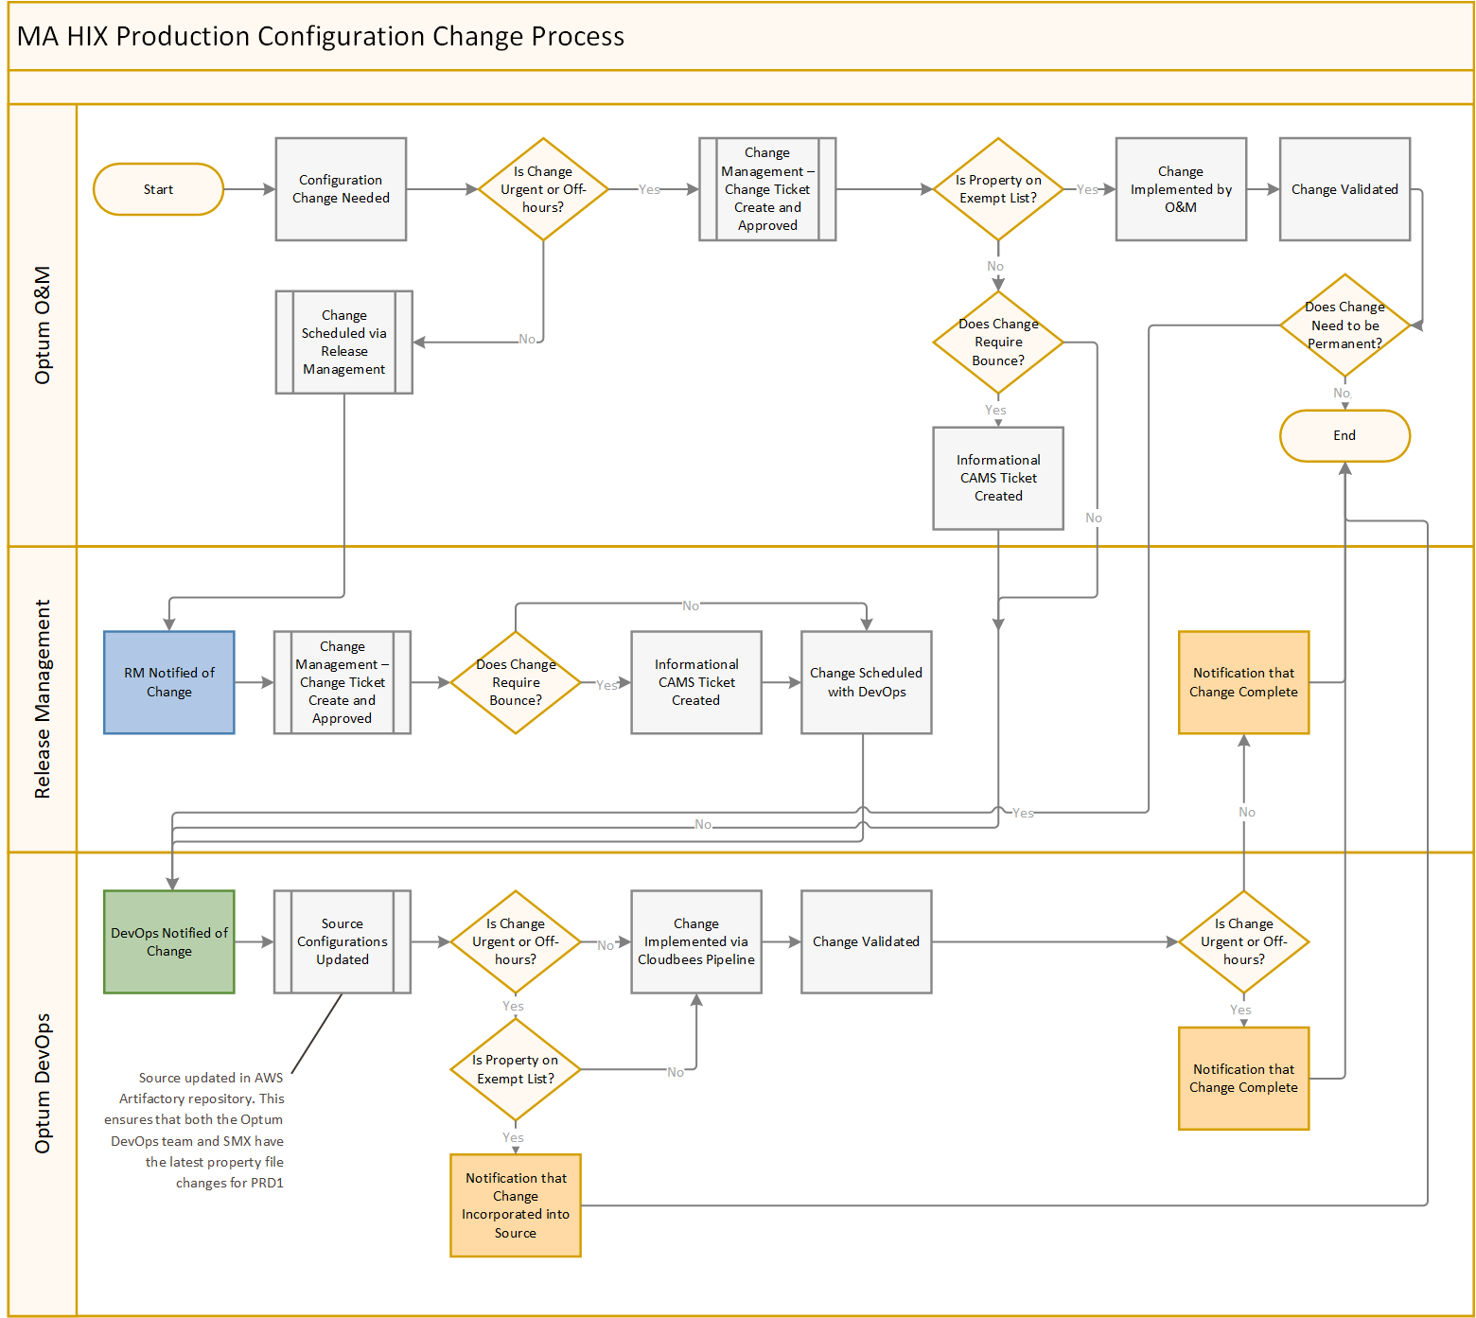

Figure 36: Configuration Change Process Flow

Appendix 8-A: Software Licensing

Specifications for required software to host hCentive application are provided by the Optum Product Team and are stored on the Commonwealth SP at this [link](https://massgov.sharepoint.com/sites/EHS-HIX-PROD/Program%20Documents/Forms/AllItems.aspx?RootFolder=%2Fsites%2FEHS%2DHIX%2DPROD%2FProgram%20Documents%2FTechnical%20Roadmap%20Planning&FolderCTID=0x012000392BA6549B48674C89F238C29C97950E&View=%7B4BAC0A25%2D9286%2D408C%2DB03F%2D2C841197AFEA%7D). EOHHHS procures and owns the licenses for all software. Optum O&M is not responsible for software licensing.

Appendix 8-E: Application Validation Procedures

**Before Maintenance:**

1. Hold and Stop jobs
2. Stop MQ Listener
3. Run and check DB queries
4. Take Dynatrace screen shots, Send to MOCC/RM

**During Maintenance:**

1. Check Banner is up (Banner needs to be put by MOCC)
2. Put up CloudFront Maintenance Page redirect (For all the 4 servers. agent/assister/portal/payment)
3. Akamai flush.
4. Ensure the redirection leads to the **Maintenance page** as expected.
5. Send Starting Notification.

**After Maintenance:**

* Restart MQ Listeners and MQ Monitoring
* Restart O&M utility to send email monitoring alerts
* Smoke test all the portals (Individual/assister/agent) including payment portals
* Individual Portal:
* Log into portal
* Preview plans and search with zip code (example - 02114) and date of birth.
* Check different filters on the preview plans screen
* Assistor Portal:

Login to Assister and add a test user (this is for first time set up), once you have the test user just check it is showing up on your account after you login to the Assister portal

* Agent Portal:
* Login to Agent portal search for a Ref ID and navigate to enrollment
* Click on Make Payment to access payment portal.  (Need to check this link working after every deployment)
* Check Role Permission Mapping Table
* Perform Dynatrace checks and take screenshots of dashboards
* Check these additional dashboards to ensure data is being recorded on them:
* Live Monitoring
* Traffic Light Numbers
* MQ Monitoring Dashboard
* Fed HUB/Commonwealth Services
* Production Health Report
* Check MQ server in Dynatrace and the jobs.
* Un-hold/Restart the held jobs
* Remove Maintenance page redirect and Banner
* Send Completed Notification

**Post Release Validation:**

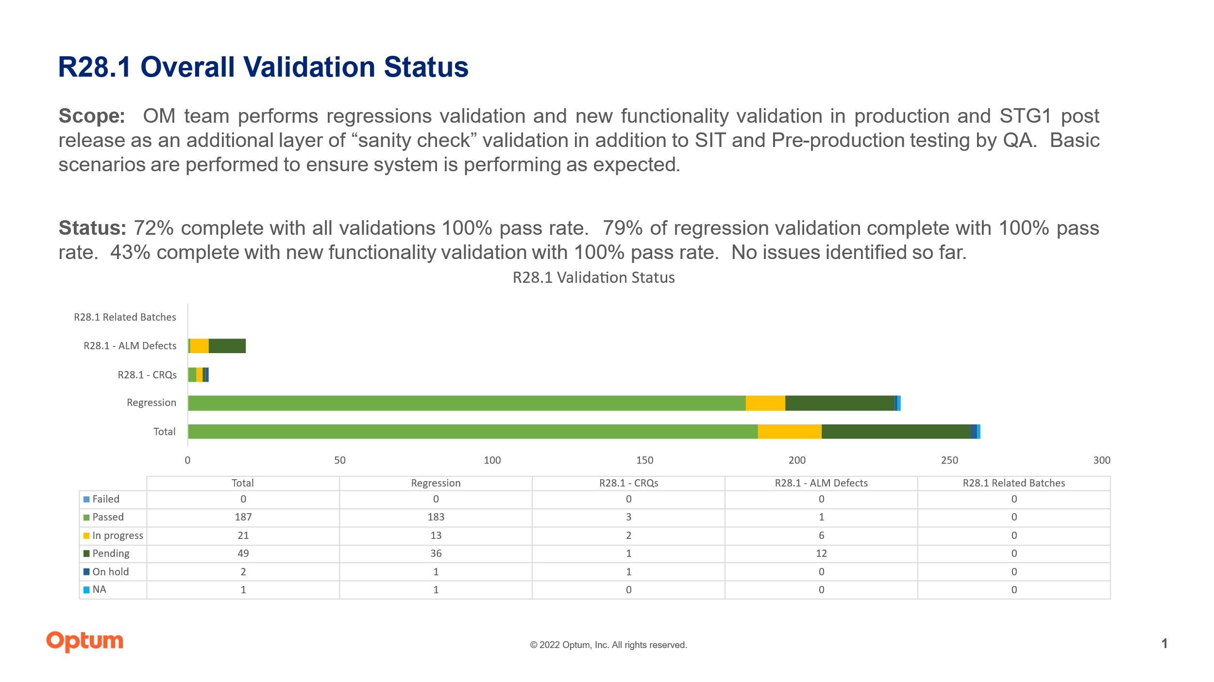

Figure 37: Post-Release Validation Status Overview

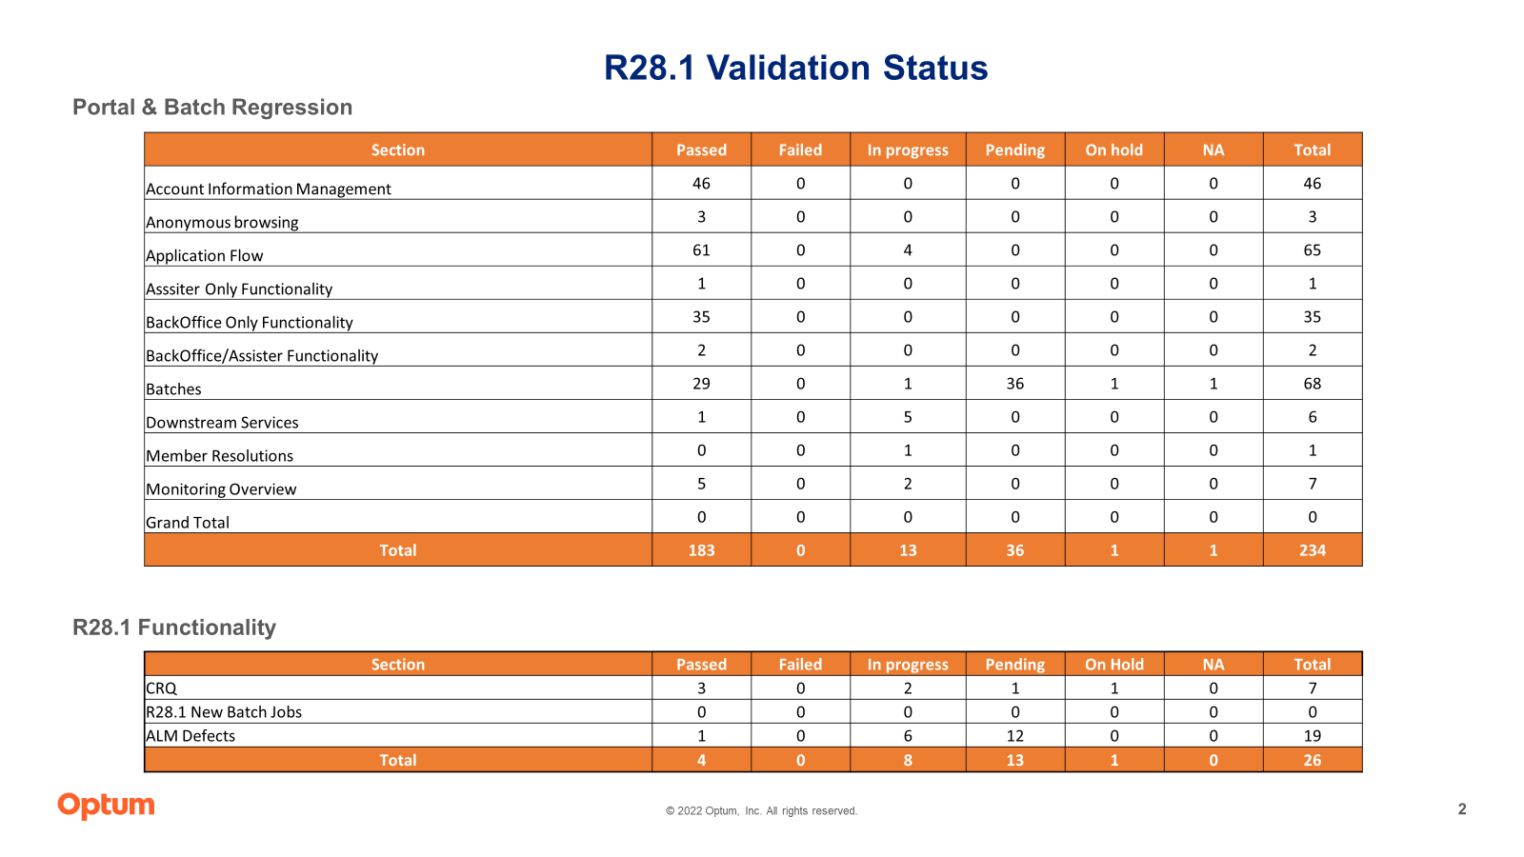

Figure 38: Post-Release Regression Validation Status

Appendix 8-H: Contact List

Table 22 – Optum O&M Contact List

|  |  |  |  |
| --- | --- | --- | --- |
| **Optum O&M** | **Name** | **Cell** | **Email** |
| 1st/2nd level | Ryan Deasy | 571-643-1542 | C. Ryan Deasy <[charles_r_deasy@optum.com](mailto:charles_r_deasy@optum.com)> |
| 1st/2nd level | Vijay Wazir | 562-508-8759 | Wazir, Vijayinder S <[vijayinder.wazir@optum.com](mailto:vijayinder.wazir@optum.com)> |
| 1st/2nd level | Rajeev Sharma | 562-673-8021 | Sharma, Rajeev <[rajeev.sharma@optum.com](mailto:rajeev.sharma@optum.com)> |
| Escalation 1 | Shiva Velappan | 703-864-2339 | Velappan, Shiva P <[shiva.velappan@optum.com](mailto:shiva.velappan@optum.com)> |
| Escalation 2 | Amit Chaturvedi | 571-612-0517 | Chaturvedi, Amit <amit.chaturvedi1@optum.com> |

Table 23 – MOCC Contact List

|  |  |  |  |
| --- | --- | --- | --- |
| **MOCC** | **Name** | **Cell** | **Email** |
| 1st level | MOCC Main phone | 857-400-7830 | Mocc Monitoring <[MOCC_monitoring@optum.com](mailto:MOCC_monitoring@optum.com)> |
| Escalation 1 | David Romero | 603-557-2809 | Romero, David <david.romero1@optum.com> |
| Escalation 2 | Keith Bengtson | 978-857-2500 | Bengtson, Keith <keith.bengtson@optum.com> |

Appendix 8-I: Acronyms

Table 24 - Acronyms

| **Acronym** | **Term** |
| --- | --- |
| AE | Auto Enrollment |
| AGI | Adjusted Gross Income |
| ALM | Application Lifecycle Management |
| API | Application Programming Interface |
| App | Application |
| APTC | Advance Payment of the Premium Tax Credit |
| ARA | Amended and Restated Agreement |
| ARD | Authorized Representative Designation Form |
| AS | Argent Scheduler |
| AVR | Automatic Voter Registration |
| AWS | Amazon Web Service |
| AZ | Application Zone / Availability Zone |
| BA | Business Analyst |
| CA | Certification Authority |
| CAC | Certified Application Counselors |
| CAMS | Cloud Assured Managed Services |
| CAT x Error | Category x Error |
| CCA | Commonwealth Health Insurance Connector Authority |
| CDO | Counselor Designated Organizations |
| CHC | Community Health Centers |
| CHIP | Children's Health Insurance Program |
| CMS | Centers for Medicare and Medicaid Services |
| CNS | Common Noticing Solution |
| CoM | Commonwealth of Massachusetts |
| COMETS | Commonwealth of Massachusetts Enforcement Tracking System |
| COVID | Coronavirus Disease |
| COTS | Commercial Off-The-Shelf |
| CR | Change Request |
| CST | Central Standard Time |
| DB | Database |
| DC | Data Correction |
| DDE | Daily Data Extract |
| DES | Disability Evaluation Services |
| DMN | Decision Model and Notation |
| DOB | Date of Birth |
| DTA | Department of Transitional Assistance |
| Dynatrace | Product name |
| DZ | Data Zone |
| EC2 | Elastic Compute Cloud |
| EDM | Electronic Data Management |
| EES | Eligibility and Enrollment System |
| EFS | Elastic File System |
| EFT | Electronic File Transfer |
| EOHHS | Executive Office of Health and Human Services. |
| ESI | Employer Sponsored Insurance |
| EX | Exclusion |
| FA | Financial Assistance |
| FDSH | Federal Data Services Hub |
| FFM | Federally Facilitated Marketplace |
| FMS | Financial Management Systems |
| FTI | Federal Tax Information |
| FTR | Failure To Reconcile |
| HCR | HIX Change Request |
| HIX | Health Insurance Exchange |
| IES | Integrated Eligibility System |
| IRS | Internal Revenue Service |
| IPPTA | Improper payment Pre-testing and Assessment |
| ITD | Information Technology Division of Executive Office of Technology Services and Security |
| ITS | Implementation and Technical Services |
| JIRA | Product name |
| JVM | Java Virtual Machine |
| KPM | Key Performance Metric |
| Lx Errors | Level x Errors |
| MA | Massachusetts |
| MAGI | Modified Adjusted Gross Income |
| MA HIX | Massachusetts – Health Insurance Exchange |
| MASSIT | Mass Information Technology (Formerly Information Technology Division (ITD) of EOTSS) |
| MDO | Manage Document Online |
| MEC | Minimum Essential Coverage |
| MEDI | Medicare |
| MEP | Medicare Eligibility Program |
| MH | MassHealth |
| MMIS | Medicaid Management Information System |
| MCO | Managed Care Organization |
| MOCC | Massachusetts Operations Command Center |
| MR | Member Resolutions |
| MSA | Master Services Agreement |
| MWS | MyWorkSpace |
| NCOA | National Change of Address |
| NMLB | No Member Left behind |
| Non-ESI MEC | Non-Employer Sponsored Insurance Minimal Essential Coverage |
| OE | Open Enrollment |
| OID | Optum ID |
| OM/ O&M | Operations and Maintenance |
| Ops | Operations |
| OTS | Operational and Technical Services |
| OWA | Operational Workaround |
| PA | Premium Assistance |
| PB | Premium Billing |
| PCC | Primary Care Clinician |
| PDF | Portable Document Format |
| PDM | Periodic Data Match |
| PECO | Peace Corp |
| PMPM | Per Member Per Month |
| PP | PA Payment |
| PPF | Pre-Populated-Form |
| Prelims | Preliminary Eligibility |
| PROD | Production Environment |
| Project O&M | Project Operations & Maintenance |
| PVC | Periodic Verification Confirmation |
| PZ | Presentation Zone |
| QA | Optum Testing Team – Quality Assurance |
| QDP | Qualified Dental Plans |
| QHP | Qualified Health Plan |
| RCA | Root Cause Analysis |
| RFI | Request for Information |
| RIDP | Remote Identity Proofing |
| RM | Release Management |
| RRV | Renewal and Redetermination Verification |
| SAD | System Architecture Document |
| SBE | State-Based Exchange |
| SBM | State-Based Marketplace |
| SLA | Service Level Agreement |
| SM | Standard Modem |
| SMX | Smartronix |
| SNAP | Supplemental Nutrition Assistance Program |
| SOA | Service-Oriented Architecture |
| SOAP | Simple Object Access Protocol |
| SSA | Social Security Administration |
| SSAP | Single Streamline Application |
| SSN | Social Security Number |
| TA | Technical Analyst |
| TBD | To Be Determined |
| TDS | Trusted Data Source |
| TRI | TRICare |
| TT | Trouble Ticket |
| USPS | United States Postal Service |
| VBF | Vital Business Function |
| VHCL | Verified Chronically Homeless |
| VHCP | Veteran Health Care Program |
| VLP | Verify Lawful Presence |
| VPN | Virtual Private Network |
| WA | Workaround |
| WAF | Web Application Firewall |
| WS | Web Services |
| WSDL | Web Services Description Language |
| WSS | Web Services Security |
| XDR | External Data Representation |
| XLC | Expedited Life Cycle |
| XML | Extensible Markup Language |
| XSD | XML Schema Definition |
| XSLT | Extensible Stylesheet Language Transformations |
| ZIP Code | Zone Improvement Plan Code |

Appendix 8-J: Glossary

Table 25 - Glossary

| **Term/ Acronym** | **Definition** |
| --- | --- |
| AIKYAM | New name for Cloud based Optum ID (OID) |
| Advance Payment of the Premium Tax Credit (APTC) | Advanced Premium Tax Credit (Note: Federal tax credits that can be applied towards a health insurance premium for individuals who qualify based on a defined set of factors) |
| Amazon Web Services (AWS) | AWS is on-demand cloud computing platforms |
| Amended and Restated Agreement (ARA) | Amended and Restated Master Services Agreement between EOHHS and OputmInsight |
| Application Lifecycle Management (ALM) | ALM is an application lifecycle management tool for software quality assurance and test management to deliver apps quickly with confidence. |
| AxWay | Secure file transfer tool |
| Cloud Assured Managed Services (CAMS) | Smartronix ticketing system |
| Commonwealth Health Insurance Connector Authority (CCA) | Health Connector state entity (QHP program focused) |
| CCA Only Household | A household will be considered a CCA only household if there are only CCA members in the application before renewal process starts. This includes partial MASSHEALTH as well i.e. the individuals who are eligible for Connector benefits and a wrapping MASSHEALTH benefit (Limited, HSN, or CMSP). |
| Complex Household | An application that contains members who are eligible for more than one type of QHP and/or has multiple tax households |
| Daily Data Extract (DDE) | The DDE program is a java-utility that extracts the data from the database and generates a file. |
| Data Correction (DC) | DCs are a one-time task created to clean up data impacted by a defect or issue which was not a defect and has been addressed and is no longer occurring. |
| Dynatrace | Dynatrace is a software intelligence platform based on artificial intelligence to monitor and application performance and user experience. |
| Exclusion (EX) | SQL script to exclude a certain population from the selection criteria of a business process executed by a batch job or jobs |
| Extensible Markup Language (XML) | Extensible Markup Language (XML) is a set of rules for encoding documents in a machine-readable format. |
| HIX Change Request (HCR) | HCRs are raised when a functional gap is identified which needs to be addressed as an enhancement. |
| Implementation and Technical Services (ITS) | Optum services provided to EOHHS as per Operational and Technical Services Contract. |
| Information Technology Division (ITD) | Division of EOTSS which is one of the notice vendors for MA HIX program. |
| Java Virtual Machine (JVM) | A virtual machine that can execute Java byte code. It is the code execution component of the Java platform. |
| JIRA | Commonwealth ticketing system |
| Key Performance Metrics (KPM) | Key performance metrics as per OTS contract. KPMs pertain to service areas that are of particular importance to the overall success of the HIX Program, and Contractor’s failure to meet them shall subject it to credits to Client against amounts otherwise owed by Client to Contractor (“KPM Credits”). |
| Level x Errors (L x Errors) | Errors related to generation, transmission and acknowledgment of 834 XMLs. |
| MassHealth (MH) | MassHealth is a program that administers Medicaid, CHIP and other subsidized health insurance programs, such as CMSP and the Health Safety Net for eligible Massachusetts residents. |
| MH only household | A household will be considered as MASSHEALTH only household if all the members in the household are full MASSHEALTH eligible. |
| Member | Any individual that has successfully been enrolled in a plan |
| Mixed Household | Mixed HHs will be any applications where there are more than two members and one of them has a MassHealth benefit without a Connector determination (ex: Standard, CarePlus, Family Assistance, CommonHealth, or just MASSHEALTH Limited/no CCA determination). |
| OpenSearch | OpenSearch is a software for searching, monitoring, and analyzing machine-generated big data via a Web-style interface. |
| Operational and Technical Services (OTS) | Optum services provided to EOHHS as per Operational and Technical Service Contract. |
| Partial MH | Partial MassHealth is an ‘emergency’ or ‘fill in the gap’ coverage provided by MassHealth to people who does not qualify for Full MassHealth but qualifies for the criteria set by MassHealth for getting Partial MassHealth. It’s not considered Minimum Essential Coverage (MEC) as it does not provide full coverage. Partial MassHealth can be given to people with or without a CCA benefit. Currently, HIX offers 3 programs which comes under Partial MassHealth – Health Safety Net (HSN), Children’s Medical Security Plan (CMSP) and Limited. |
| Qualified Health Plan (QHP) | Qualified Health Plan (Note: defined as a health plan certified by the marketplace to meet new benefit and cost-sharing standards) |
| Quality Analyst (QA) | QA is responsible for applying the principles and practices of software quality assurance throughout the software development life cycle. |
| QuickSight | Amazon QuickSight is a machine learning-powered business intelligence service built for the cloud under the Amazon Web Services umbrella |
| Smartronix (SMX) | Smartronix is an information technology and engineering solutions provider specializing in Cloud Solutions |
| Standard Modem (SM) | One of the notice vendors for MA HIX program. |
| Trouble Ticket (TT) | Type of JIRA ticket which is used to track Production defects. |
| War Room/ high priority incident triage call | War room/ high priority incident triage calls are conference phone calls initiated when a P1 & P2 tickets are reported. Calls are initiated by Optum O&M or Mocc team and can include SMX and other vendors as required to investigate and address production issue. |
| Workaround (WA) | A Workaround is a method to reduce or eliminate the impact of an Incident or Problem for which a full resolution is not yet available. |
| Workdocs | Amazon WorkDocs is a fully managed, secure content collaboration service. You can easily create, edit, store, and share content |